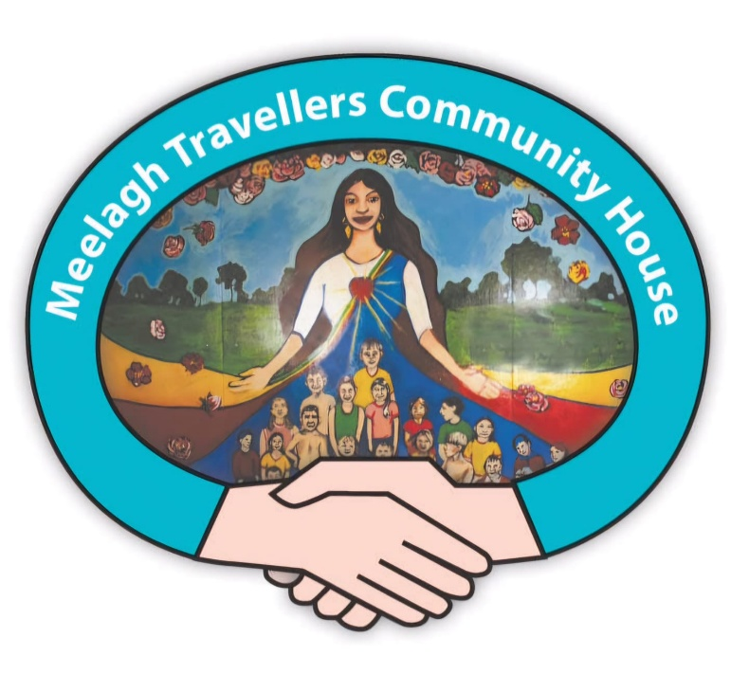
Meelagh community development worker (part time role -25 hours per week)
The Meelagh community development worker will support and oversee the running of Meelagh community house, situated on Meelagh Traveller group housing scheme in Mahon, Cork. The role involves coordinating activities in the centre, advocating for Traveller rights, supporting families around a range of issues and empowering residents of Meelagh in organising local activities/groups and participating in local decision making. The role will primarily based at Meelagh Community House, with outreach to the surrounding community and other meetings off site within Cork city as required. The worker is employed by Cork Traveller Women’s Network and will work as a member of our team.

Background
Meelagh community development project provides a range of culturally appropriate family supports and programmes for the families of Meelagh Traveller group housing scheme (approximately 20 families). The project, which has run since 2010 is located in a Traveller led community centre in Mahon, Cork city. The role will primarily based at Meelagh Community House, with other meetings off site within Cork city.

Salary €36,153 per annum for 25 hours per week. (Role funded through the HSE Cork Kerry Traveller Health Unit.)

Main Duties:
Duties will include the following:
- Support the development of Meelagh community centre
- Manage & co-ordinate the family support services in Meelagh
- Manage the day to day running of the centre including programme planning, financial management and tutor support, supervision & training
- Set up relevant health, education & cultural programmes & activities in response to identified needs through community outreach & consultation
- Encourage and support Traveller representation on centre management through a mentoring & leadership supports
- Support the community reps to advocate for their needs in key decision making fora
- Encourage & support a sense of ownership & pride in the Meelagh centre in all our community including children & youth
- Advocate for the rights of Travellers and provide support and signposting to services to individuals and families around issues that affect their lives.
- Manage the Meelagh centre budget and keep appropriate records
- Develop funding applications to implement programme of activities key activities in Meelagh: • After School Programme • Youth drop-in • Young Girls Group • Women’s Group • Health Events • Cultural Events
- Network with and work with key agencies committed to supporting our overall aim & key objectives to secure resources
- Link with and report to Cork Traveller Women’s Network
- Undertake training and attend external meetings as directed by the co-
ordinator
- Participate in team meetings with CTWN

Person specification:
- Qualifications in community development or related education and/or significant community work experience
- Experience of working with Traveller projects/families and young people
- Awareness of and respect for Traveller culture and traditions
- Experience providing support and advocacy in a community setting
- Experience overseeing community based project work
- Excellent communication skills, with people from different backgrounds
- Ability to Network with external agencies
- Be able to manage personal and professional boundaries including maintaining confidentiality and always showing respect
- Committed to social inclusion and equality of outcomes
- Willing to work flexibly and be responsive to individual support needs
- Proficient admin skills: writing reports, keeping accounts, maintaining budgets, using MS office applications and ability to write funding applications
- Be able to work as part of a team (CTWN staff team)

