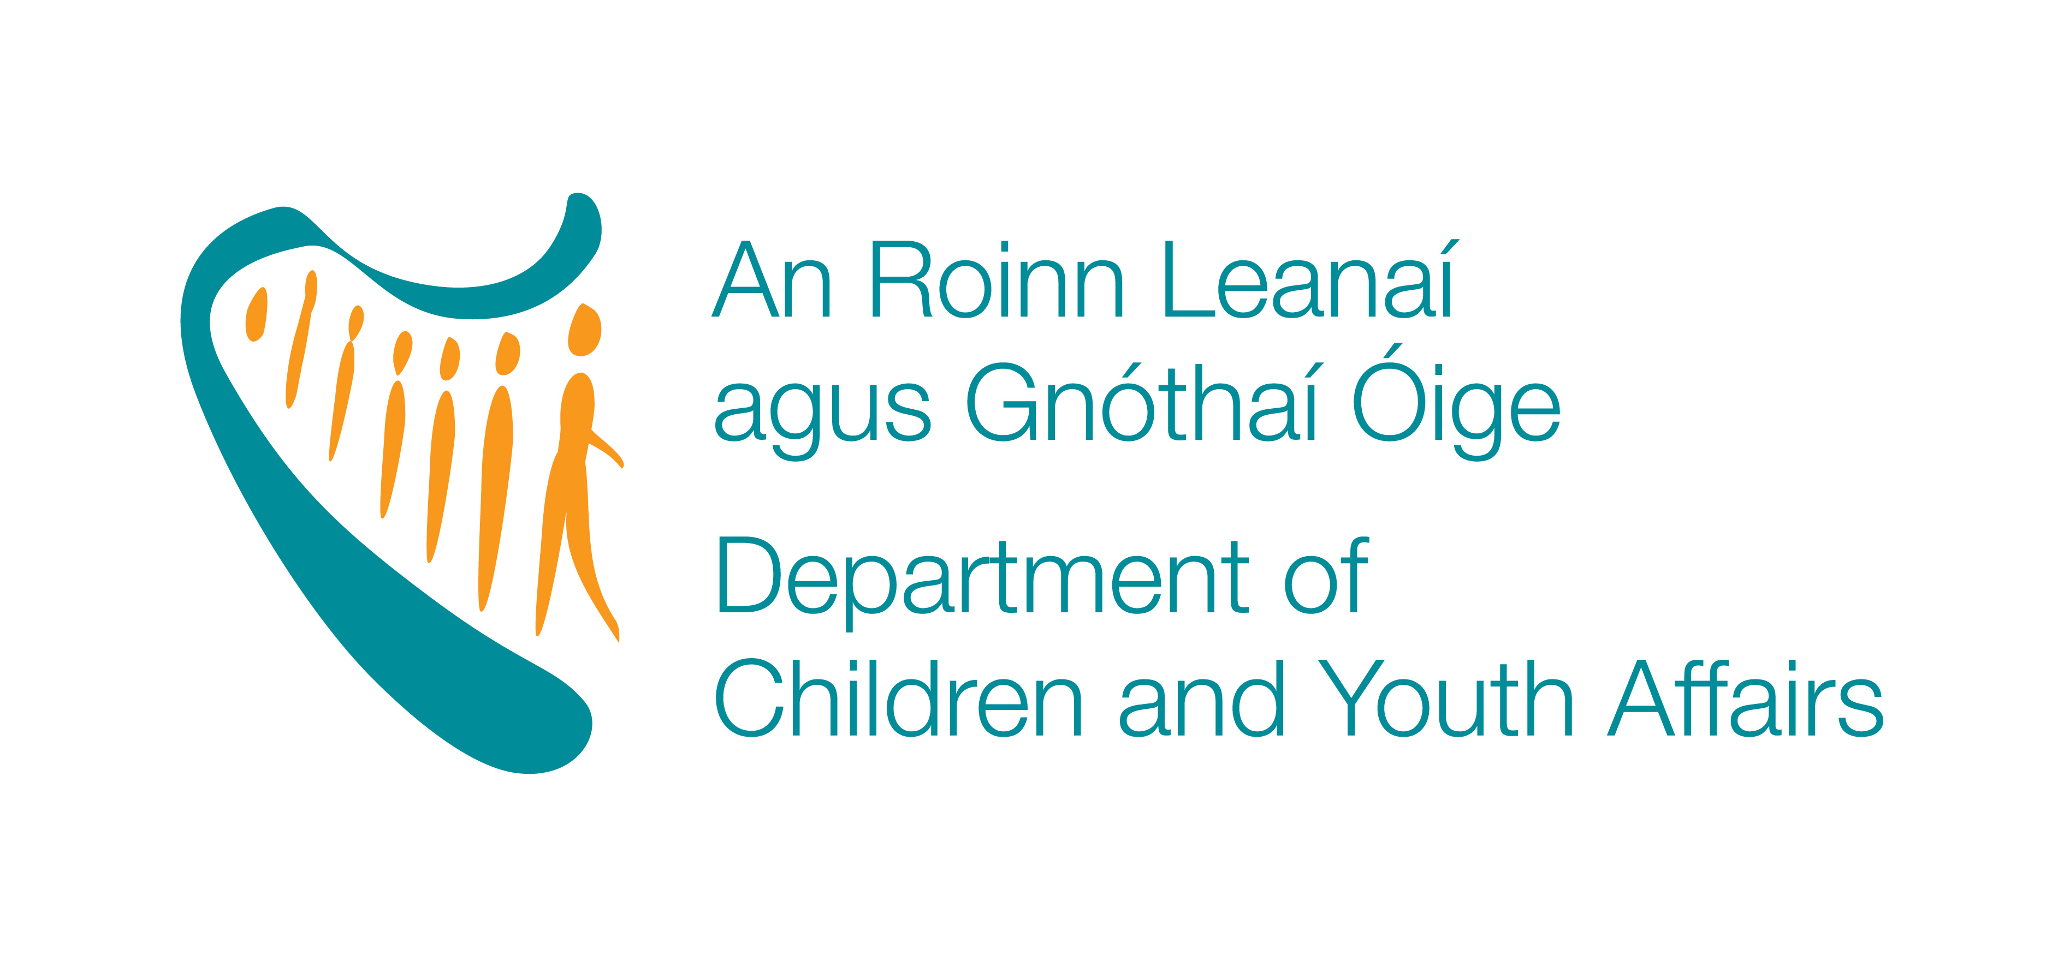

For Office use only

Sligo School Completion Programme
Project Worker

Surname ___________________________

First Name ___________________________

Telephone No ___________________________ Mobile No _________________

Correspondence
Address ___________________________

___________________________

___________________________

____________________________

____________________________

Further Education & Training

Date  From To |  | Name of College, University | - Title of Qualifications Obtained  - Subjects Taken | 1.Date Conferred  2. Precise Grade | Name & Tel No of Contact Person

Have you received Child Safeguarding training to date? Yes _____ No_____

If yes, who provided the training? __________________
Please include copy of certificate

Employment History (excluding present or last employment)
Please include any voluntary/community work, but exclude work placement which was conducted as part of a qualification obtained.

Dates  From To | Period of Employment Years/Months | - Employers Name & Address  - Supervisors Name, Title, Contact No | - Title of post  - Statement of Duties & Responsibilities
 |  | 1. | 1.
 |  | 2. | 2.
 |  | 1. | 1.
 |  | 2. | 2.
 |  | 1. | 1.
 |  | 2. | 2.

Current/Last Employment

Name of Employer _________________ Job Title _______________________

Address __________________________________________________

__________________________________________________

__________________________________________________

Telephone No __________________

What period of notice does your employer need? _________________________

Date joined __________________ Date finished __________________

Describe briefly your present or last employment- outline your main responsibilities, to whom you are responsible and who is responsible to you.

What does the area of social and educational disadvantage mean to you and give a brief outline of your experience, if any, in this area.

For Administration Purposes only
Further Personal Details

REFERENCES:
Name:

Business Address:

Occupation:

Telephone No:

Name:
Business Address :

Occupation:
Telephone No:

Please note that no enquiries will be made of your present employer without prior permission

In order to ensure Equality of Access to all applicants please indicate if you require any special aids, equipment or facilities to attend the interview.

DECLARATION: It is important that you read this declaration carefully and then sign.
“ I declare that to the best of my knowledge and belief that there is nothing in relation to my conduct, character or personal background of any nature that would adversely effect the position of trust in which I would be placed by virtue of this appointment. I hereby confirm my irrevocable consent to the School Completion Programme to making such enquiries as the programme deem necessary in respect of my suitability for the post in respect of which this application is made. I hereby accept and confirm the entitlement of the programme to reject my application or to terminate my employment (in the event of a contract of employment having been entered into) if I have omitted to furnish the programme with any information relevant to my application or my continued employment with the programme or where I have made any false statement or misrepresentation relevant to this application or my continuing employment with the programme.

Furthermore, I hereby declare that all the particulars furnished on this application are true, and that I am aware of the qualifications and particulars for this position. I understand that I may be required to submit documentary evidence in support of any particulars given by me on my application form. I understand that any false or misleading information submitted by me will render me liable to automatic disqualification”

“I understand that if my application is not shortlisted for this appointment, this document will be destroyed immediately by Sligo SCP. If I am selected for interview, this document will retained by Sligo SCP until appointment is made and panel formed. If I am successful and appointed to this position or placed on a panel, Sligo SCP will retain this application form for the duration of my employment / lifetime of the panel. If I am unsuccessful at interview, this document will be destroyed by Sligo SCP following the interview process”

Failure to sign the application form will render it invalid.

SIGNED____________________________ DATE ___________________________

Completed application forms should be returned to

Sligo School Completion Programme
c/o Mercy College
Chapel Hill,
Sligo.

or by email to mary.mchugh@scp.ie no later than Thursday 11th of September 2025

