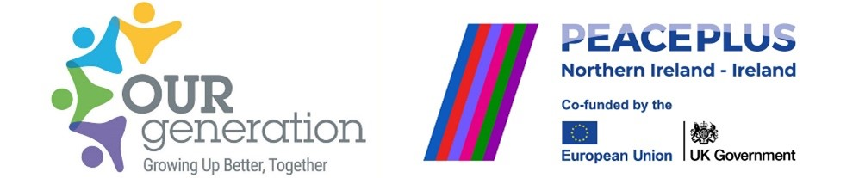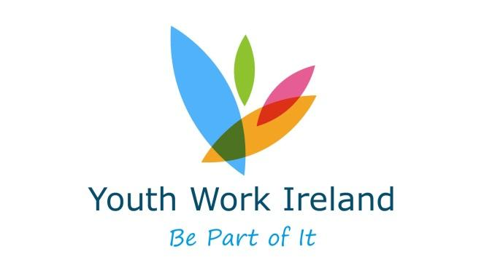

**JOB DESCRIPTION –** **duties for:**

**(PEACEPLUS –3.3 Youth Mental Health and Wellbeing)**

**(Youth Work Ireland)**

Title: Our Generation Youth Worker - Youth Work Ireland

Responsible to: Our Generation Programme Coordinator - Youth Work Ireland

Links to: Partner organisations, Programme Youth Workers, Administrator

Timescale: March 2025 – Sept 2027 - fixed term contract

Location: One post is available, with one in the following location: DONEGAL

The position is HYBRID - working from a remote location TBC with (almost daily) travel to schools, community organisations, youth clubs and youth organisations across County Donegal.

Project: ‘Our Generation’

Funder: SEUPB - Peace Plus

Hours: 35 hours per week

Salary: Dev Officer grade 1 point 8 starting at €41,500.49

**Description of Project**

**Investment area 3.3 Youth mental health and wellbeing**

This will support additional, non-formal provision activity involving cross community and cross-border multi-partner collaborative approaches, which will lead to improved understanding of youth mental health and wellbeing issues and the sharing of best practice across the Programme Area to improve service delivery.

**Job Responsibilities**

**YWI targets and deliverables**

The Development Officer will be part of a team of four full-time Youth Workers and one full-time Administrator that will be responsible for meeting ambitious deliverables through the provision of the following Joint Training Schemes in the counties of Louth, Cavan, Monaghan, Sligo, Leitrim and Donegal:

Be Well+

Be Well+ will contribute to peace and reconciliation through the development of enhanced emotional resilience in our young people, aged 12 – 18 with a specific focus on addressing the management of anxiety, worry and stress.

Yes+

Yes+ will contribute to peace and reconciliation through the development of enhanced emotional resilience in our young people, aged 14 – 24 with a specific focus on addressing identities, relationships, and positive decision making.

Stand Upp+

StandUpp+ will contribute to peace and reconciliation through the development of enhanced emotional resilience in our young people, aged 14 – 24 with a specific focus on addressing identities, power and difference, relationships, violence prevention and positive decision making.

Youth Action+

Youth Action+ will contribute to peace and reconciliation through the development of enhanced emotional resilience in our young people, aged 13 – 24 with a specific focus on addressing identities, power and difference, relationships, violence prevention and positive decision making.

Key Worker Training in Be Well+, Yes +, Stand Upp + and Youth Action +

The key worker training will equip participants to deliver four Youth Work Ireland programmes in order to contribute to peace and reconciliation through the development of enhanced emotional resilience in our young people.

**JOB DESCRIPTION**

**Job Responsibilities**

**Recruit for Youth Work Ireland Deliverables**

* Recruit young people through proactive recruitment methods by proactively linking in and promoting the programmes with schools and community organisations.
* Identify barriers to participation and mitigate against these.
* Ensure planned shared contact programmes that involve cross community/cross border participation.
* Coordinate with partners in delivery.

**Plan/Implement**

* Involve young people as co-designers of a planned but flexible programme.
* Create and implement a range of programmes with the core elements of building peace through emotional resilience (YES+ Training, Be Well+, Youth Action + StandUpp +).
* Make practical arrangements (travel; refreshments; venue etc) within agreed budget.
* Co-ordinate programme activities with other necessary supports.
* Liaise with other partners to create collaborations and opportunities for further cross community and/or cross border engagement.
* Implement programme sessions as per fidelity checklists

**Record**

* Use recording and monitoring tools as per requirements of SEUBP
* Use evaluation tools as per the requirements of project evaluation framework
* Understand and apply the outcomes based model of evaluation in a structured and organised manner.
* Participate in observations on practice and programme reviews.
* Participate in team and project reviews.
* Upload regular communications and promotion through social media.

**Review**

* Follow all financial, monitoring and administrative duties for tasks, as required by Project lead.
* Ensure ongoing recording of practice for dissemination and evaluation purposes.
* Ensure critical reflection practices are in place to aid dialogue and action which is current and responsive to need.
* Identify and undertake training appropriate to the needs of the post in agreement with Line Manager (as part of your Continuous Professional Development).

**General**

* Support the promotion and marketing of the PEACE PLUS programme in accordance with agreed objectives (any publicity must be agreed with the project co-ordinator).
* Promote the project outcomes and impact through regular updates on the agency web site, social network sites, agency newsletter and the e-news (adhering to SEUPB guidelines).
* Maintain administrative systems required to support the work of the project (procurement, purchase order, raising cheque requisitions).
* Work within agreed budgets, as laid down by the Project co-ordinator adhering to Youth Work Ireland’s financial procedures at all time.
* Be proactive in the development of resources for peace building through emotional resilience programmes that enable practitioners to work more effectively with young people.
* Attend and contribute to relevant meetings (lead partner, funder).
* Follow policies and practices as set out by Youth Work Ireland especially adherence to Safeguarding Policies and Procedures and Data Protection.
* Reflect the ethos, policies and practice of Youth Work Ireland at all time.

**Competencies**

As per Youth Work Ireland Competency Framework

**Essential Criteria:**

* A Professional Qualification, (Level 7 as per the National Framework of Qualifications- www.nfq-qqi.com) in Social Work, Youth and Community Work, Social Care or related Social Science Discipline, Diploma or Degree level.
* Experience in effectively delivering manualised programmes, packs, or structured sessions to young people in challenging environments
* Willingness to travel and to engage with young people in a variety of contexts on a daily basis
* Full driving licence and access to car

**Desirable Criteria:**

• A Professional Qualification at level 8

• Experience of project coordination in a similar setting

• Knowledge of peace building and working in a cross-border environment

**Application Process**

* Please email an up-to-date CV and a cover letter to Fernanda Gomes Batista at **fgomesbatista@youthworkireland.ie**. Until **Friday 12/09/25 (by 5pm).**
* In your cover letter, please explain how you meet the essential criteria for the role.
* Make sure to confirm whether you hold a full, clean driving licence and have access to a car in order to meet the travel requirements of the position.
* **Wednesday 17/09/25:** Online interviews will take place.

