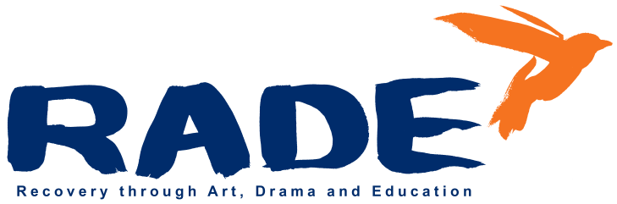

**OLV Building**

**Cathedral View Court**

# Off New Street

# Dublin 8

**Tel: 01 454 8733 / 01 454 6406**

**Email: info@rade.ie**

**Website: www.rade.ie**

**Project Director/Manager**

**Job Summary :** To oversee, develop and effectively deliver services of the RADE Programme and Community Employment Scheme and to uphold the philosophy and working ethos of RADE.

**Service Delivery and Oversight of CE Scheme**

* Manage and deliver the Community Employment Scheme & HSE Programme in line with the requirements of all funders.
* Establish and maintain working relationships with community agencies and local Drug and Alcohol Task Force.
* Develop links with statutory and voluntary agencies.
* Oversee and monitor service user assessments and support plans.
* Regularly engage with and build a professional relationship with participants.
* Ensure that service user forums are convened on a regular basis and that appropriate records are maintained.
* Provide a high standard and client-centred service in collaboration with RADE staff.
* Undertake ongoing reviews and assessments of care practices.
* Take responsibility for the development, implementation and recording of practice standards within the service.
* Implement service policy and procedures in conjunction with the team to ensure appropriate service delivery. Ensure policy and procedures are reviewed regularly.
* Liaise with other services in addiction and related arenas.
* Keep up to date on recent developments and best practice and quality standards in the delivery of services to clients.

**Creative Development**

* Take responsibility for and work with RADE team to manage and deliver overall creative programme.
* Recruit and engage contemporary Irish artists to devise multi-disciplined creative work with participants.
* Oversee and work with RADE team to organise theatre performances and film production both for the public and other drug services.
* Oversee annual publication of creative writing and graphic art books and exhibition of artworks generated by participants.
* Oversee exhibiting of participant’s work in other drug services and community centres.
* Maintain and develop relationships with partner arts organisation such as: The National College of Art and Design, The Abbey Theatre, Smock Alley Theatre Company, Gaiety School of Acting, The Project Arts Centre, The Gate Theatre and The Pavilion Theatre, Film Base, Irish Film Institute, RTE Radio drama, Museum of Modern Art, The National Gallery and National Libraries.
* Create internships and progression pathways for participants.
* Strengthen existing relationships with casting agents and film production companies.
* Develop fund-raising and manage grant applications for creative projects.
* Oversee team management for delivery of daily yoga, meditation and/or Tai Chi classes.

**Management, Teamwork, Staffing and Volunteers**

* Management of RADE team – to include all staff and volunteers, including induction and recruitment.
* Ensure a consistently high standard of care plans, key working, assessments and referrals to the programme.
* Oversee the ongoing development of appropriate staffing structures and service policies and procedures.
* Ensure that an effective team approach is maintained and that the team works to a high standard in carrying out its brief and tasks.
* Work as part of a team with regular and consistent communication participating actively in all team meetings.
* Manage staff rota and facilitate support as needed.
* Ensure maintenance of appropriate records of work and statistics by all staff.

**Administration, Reporting & Finance**

* Ensure that adequate record systems are developed and maintained.
* Work with staff to ensure that client care plans are kept updated, statistics are collated and reports on aspects of the service are written up on a regular basis.
* Ensure appropriate financial controls and systems are maintained in consultation with the Chairperson and Board of Directors.
* Oversee and manage all RADE and project budgets working closely with RADE finance officer.
* Work with Board and finance officer on audits and year end reporting.
* Produce standard monthly and quarterly reports for submission to the Chairperson and Board of Directors.
* Ensure compliance with the Charities Regulator and CRO in collaboration with the Board.
* Manage and submit annual grant aid reviews to funders.
* Attend Board Meetings and prepare relevant management reports.
* Oversee implementation of governance, compliance and risk management strategies and policies.
* Comply with the Board of Directors’ requirements in relation to all the appropriate paperwork for the service, such as client files, daybooks, accident reports.

**General Responsibilities**

* Communicate with and maintain appropriate accountability to the Chairperson and Board of Management.
* Collaborate with the Board on long-term strategy & vision for the Organisation.
* Report to the Chairperson of the Board of Directors for individual support, supervision, performance appraisal and working within the parameters of RADE and H&S policies and procedures.
* Working with RADE staff and external consultant to ensure that IT information storage and recording systems and other filing systems are kept up to date.
* Attend training events, and other functions as necessary.
* Maintain a flexible approach to the work in response to organisational change, development and review of best practice.

**The building**

* Ensure that Health and Safety standards are maintained in accordance with Health and Safety provisions to ensure a safe and secure environment for participants and staff.
* Ensure that required building and work practice risk assessments and adjustments are regularly carried out~~.~~
* Ensure the maintenance and repair of the equipment, furnishings and fabric of the property to a high standard.
* Liaise with property owner and licensor Dublin City Council

**Terms**: Permanent contract with 6-month probationary period

**Salary:** On application

**Reports to:** Chairperson of the Board

**Location**: RADE, Cathedral View Court, Dublin 8.

**Hours:** 40 hours per week Monday to Friday

**Annual leave**: 24 days

**RADE reserves the right to review and amend this job description as appropriate.**

**RADE is an equal opportunities employer**