#
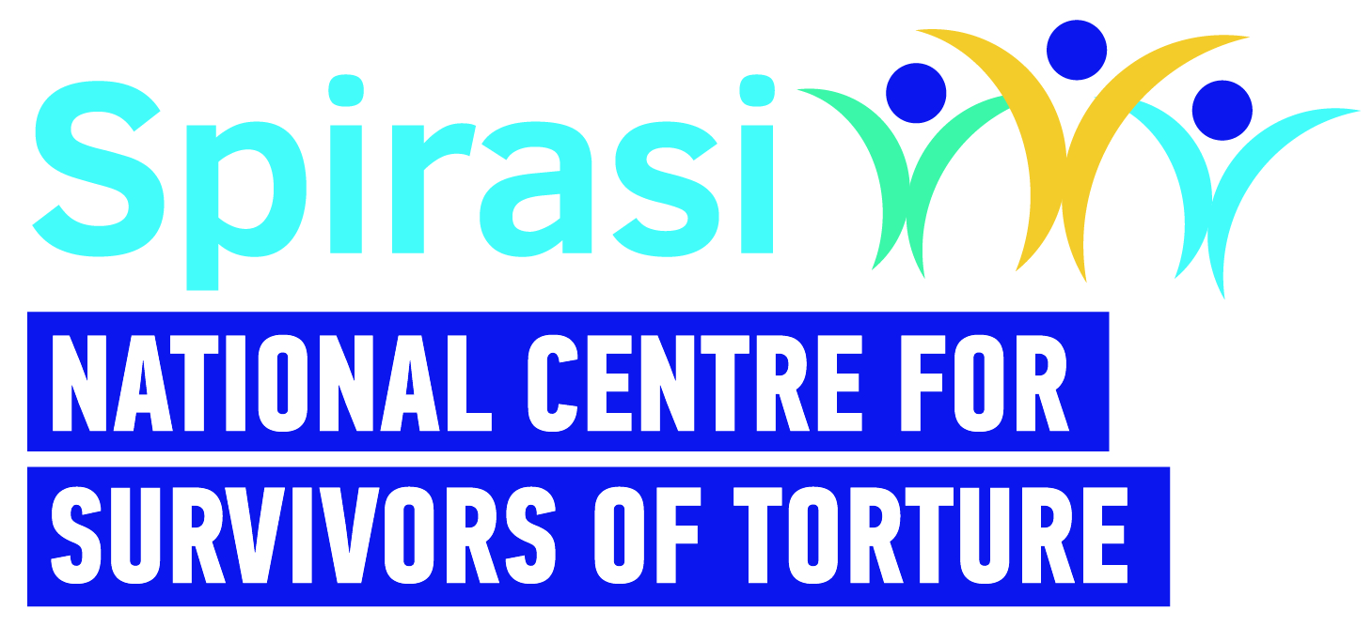 | HR Co-Ordinator - Job Description
Title: | HR Co-Ordinator
Work Schedule: | 35 hours per week (possibility of four-day week, pro-rata)
Contract Type: | One Year Fixed Term
Rate of Pay: | Scale: Approx. €35-40,000 pa
Reporting: | Acting Head of Operations
Location: | Spirasi, 213 North Circular Road, Phibsboro, Dublin 7 with hybrid working in accordance with Spirasi Hybrid working policy.
Main Purpose of Role
Spirasi is seeking to appoint a suitably qualified, capable and proactive HR Co-ordinator to support the day-to-day operations of our organisation, with a particular focus on HR administration. This is a key support role, ideal for someone with experience in HR processes and office co-ordination, who thrives in a varied role and is comfortable taking initiative.

You will co-ordinate recruitment and onboarding processes, ensure accurate and timely payroll administration, handle employee lifecycle paperwork, co-ordinate all Garda Vetting and help ensure compliance. You will be a point of reference and support for staff and managers on HR procedures and policies.

Main Responsibilities
- Coordinate end-to-end recruitment processes, including advertising roles, scheduling interviews, reference checks, and issuing contracts.
- Maintain and update employee records, including contracts, leave requests, and other key documentation, using HR Locker among other tools.
- Oversee payroll input and liaise with external payroll providers to ensure accurate and timely processing.
- Support employee onboarding and offboarding processes, including induction scheduling and exit interviews.
- Co-ordinate all Garda Vetting across the organisation.
- Ensure HR practices comply with employment legislation and internal policies.
- Liaise with IBEC on employment queries as needed and maintain awareness of relevant HR developments.
- Support managers in understanding HR policies and procedures. Assist with general administrative duties as required.
- Prepare reports or data summaries as required (e.g. staff turnover, leave balances).
Person Specification – Knowledge, Skills and Experience Required
Essential
• A relevant qualification in HR.
- At least 2 years’ experience in a similar HR role.
• Knowledge of GDPR and data protection obligations.
• Knowledge of employment law and best practice as it applies to the role of HR
Co-ordinator.
Additional Skills & Attributes
- Possesses experience and understanding of cross-cultural work in HR.
- Strong organisational and administrative skills.
- Ability to manage multiple tasks with good attention to detail.
- Excellent interpersonal and communication skills.
- A self-starter with the ability to work independently and use good judgment.
- Comfortable working in a small organisation and adaptable to changing needs.
- Proficient in IT (Word, Excel, PowerPoint, Email).
- Excellent self-care practices.

Desirable criteria:
- Experience in the not-for-profit or charity sector.
• Familiarity with using IBEC or other employer advisory services.
• Experience using HR software or systems.

Please note:
- This job description is not exhaustive; the post holder may be required to take on additional duties relevant to the role and contribute to its development.
- Garda clearance is a requirement for all Spirasi staff, both upon hiring and throughout employment.
- References will be a prerequisite for employment.
- Candidates must have the right to work in Ireland at the time of application and for the duration of employment.
- Applicants with qualifications obtained outside the Republic of Ireland must provide evidence of validation by the Irish Department of Education at the time of application.
- Remote work requires a designated, single workspace in the home or an alternative office.
- All personal data received will be processed in accordance with the Data Protection Acts 1988, 2003, and GDPR (2018) and used solely for recruitment and administrative purposes.
- Spirasi is an equal opportunities employer. Recruitment decisions are based on merit, aligned with job and skill requirements.

Support & Development
- While this is a standalone role, the successful candidate will be supported by the CEO and receive monthly mentoring from a volunteer HR Director (Trustee level).

