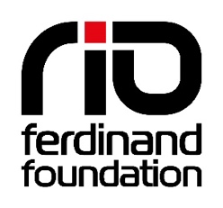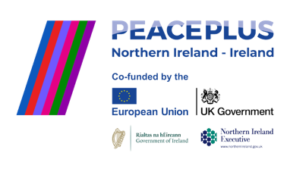

**Tender Specification:** Public Relations Services

**Issued by:** Rio Ferdinand Foundation

**Tender Title:** Provision of Public Relations Services – Rio Ferdinand Foundation PEACE Academy

**Issue Date:** 13.08.2025

**Closing Date:** 19.09 2025

**Contact for Queries: Donald Forde,** [donald@rioferdinandfoundation.com](mailto:donald@rioferdinandfoundation.com)

**Scope**

The Rio Ferdinand Foundation are looking to procure the services of a Northern Ireland or Republic of Ireland based PR, Communications and Media agency to support a new exciting new cross-border PEACE Academy programme in Belfast and Sligo, supported by PEACEPLUS, a programme managed by the Special EU Programmes Body (SEUPB) <https://www.seupb.eu/> The aim of this new three-year programme, is to deliver and evidence a PEACE Academy pathway of engagement, learning, social action and employability that will inspire young people from communities in Northern Ireland and Ireland to create shared experiences and build a long-term response to sectarianism, racism and hate on a cross community and cross border basis.

**Objectives**

The appointed PR agency will:

* Raise awareness of the Foundation’s work on delivering the PEACE Academy programe.
* Support campaign launches, events, and youth-led initiatives.
* Develop and deliver media strategies that engage key stakeholders.
* Enhance our reputation and influence within the youth, education, and social impact sectors in Ireland and the Republic of Ireland.

**Scope of Services**

The successful agency will be expected to provide:

* Planning and delivery support of a PR strategy and campaign for the PEACE Academy programme
* Mapping and supporting engagement of key programme stakeholders
* Preparation of content and engagement with Northern Ireland and Republic of Ireland based media publications
* Monitoring and reporting of media coverage and impact.

**Deliverables**

* Support to pre-agreed strategic campaigns – Number to be confirmed
* Monthly media coverage reports.
* Press releases and media kits for key events
* Support for youth-led media and storytelling initiatives.

**Requirements**

* Strong understanding of the political and social landscape of Northern Ireland and the Republic of Ireland
* Alignment with Rio Ferdinands core vision and values
* Proven track record of promotion of similar projects and programmes that aim to promote mutual understanding between communities in the context of social justice and social mobility
* Minimum annual turnover of £50,000
* Insurance coverage [e.g. Employers Liability, Public Liability, Professional Indemnity]

**Duration**

* The contract will be for an initial period of 12 months, with the possibility of extension to 36 months based on performance and funding.

**Budget**

* The indicative budget for this contract is €10, 000 per annum, inclusive of all fees and expenses.

**Evaluation Criteria**

* Tenders will be evaluated based on:
* Quality of Proposal (40%) – Understanding of our mission, creativity, and strategic approach.
* Experience & Track Record (30%) – Relevant experience in the charity, youth, or social impact sectors.
* Value for Money (20%) – Cost-effectiveness and transparency.
* Social Value (10%) – Commitment to diversity, inclusion, and youth empowerment.

**Evaluation Criteria**

Interested agencies should submit:

* A cover letter and company profile.
* A proposal outlining approach, methodology, and timelines.
* Case studies of relevant work.
* Team bios and roles.
* Pricing structure and breakdown.
* References from previous clients.

**Timeline**

* Tender Opens: [14.08]
* Deadline for Questions: [06.09.2025]
* Tender Closes: [19.09.2025]
* Interviews (if required): [26.09.2025]
* Contract Awarded: [01.10.2025]
* Start Date: [6.10.2025]