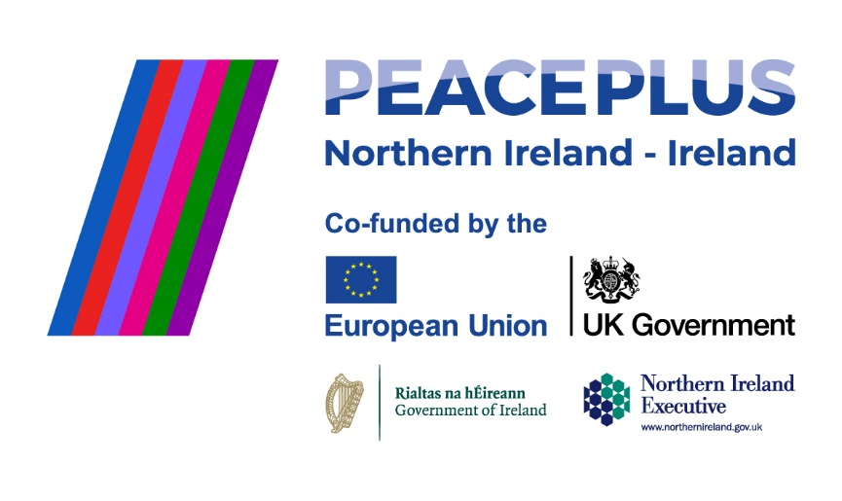
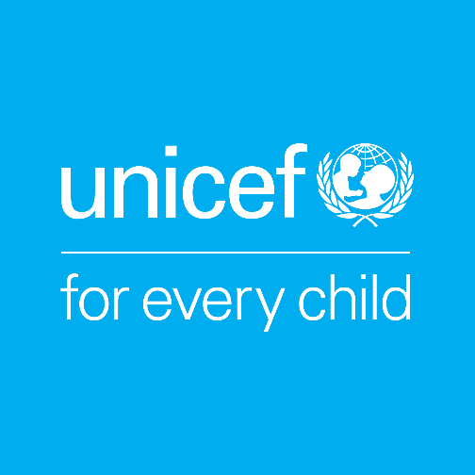

UNICEF works in some of the world’s toughest places, to reach the world’s most disadvantaged children. To save their lives. To defend their rights. To help them fulfil their potential. Across 190 countries and territories, we work for every child, everywhere, every day, to build a better world for everyone. UNICEF is the world’s largest children’s humanitarian organisation.

Job Title | COLOUR Project Coordinator
Reporting To | Head of Advocacy and Public Policy
Location | Preferably in the border region, though applicants based in/near Dublin will be considered.
Hours | 37.5 hours a week
Salary Range | Commensurate with experience
Duration | Fixed-term, 4 Year contract (supported by PEACEPLUS, a programme managed by the Special EU Programmes Body (SEUPB).

About the COLOUR Project
The COLOUR Project (Communities of Learning, Openness, and Understanding through Rights) is a four-year, cross-border and cross-community project supported by PEACEPLUS, a programme managed by the Special EU Programmes Body (SEUPB). The project is led by UNICEF Ireland in partnership with UNICEF UK, Kids’ Own Publishing Partnership, and Ulster University. Through a rights-based, creative, and collaborative approach, the project aims to bring together primary schools from both sides of the border to build positive relationships within and between communities.
Role Overview
We are seeking an experienced and dynamic Project Coordinator to play a central role in ensuring the smooth and successful delivery of the COLOUR Project. Employed by UNICEF Ireland as the lead partner, the postholder will combine strategic oversight with strong operational and interpersonal skills to manage activities and deliverables across multiple partners and work packages. The role involves close collaboration with consortium partners, funders, and school communities, with a focus on inclusion, human rights, and fostering positive cross-community relationships. While not primarily a front-line delivery role, the successful candidate will embody the project’s values, treating all participants and partners with respect, openness, and integrity.

Responsibilities

Project Oversight & Coordination
- Monitor and evaluate overall project progress across all work packages, ensuring delivery against timelines, outputs, and outcomes.
- Oversee cross-cutting elements of the project including safeguarding, gender mainstreaming and inclusion.
- Maintain and regularly update internal project plans, risk registers, and reporting frameworks.
Consortium Management
- Coordinate activities and communication across consortium partners to ensure cohesion, collaboration, and accountability.
- Build synergies across work streams and support partners in aligning their contributions with shared goals.
- Facilitate regular partner meetings and provide project documentation and minutes.
Reporting & Compliance
- Lead on narrative reporting to the Special EU Programmes Body (SEUPB), ensuring clarity, accuracy, and timeliness in all submissions.
- Liaise with partners to collect and compile reporting inputs.
- Ensure adherence to PEACEPLUS regulatory requirements, including on monitoring, evaluation, and horizontal principles.
- Ensure the project complies with GDPR regulations.

Stakeholder Engagement
- Serve as a primary point of contact for the project with internal and external stakeholders.
- Support effective communication and engagement strategies with participating schools, local stakeholders, and relevant authorities.
- Represent the project at relevant meetings, events, and forums.
Financial Coordination
- Collaborate closely with finance teams across consortium partners to support timely and accurate financial reporting.
- Monitor budget progress and assist with reforecasting to keep the project on track.
- Ensure procurement and expenditures comply with funder guidelines and requirements.
Operational and Team Support
- Adhere to and promote UNICEF Ireland’s safeguarding policies and procedures.
- Support partner organisations to uphold safeguarding standards across all project activities.
- Contribute to team and board updates as well as international UNICEF thematic working groups.

Person Specification
Essential Skills and Qualifications:
- Proven experience in project management within multi-partner or cross-sector programmes.
- Strong understanding of monitoring and evaluation frameworks, including reporting to funders.
- Excellent organisational and coordination skills, with the ability to manage multiple workstreams.
- Excellent communication and stakeholder engagement abilities.
- Familiarity with concepts of inclusion, gender equality, and rights-based approaches.
- Proficient in digital tools (Microsoft Office, project management software, social media platforms).
Desirable Attributes and Skills:
- Experience managing PEACE or EU-funded programmes.
- Knowledge of the education landscape in Ireland and Northern Ireland.
- Experience working in cross-border or cross-community initiatives.
- Exceptional written and verbal communication skills, including resource and policy development.
- Strong time-management abilities with a track record of meeting deadlines.
- Creative problem-solver with strong interpersonal and networking skills.
- Commitment to the principles of UNICEF and the UNCRC.
- A collaborative, flexible and reliable team player with a positive attitude.
- Full driving licence with access to a car.

Terms of Employment
This is a fixed-term contract for 4 years, aligned with the COLOUR Project’s funding from PEACEPLUS through 2029. The project operates primarily in the border region, so ideally the role will be based within one of the border counties, with predominantly remote work and regular travel across the region. Alternatively, the role can be based at UNICEF Ireland’s Dublin office, where a hybrid working policy applies.

Expected start date: As soon as possible.

UNICEF Ireland is committed to adhering to the highest standards of child protection and child safeguarding. UNICEF reserves the right not to employ staff or engage volunteers or other representatives who are deemed to pose or potentially pose a risk to the protection of children, to the full extent permitted by law. Additionally, all candidates must sign UNICEF Ireland’s Child Protection Policy & Procedures before commencing employment, engaging as a volunteer, intern, consultant or representative of UNICEF Ireland.

To apply please submit your CV & a cover letter via email to:
Aibhlín O’Leary at aibhlin@unicef.ie by 5pm Wednesday 27th August 2025, with interviews to be scheduled promptly after the closing date.

