

**Senior Youth Worker Role Definition**

**The following 7 aspects are key to this role:**

1. **Leadership:**

**Passion for the work and conviction about the right to education for all. Upholding the ethos, values and vision of Candle**

* **Being an advocate for the aims/goals of the Organisation**
* **Building a culture of respect for all**
* **Developing rigorous ethic best practice**
* An orange umbrella with black text

  Description automatically generated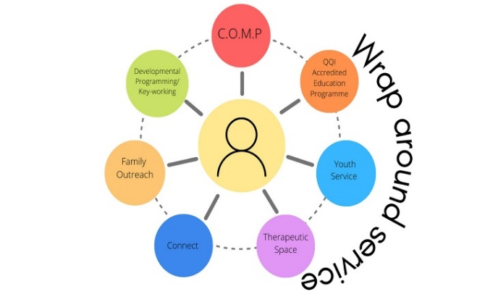**Building strategic alliances**

1. **Young people’s Development and Welfare:**

* **Young people focused in everything**
* **Key focus is providing a service which meets the needs of young people**
* **Priority of safety of young people**
* **Child safeguarding statement and responsibilities as mandated persons**
* **Keen awareness of the needs of young people, particularly those who are most vulnerable**
* **Commitment to the personal, social development of each**
* **Attuned to the mental health needs**

1. **Leadership of staff:**

* **Supporting, motivating and empowering staff**
* **Team cohesion and solidarity**
* **Training & development opportunities for staff to be identified**
* **Reporting & accountability for responsibilities**

1. **Programme Delivery:**

* **Preparation, Implementation & review of Strategic Plan and Operational Plan in collaboration with staff team**
* **Outcome focused**
* **Cohesion of project area within an integrated service provision at Candle**
* **Initiative in project area – innovation and creativity**
* **Clear objectives and rigorous attention to preparation**
* A picture containing window, floor, indoor, room

  Description automatically generatedA picture containing tree, outdoor, building, house

  Description automatically generated**Managing timelines**

**

1. **Frontline work:**

* **Delivery of programming within the service**
* **Delivery of programming across the organisation**
* **Contributing daily to creating an environment that is safe, nurturing and facilitative of young people**
* **Working as a team member on the ground in responding to the daily needs of young people**
* **Being flexible and adaptive to the changing needs of young people and the Candle Organisation in relation to frontline work**
* **Prioritizing the requirements of young people as they present**
* **Being adaptive to assuming various rules in order to meet the demands of service provision**
* **Mentoring, supporting and advocating for young people as a central team of each working day**

1. **Administration and Finance**

* **Managing a budget for project area**
* **Be accountable for preparation of budgets and expenditure in accord with Candle’s financial policy and procedures**
* **Reports for funding agencies**
* **Reports on project area for Management**
* **Preparation of business plans for project area**
* **Funding applications as required**
* **Completing online and paper records for funding agencies and Candle Organisation**
* **Updating website and other social media**