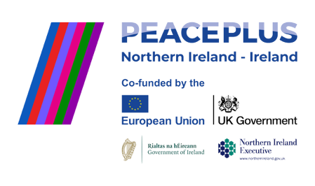

**Job Description**

**POST DETAILS:**

**Job Title:** Administrative Officer

**Location:** Belfast or Sligo (with responsibilities in both regions)

**Salary:** £28,000/€32,200 per annum pro rata

**Hours:** 18 hours per week [with options considered for a full time position if skills set/experience matches other roles being advertised, eg Monitoring or Finance Officer]

**Role Brief:**

The Rio Ferdinand Foundation are recruiting an experienced Administrative Officer for our exciting new cross-border PEACE Academy programme in Belfast and Sligo, funded by the Special EU Programme Body (SEUPB) PEACEPLUS programme <https://www.seupb.eu/>

The aim of this new three-year programme, is to deliver and evidence a PEACE Academy pathway of engagement, learning, social action and employability that will inspire young people from communities in Northern Ireland and Ireland to create shared experiences and build a long-term response to sectarianism, racism and hate on a cross community and cross border basis.

We are seeking an experienced administrative professional who can lead on the operational and back-office administration of this programme.

**KEY DUTIES/RESPONSIBILITIES:**

This role will:

* Work with the Programme Manager to devise appropriate administrative processes to support the regional delivery teams together with senior management.
* Work with our regional Coordinators on the administrative function of sessions and events i.e., booking and risk assessing suitable venues, disseminating promotional materials, booking travel arrangements, arranging refreshments for young people, equipment orders etc.
* Work with our Training Officer on administrative function of workshops and training course delivery including course paperwork, learning materials and resources, venues, certificates distribution etc.
* Work with our Finance Officer on the financial administration of the programme.
* Organise and order any staff kit required from our approved suppliers.
* Disseminating project materials as well as communications outputs circulating to the wider team and partners as required.
* Attend partnership meetings to take minutes and follow up on any key actions.
* Input to funder reports and attending meetings as and when required.

**Person Specification/Key skills:**

* + Currently resident in the Republic of Ireland or Northern Ireland
  + Degree level education or similar experience
  + At least two years administrative experience
  + Experience of administrative support for diverse and complex projects
  + Willingness to support wider programme deliverables including attending events.
  + Ability to build positive working relationships with young people, community stakeholders, colleagues and partners
  + An interest/experience in Youth work
  + Ability to prioritise and manage workload in a fast-paced environment
  + Competent working independently as well as part of a small team
  + A confident communicator with good written and spoken English
  + IT skills including Microsoft office and VIEWS (essential)
  + Experience in writing reports to meet agreed deadlines
  + Positive and enthusiastic with a can-do attitude.

*Desirable*

* Experience of working on a government or public sector funded programme such as SEUPB.

**Role Requirements**

At Rio Ferdinand Foundation, we are committed to working in a diverse organisation and strive to provide equality of opportunity for all. We encourage and welcome applications from individuals, regardless of age, disability, sex, sexual orientation, gender reassignment or identity, pregnancy and maternity, race, religion or belief and marriage and civil partnership.

If as a disabled applicant (as defined under the Equality Act 2010) you would like to request that your application is considered under our Guaranteed Interview Scheme (GIS) please let us know.

**As part of our commitment to safeguarding, successful candidates will be subject to an enhanced Access NI check or Garda Vetting.**

Applicants must be able to provide proof of eligibility to work in Ireland and the UK.

**Application Deadline** – Tuesday 2nd of September [we will be reviewing applications received before the deadline]

**Interviews** – Monday 7th to Wednesday 10th September