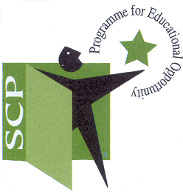SCHOOL COMPLETION PROGRAMME, CABRA AREA
St. Finbar’s BNS, Kilkieran Road, Cabra, Dublin 7
Area Coordinator: Amy O’Neill amy.oneill@scp.ie 0861766801

SCP Project Worker Application Form

PERSONAL DETAILS

Surname: |  | First Name(s):
Address for Correspondence: |  | Home Address (if different):
Email Address: |  | Mobile Telephone Number:
Do you have an ability to speak Irish?  Yes No  Double click in the applicable box & select ‘checked’ |  | Level of Irish:
Have you ever worked with or volunteered in a school or school completion programme before?  Yes No  Double click in the applicable box & select ‘checked’ |  | If your answer is Yes, outline previous positions & locations of the schools:
Current Occupation (if applicable): |  | If currently employed – how much notice must you give?

Please say (in 150 words or less) why you are applying for this position and what qualities you consider you will bring to this position.

Please give examples (in 150 words or less) of specific approaches and practices that you would use to support children and young people in schools.

Please give examples (in 150 words or less) of outcomes that you would work towards in supporting children and young people in schools.

Please give an example (in 150 words or less) of a time when you took a leadership role within a team. What were the challenges and learning in this experience?

REFERENCES

Please list name, address, telephone number and email address of two referees:
Referee #1 |  | Referee #2
Name |  | Name
Address |  | Address
Telephone No |  | Telephone No
Email address |  | Email address

HOW TO RETURN YOUR APPLICATION FORM
Once complete, please return this form (with an accompanying CV and a cover letter):

- By email: amy.oneill@scp.ie

- Or by post to:
Amy O’Neill,
School Completion Programme, St. Finbar’s BNS, Kilkieran Road, Cabra, Dublin 7

Applications to be submitted by 5pm Wednesday 14th June 2023

