****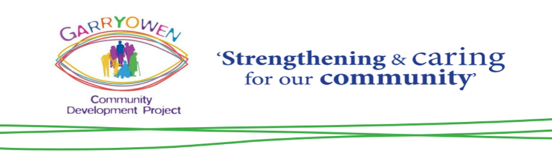

**Job Description**

**Position: ParentChild+ Home Visitor (*Primary School Term Only)***

**Reporting to: The Coordinator**

**Purpose of Position:**

The ParentChild+ Programme home visitors teach parents and children to bond through learning and play. The programme is designed to strengthen the natural bond between parent and child and to encourage a love of learning. It employs a non-directive approach and encourages the parent to be the child’s first and best teacher. This programme prepares children for later success in school.

**Key Responsibilities:**

* Visit the families assigned to you for two half-hour sessions a week, during the primary school term
* Engage the parents and children using toys and books to promote learning so that the child sees its parent as its first and best teacher
* Introduce a new book or toy every second visit. Leave the item as a gift, encouraging them to use it in between and use it again on the next visit
* Ensure that the parents sign for the gifts each week
* Write online reports for each visit
* Attend weekly supervision meetings on Wednesday mornings
* Participate in training
* Any other duties as assigned by the ParentChild+ Coordinator

**Supervision meetings:**

Home Visitors must attend a weekly supervision meeting. This meeting takes place with the Coordinator and the rest of the home visiting staff. This provides an opportunity to report back on how the visits are going, to receive feed-back and support from the Coordinator and provides an opportunity to collect books and toys for the next week. Supervision meetings are every Wednesday morning for 2 hours.

**Key skills, experience & qualities required:**

* An energetic, confident and pro-active individual with strong interpersonal and communication skills
* A ParentChild+ Home Visitor needs to be a good listener, non-judgemental, have a positive attitude and be discreet as they must keep information confidential
* An ability to encourage learning and engage with parents and children
* Proficient English, reading skills and vocabulary are required to communicate successfully with families and write up visit reports as well as to promote the development of the children’s literacy and English skills
* Basic IT Skills are required
* Commitment to undertake training to achieve a relevant QQI qualification
* Commitment to take up to 10 families on caseload
* Full clean drivers licence and access to own vehicle
* Previous experience of working with children, as a home visitor or within a similar position will be an advantage
* Relevant training or qualifications also an advantage

**Wages:** €13.25 - €13.85 per hour

Remuneration varies according to number of visits made. On average home visitors work approximately 60-80 hours per month.

**Annual Leave:** Paid as 8% of hours worked

**Note:**

The functions and responsibilities assigned to the position of ParentChild+ Home Visitor are based on the current stated role and objectives of Garryowen CDP. These functions and responsibilities may alter in line with any change in the role and objectives of Garryowen CDP. The post is subject to funding, Garda vetting, reference checks.

**Applications by e-mail only** using thestandard application form (attached) to [Manager@GarryowenCDP.com](mailto:Manager@GarryowenCDP.com) by 12.00 p.m. on Wednesday 27th August 2025.