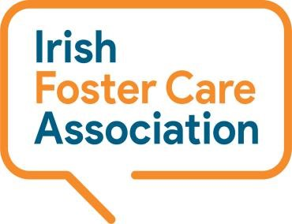

**Synergy Centre**

**TU Dublin Campus**

**Tallaght**

**Dublin 24, D24A386**

**Tel: 01 459 9474**

**National Helpline Service - Volunteer Application Form**

**Please complete this form and return via email to** [**volunteer@ifca.ie**](mailto:volunteer@ifca.ie) **or post to the above address.**

|  |  |
| --- | --- |
| **Surname:** |  |
| **First Name:** |  |
| **Address:** |  |
| **Telephone:** |  |
| **Date:** |  |
| **Email:** |  |

**Please tell us why do you want to volunteer on the National Helpline Service?**

|  |
| --- |
|  |
|  |
|  |
|  |
|  |
|  |

**Please tell us what you hope to gain from your experience with us?**

|  |
| --- |
|  |
|  |
|  |
|  |
|  |
|  |

**Please tell us about any educational background, work or volunteering experience that would be relevant to the volunteer role you are applying for.**

|  |
| --- |
|  |
|  |
|  |
|  |
|  |
|  |

**Please tell us of any other hobbies, skills, special interests or qualities you have that may be relevant to the volunteer role you are applying for?**

|  |
| --- |
|  |
|  |
|  |
|  |
|  |
|  |

**The Helpline runs Monday to Friday 11am to 3pm and our Volunteers support the Helpline one day a week in this time. Is there a day/times that suit you or please feed back any other comments on your availability?**

|  |
| --- |
|  |
|  |
|  |
|  |
|  |
|  |

**A 10 week in-person course in Counselling Skill is an essential part of our training for the role. Can you confirm your availability to commit to this as part of your Helpline Induction and Training programme, please comment below?**

***(Note: Applicants can seek an exemption where they have already done a module in Counselling or similar at Level 6 or above)***

|  |
| --- |
|  |
|  |
|  |
|  |
|  |

**References: Please supply us with the names of two referees (non-relatives)**

|  |  |
| --- | --- |
| **Name:** |  |
| **Address:** |  |
| **Email:** |  |
| **Telephone** |  |

|  |  |
| --- | --- |
| **Name:** |  |
| **Address:** |  |
| **Email:** |  |
| **Telephone** |  |

**Do you have any special needs you would like to share with us or is there anything else you would like to share?**

|  |
| --- |
|  |
|  |
|  |
|  |
|  |
|  |

***\*\*Note: Interview and Garda Vetting is a requirement for all Helpline volunteer roles\*\****