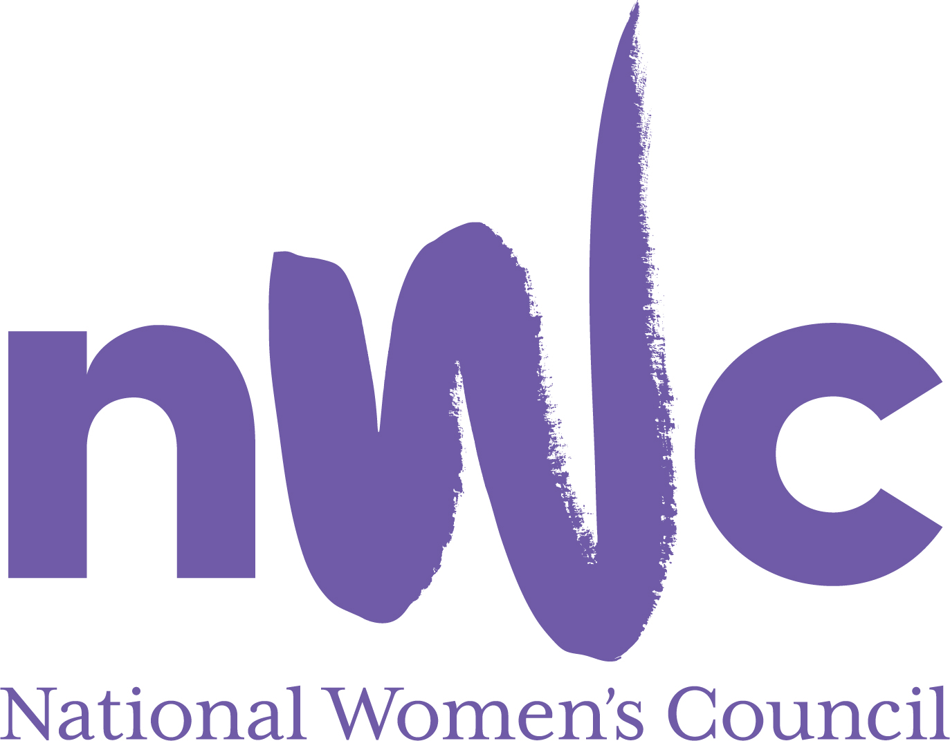

Application Form for the Post of
Events & Administrative Assistant

In order to be considered for the post Administrator with the National Women’s Council (NWC), candidates must submit this completed and signed application form to be received by midnight, 14th August 2025.

Please send your completed form to Anne Gibney, anneg@nwci.ie

Please note a CV is not required and should not be submitted.

NWC is an equal opportunities employer and welcomes applications from all interested parties including people from diverse backgrounds and under-represented groups including ethnic minority groups and people with disabilities. NWCI offers a number of flexible working arrangements.
Selection will be based on the information in the application form alone.
Candidates should note that salary will not be subject to negotiation. Successful candidate will commence on first point of the scale. Salary for 4 days a week is €23,534
The closing date for receipt of completed and signed application form is midnight 14th August
Initial online interviews to take place on 22nd August
In person interviews to take place on 28th August

PERSONAL DETAILS
NAME:
ADDRESS:

TELEPHONE:
EMAIL:

RELEVANT EDUCATION AND TRAINING HISTORY
Please outline your educational background and any training relevant for this post

PRESENT (or if unemployed most recent) EMPLOYMENT – This post requires at least 2 years’ relevant experience
Name and Address of employer
Post held:
Duties of Post:
Date Appointed: Period of notice:

PREVIOUS WORK EXPERIENCE
Please list, starting with the latest, any relevant previous positions you have held, with a brief description of duties and dates.
Employer:
Post held:
Period of Employment:
Reason for leaving:
Employer:
Post held:
Period of Employment:
Reason for leaving:
Employer:
Post held:
Period of Employment:
Reason for leaving:
OTHER INFORMATION
Are you willing to undertake training relevant to the post?
Yes No

If appointed, when can you commence employment?

I already have a legal right to work in Ireland
Yes No

I will require a work permit
Yes No

RELEVANT COMPETENCIES FOR THE POST
The job description shows qualifications, experience and skills required or desirable to be able to carry out the responsibilities of this post. Please therefore address all these elements as listed in table below, drawing upon all of your experience, whether in paid employment or in a voluntary capacity. Please add additional space as necessary

PROFESSIONAL KNOWLEDGE EXPERIENCE AND SKILLS – Please limit each answer to no more than 200 words
Excellent communication skills, both verbal and written, and the ability to build relationships

Excellent administration skills with a high level of attention to detail

Proficient in the use of Microsoft Word, Excel, Outlook, Zoom and other apps

Proven ability in updating website and producing social media content

Experience in managing the logistics of online/in person events

Flexible ability to deal with last minute tasks and integrate them with the overall workload

Ability to work on own initiative and as part of a team

Solution focused with the ability to address difficulties in a positive & calm manner

PLEASE DESCRIBE IN 200-300 WORDS WHY YOU ARE A GOOD FIT FOR THIS POSITION

REFEREES
Please give the names, addresses and phone numbers of two referees (one should be a current or most recent employer):

DECLARATION I declare that the information set forth in this application form is, to the best of my knowledge, true and complete.

Signature:
Date:
This position is for 4 days a week. Contract is for a period of 12 months.
Late applications will not be reviewed.

