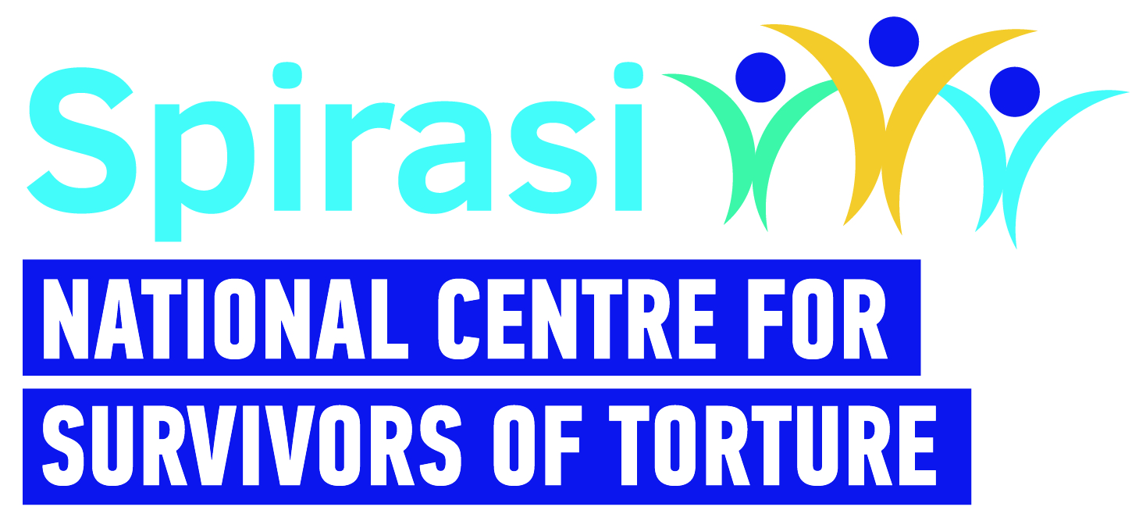 | ESOL Tutor - Job Description
Title: | ESOL Level 5 Tutor
Work Schedule: | 12 hours per week: Tuesday - Thursday
Contract Type: | Casual, Part-time
Rate of Pay: | €41.17 hourly
Reporting: | Education & Integration Manager
Location: | Spirasi, 213 North Circular Road, Phibsboro, Dublin 7 with hybrid working in accordance with Spirasi Hybrid working policy.
Main Purpose of Role
Spirasi is seeking to appoint a suitably qualified, passionate and dedicated person to deliver English for Seekers of Other Languages (ESOL) level 5 classes. The successful candidate will play a crucial role in providing high-quality QQI English language instruction to adult learners from a range of linguistic backgrounds, many of whom are in highly vulnerable situations.

Main Responsibilities
- Deliver four (4) hours English classes per day on Tuesdays, Wednesdays and Thursdays (two days online and one day onsite).
- Responsible for developing and implementing effective lesson plans, creating a supportive learning environment, and assisting students in their language acquisition journey.

*************************
- Facilitate 12 hours weekly English Language classes: Design and deliver engaging and interactive lessons that cater to the specific language needs of adult learners at QQI Level 5, focusing on reading, writing, listening, and speaking skills. Utilize a variety of teaching methods and materials to ensure students' comprehension and progression.
- Curriculum Development: Collaborate with other ESOL teachers and Coordinator to develop and update the ESOL QQI Level 5 curriculum, incorporating relevant learning objectives, assessment methods, and learning outcomes.
- Student Assessment: Conduct regular assessments and evaluations to track students' progress, identify areas of improvement, and provide constructive feedback on their language development.
- Classroom Management: Establish a positive and inclusive classroom environment that fosters active participation, mutual respect, and a passion for learning.
- Support and Guidance: Provide ongoing support and guidance to students, addressing their individual needs and challenges in language acquisition and forwarding psychosocial needs to the Education Manager.
- Cultural Sensitivity: Demonstrate cultural sensitivity and awareness in the classroom, promoting cross-cultural understanding and fostering an inclusive learning environment that celebrates diversity.
- Technology Integration: Utilise educational technology and digital tools to enhance language learning experiences, making use of multimedia resources, language learning apps, and online platforms when appropriate.
- Professional Development: Engage in continuous professional development activities to stay updated with the latest ESOL teaching methodologies, language assessment techniques, and advancements in the field of language education.
- Collaborative Approach: Work closely with colleagues, academic staff, and administrative personnel to support Spirasi’s overall educational goals and contribute to a cohesive learning community.

Person Specification – Knowledge, Skills and Experience Required
Essential criteria: Essential Qualifications & Accreditation
- Recognised qualification in English Language Teaching (ELT) and experience of teaching adults from asylum seeking and migrant backgrounds across a range of language abilities.
- A minimum of three years relevant teaching experience preferably in the not-for-profit/charity or community sector.
- Proven track record in delivery and assessment of ESOL.
- Excellent communication skills, written, verbal and numerical.
- Appropriate interpersonal skills with the ability to build rapport with colleagues and students.
- Experience in working in a multidisciplinary setting.
- A suitable workspace for remote working.
- Commitment to the mission and ethos of Spirasi.

Additional Skills & Attributes
- Possesses experience and understanding of cross-cultural work in education.
- Proficient in IT (client management systems (CRM), Word, Excel, PowerPoint, Email).
- Excellent self-care practices.

Desirable criteria:
- Knowledge of the Adult Education System in Ireland.
- Third Level Qualification in relevant area.
- Experience working with asylum seekers and refugees.
- Experience using Salesforce.
- Experience working with interpreters.
- Knowledge of the international protection system in Ireland.
- Ability to speak another language, e.g. Arabic, French.
- Ability to keep professional boundaries and practice good self-care.
- Excellent ability to represent, to advocate and to network.

Please note
- This job description is not exhaustive; the post holder may be required to take on additional duties relevant to the role and contribute to its development.
- Applicants with qualifications obtained outside the Republic of Ireland must provide evidence of validation by the Irish Department of Education at the time of application.
- Garda clearance is a requirement for all Spirasi staff, both upon hiring and throughout employment.
- Candidates must have the right to work in Ireland at the time of application and for the duration of employment.
- Remote work requires a designated, single workspace in the home or an alternative office.
- All personal data received will be processed in accordance with the Data Protection Acts 1988, 2003, and GDPR (2018) and used solely for recruitment and administrative purposes.
- Spirasi is an equal opportunities employer. Recruitment decisions are based on merit, aligned with job and skill requirements.

