
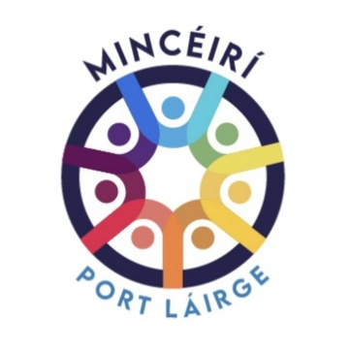

Person Specification for the post of Local Training Initiative Co-ordinator
Full-Time Fixed-Term Contract
 | ESSENTIAL CRITERIA  (What you must have to be considered for the job) | DESIRABLE CRITERIA  (not necessary to have these but would be an advantage)
VALUES | - Committed to the Principles and Practice of Community Development  - Understanding of the effects of poverty, social exclusion, discrimination and racism on Traveller learners and their families and community  - Understanding of impact of historical statutory neglect on Traveller’s educational opportunities  - Belief in the principles of adult education  - Understanding and respect for Traveller culture  - Commitment to Traveller self determination  - Committed to maintaining confidentiality
PERSONAL QUALITIES | - Patient  - Willingness to learn from the learners  - Assertive and confident  - Approachable and friendly  - Flexible  - Challenging and open to being challenged  - Non-judgmental  - Anti-racist/ commitments to the nine grounds of Irish Equality legislation.
EXPERIENCE AND KNOWLEDGE | - At least 3 years’ experience of working from a community development approach  - Experience of co-ordinating and/or delivering Level 4 QQI or equivalent  - Knowledge and awareness of the issues that impact on the lives of Travellers e.g., racism and discrimination, accommodation issues etc.  - A knowledge of the 9 grounds covered under the Irish equality legislation
SKILLS AND ABILITIES | - Good co-coordinating skills  - Budgeting skills  - Ability to support and supervise tutors  - Ability to support learners  - Excellent communication skills  - Excellent organisational skills  - Negotiation skills  - Excellent computer skills  - Ability to work on own initiative and as part of a team  - Ability to maintain professional boundaries
EDUCATION AND TRAINING | - Level 7 or higher qualification in Community Development/Education or related fields

