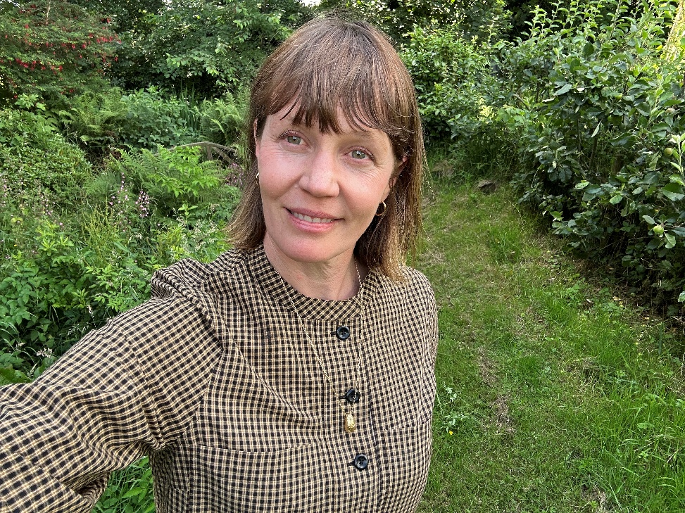

"As an artist and lecturer at the National College of Art and Design, Dublin I found this course incredibly valuable. It deepened my understanding of complex climate issues and offered fresh perspectives through the diverse mix of industries, experiences, and expertise represented in the classroom. I plan to embed this learning into my institution and teaching, helping to develop more sustainable creative practices and course content." – Seoidín O’Sullivan, former participant on the Climate Leadership Development Micro-credential, Artist and Lecturer at the National College of Art and Design, Dublin, Ireland.

