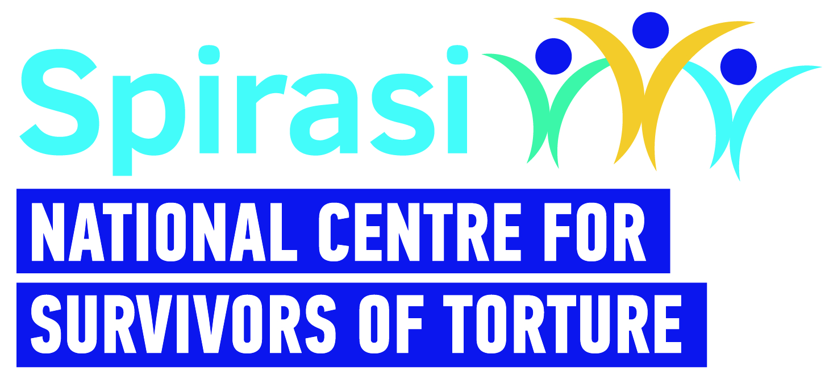 | Therapist - Job Description
Title: | Psychotherapist
Work Schedule: | Part-time (28 hours)/Full-time (35 hours)  (Working week is Monday – Friday)
Contract Type: | 18 months Fixed Term
Rate of Pay: | €53,152 (pro-rata)
Location: | Spirasi, 213 North Circular Road, Phibsboro, Dublin 7 with hybrid working in accordance with Spirasi Hybrid working policy.
Main Purpose of Role
Spirasi is seeking a psychotherapist to provide individual and group therapeutic interventions — both online and in person — for survivors of torture from diverse cultural backgrounds. The role also involves conducting client assessments, administering psychological scales, and preparing clinical reports. In addition, the psychotherapist will co-ordinate referrals within Spirasi to ensure clients receive any additional support they may need.

Main Responsibilities
Client Work & Interventions
- To undertake initial consultations/assessments with survivors of torture, focusing on both strengths and difficulties.
- To carry out clinical assessments, including the use of psychological scales.
- To conduct risk assessments and implement risk management plans as appropriate.
- To provide evidence-informed therapeutic interventions, both individual and group, to adult survivors of torture.
- To provide crisis intervention when necessary.
- To have a minimum of four client contact hours per day, either as individual sessions, group sessions, or initial consultations.

Documentation & Reporting
- To document client progress in case files, maintaining accurate and confidential records using Spirasi’s CRM, and to comply with all reporting requirements.
- To provide written reports/letters to other services as necessary.

Collaboration & Meetings
- To liaise and consult with other professionals in supporting clients attending Spirasi.
- To participate in multidisciplinary team (MDT) supervision, group clinical supervision, and line management for support and guidance.
- To participate in monthly case management meetings, team meetings, clinical team meetings, all-staff meetings, and other necessary meetings.
Professional Standards & Compliance
- To adhere to all agreed organisational policies, processes, procedures, and guidelines.
- To comply with responsibilities under the Data Protection Acts 1988, 2003 & 2018 (GDPR).
- To maintain professional and personal boundaries.

Development & Training
- To undertake regular external supervision.
- To play an active role in the development of services and contribute to evaluation processes.
- To take part in organisational events, training, and planning.
- To participate in continuous professional development.

Person Specification – Knowledge, Skills and Experience Required
Essential criteria: Essential Qualifications & Accreditation – Candidates who do not meet these essential criteria will NOT be considered.
- Doctorate or equivalent in Clinical/Counselling Psychology. Candidates qualified overseas must provide evidence of validation by the Department of Health at the time of application.
- Psychotherapists accredited by the Irish Council for Psychotherapy (ICP) or the Irish Association for Counselling and Psychotherapy (IACP) with a minimum of two years’ post-accreditation experience.
- Fully insured.
- Must be resident and professionally accredited to work in Ireland.
- Must have permission to work in Ireland.
- Able to speak and write English to IELTS Level 8 (Expert User).

Clinical Experience & Skills
- Minimum of three years’ experience working with complex trauma.
- Proficient in a trauma-focused approach.
- Able to provide a range of therapeutic modalities.
- Experience providing therapeutic interventions both individually and in groups.
- Experience working remotely via phone and online platforms.
- Experience writing reports and clinical letters.
- Experience working effectively both independently and as part of a multidisciplinary team.

Additional Skills & Attributes
- Possesses experience and understanding of cross-cultural work in therapy.
- Proficient in IT (client management systems, Word, Excel, PowerPoint, Email).
- Excellent self-care practices.

Desirable criteria:
- Experience working with asylum seekers and refugees
- Experience using Salesforce
- Experience working with interpreters
- Knowledge of the international protection system in Ireland
- Ability to speak another language, e.g. Arabic, French.
Please note
- This job description is not exhaustive; the post holder may be required to take on additional duties relevant to the role and contribute to its development.
- Applicants with qualifications obtained outside the Republic of Ireland must provide evidence of validation by the Irish Department of Health at the time of application.
- Garda clearance is a requirement for all Spirasi staff, both upon hiring and throughout employment.
- Candidates must have the right to work in Ireland at the time of application and for the duration of employment.
- Remote work requires a designated, single workspace in the home or an alternative office.
- All personal data received will be processed in accordance with the Data Protection Acts 1988, 2003, and GDPR (2018) and used solely for recruitment and administrative purposes.
- Spirasi is an equal opportunities employer. Recruitment decisions are based on merit, aligned with job and skill requirements.

