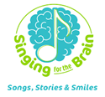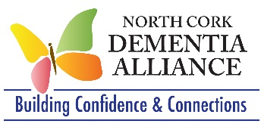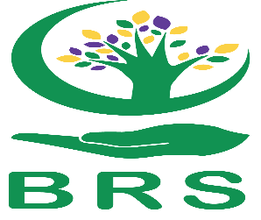

**Job Title: Dementia Services Co-ordinator/ Singing for the Brain Project Worker (Dual role)**

**Salary :** **€43,400**

**Hours:**37 hours per week

* 29.5– North Cork Dementia Alliance
* 7.5 hours - Singing for the Brain

**Location:**Initial office Base inMallow

* Hot spotting desks in other locations across North Cork may be required
* Travel will be required

**Reports to:**Service Lead, North Cork Dementia Alliance

**Background**

The **North Cork Dementia Alliance** provides supports and services to people with dementia and their families. It is led by the HSE North Cork Occupational Therapy service in collaboration with The Alzheimer Society of Ireland and Ballyhoura Rural Services. [www.ncdementiaalliance.ie](http://www.ncdementiaalliance.ie/).

**Singing for the Brain (SFTB)** is an arts and health initiative providing inclusive social music groups in the community. The programme recognises the therapeutic effects of music on the brain and body and utilises singing as a means to stimulate memory and promote health and wellbeing. Unlike traditional choirs, SFTB does not require participants to have a high level of singing experience or the ability to read music. There are 10 weekly Singing for the Brain groups operating in Cork.

The successful candidate will work with both the North Cork Dementia Alliance and Singing for the Brain Ireland, two groups that are closely aligned and funded by the HSE. This post will be funded by the HSE and Ballyhoura Rural Services will be the employer. The successful candidate will report to the Service Lead of the North Cork Dementia Alliance.

**JOB PURPOSE**

**North Cork Dementia Alliance:**

* Provide group and one to one supports for people with dementia and their families
* Develop new supports for people with dementia and their families
* Raise awareness of dementia

**Singing for the Brain (SFTB):**

* Co-ordinate Singing for the Brain across Cork City and County
* Ensure the continuation and expansion of existing SFTB groups
* Develop new groups in Cork North and Cork South

**MAIN DUTIES & RESPONSIBILITIES**

**North Cork Dementia Alliance (NCDA)**

* Organisation and facilitation of existing groups, dementia cafes and supports for people with dementia and their families
* Develop new supports for people with dementia and their families
* Promote the NCDA through social media and other information sources
* Work with community groups and the public to increase awareness of dementia
* Liaise & collaborate with NCDA colleagues and other professionals involved in providing dementia care.
* Work with NCDA colleagues on fundraising initiatives
* Attend team meetings and training courses as necessary.
* Undertake administrative duties of NCDA
* Record and monitor all work undertaken and to produce regular progress reports to enable effective monitoring and evaluation of the service
* Undertake any other tasks consistent with the general remit of the post.

**Singing for the Brain (SFTB):**

* Provide ongoing support to existing SFTB groups in Cork City & County, on-line alongside SFTB administrator and SFTB steering group. This will involve visiting existing groups
* Plan the development of new groups with support from SFTB administrator
* Create, develop and review SFTB core documents in relation to the roles and responsibilities of coordinators and musical facilitators
* Promotion of SFTB through social media, flyers, information events and promotional videos. Liaise with HSE communications in relation to such promotion
* Planning and coordination of large scale events e.g. Summer Jamboree
* Liaise, communicate and meet with SFTB project administrator and Project Founding Director and others as required
* Work with colleagues in HSE Community Work and other in development and operation of the project.
* Plan, coordinate and host SFTB steering group meetings.
* Responding to enquiries about SFTB from outside Cork & Kerry to deliver/develop the programme in partnership with the SFTB administrator
* Explore opportunities for research and feedback mechanisms
* Collate data as required

*The above duties and responsibilities are not intended to be a comprehensive list of all duties involved. This post is evolutionary and consequently the appointee may be required to perform other duties as appropriate to the post which may be assigned to him/her from time to time.*

**REQUIREMENTS:**

**Essential requirements**

* Third level health, social care or community development qualification
* Experience, an understanding and an interest working with people with dementia and their families
* Excellent communication skills (written and verbal)
* Excellent co-ordination and organisational skills
* Work on own initiative and with others
* Be motivated and enthusiastic
* Group facilitation skills
* An ability to work in a flexible manner
* Be in a position to occasionally work evenings
* Proficient IT and social media skills
* Full drivers licence and access to own car (mileage costs covered)
* Commitment to continuing professional development

**Desirable requirements**

* Service/project development skills
* Experience working with the voluntary sector

**For further information contact Sheena Cadoo, Project Lead, North Cork Dementia Alliance**[**sheena.cadoo@hse.ie**](mailto:sheena.cadoo@hse.ie)**or**[**086 787 1818**](https://www.activelink.ie/vacancies/community/0867871818)**.**[**www.ncdementiaalliance.ie**](http://www.ncdementiaalliance.ie/)

**Please email your CV along with a cover letter outlining your suitability for the post to Sheena Cadoo by: 5th August 2025**

**Interviews may be held the week of 14th August 2025**