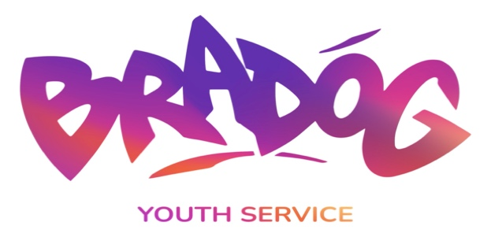

POST: Detached Youth Worker
EMPLOYED BY: Bradog Youth Service

REPORTS TO: Project Leader

MAIN ROLE:

The Detached Youth Worker is responsible for identifying young people at risk in the community through contact with local schools, youth groups, Gardai, probation services etc and assessing their needs. Then planning, developing, implementing and evaluating developmental/educational programmes to meet the needs of the young people, aligned with our UBU funding service requirement and Justice funding requirements as agreed with the Project Leader and the board of directors. This role will consist of detached street work engaging with “Hard to Reach” young people.

In Conjunction with the Project Leader the detached youth worker will be involved in the following
- Developing appropriate responses to young people not engaged in services within the community.

- Ensuring a youth work approach, adopting youth work methodologies which include one to one support and follow up, agency visits, advocacy work, street work, and non-formal activities that meet young people where they are at.

- Planning, developing, delivering and evaluating educational responses to issues such as drug abuse, youth homelessness, racism, bullying, equality, early school leaving, health education etc.

- Supporting and developing holistic approaches to enable young people to become more active, empowered and connected gaining a sense of belonging within their community.

- Targeting and identifying young people who would benefit from involvement in detached programmes and activities.

- Promoting the overall work of the project and supporting the organisational needs.

- Attendance at meetings as required eg team meetings, sub committee meetings etc

- Compiling any reports deemed necessary by the Project Leader or board of management

- Identifying potential volunteers that can enhance the service.

- Evaluating the work of the project using the City of Dublin Youth Services and Justice evaluation systems.

- Liasing with other agencies working with young people in the community to maximise the service provided, including a limited attendance at appropriate committees.

- Offering support to aid the development of the existing youth groups in the area.

- The development of appropriate policies and responses to issues affecting young people – e.g. drug abuse – involving local schools, parents, and other agencies.

- Interagency collaboration and where relevant referring young people on to appropriate services.

- Participate in relevant in-service training as agreed by the Project Leader and board of management.

- Carrying out all lawful instructions of the management committee.

PLEASE NOTE:
The nature of this post requires the holder is flexible in working hours to cover the operational times of the service and the centre on a rota basis. This will involve scheduled evening and regular weekend work and residentials throughout the year.

