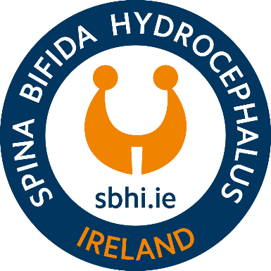

**FAMILY LIAISON OFFICER**

At Spina Bifida Hydrocephalus Ireland we're looking for a Family Liaison Officer to join our values-driven, collaborative, and deeply rewarding team.

**JOB SPECIFICATION**

**Job Title:** Family Liaison Officer

**Reports to:** CEO

**Nature:**  Full Time, 35 hours per week

**Location:** Hybrid working from our National Resource Centre, Clondalkin and from home

**Date:** July 2025

**Salary**: HSE 6416 Family Support Worker Pay Scale

**PURPOSE OF JOB**

SBHI is seeking a compassionate, motivated, and skilled Family Liaison Officer (FLO) to provide person-centred support to individuals and families affected by Spina Bifida and/or Hydrocephalus in the Cavan, Monaghan, Louth, Meath and North County Dublin regions.

This is a frontline outreach role that combines advocacy, coordination of supports, and emotional guidance. The successful candidate will offer personalised assistance through a variety of communication channels—face-to-face visits, phone support, email, social media, and organised events. The FLO is key to ensuring individuals and families are fully supported, connected, and empowered to access relevant health, education, social, and community-based services throughout all life stages.

**KEY RESPONSIBILITIES**

* Provide individualised support to people with Spina Bifida and/or Hydrocephalus and their families in the designated area.
* Facilitate and deliver a person-centred service based on each client's unique needs, goals, and circumstances.
* Refer clients to appropriate medical, therapeutic, educational, social, and local authority services.
* Respect each client's autonomy, ensuring dignity, confidentiality, and equality in all interactions.
* Promote independent living and encourage participation in employment, education, and community life.
* Support access to respite services and assist in coordinating care where needed.
* Help plan and deliver SBHI events and programmes such as seminars, workshops, family weekends, and other initiatives, both locally and nationally.
* Provide regional cover for other Family Liaison Officers as required during periods of leave or high caseload.
* Advocate on behalf of clients and represent their needs to services, agencies, and SBHI staff including senior management.
* Develop strong working relationships with staff in maternity hospitals in the region and attend the quarterly Spina Bifida clinic at Temple Street.
* Collaborate with local SBHI Branches to support community-led initiatives.
* Maintain accurate records and case notes; contribute to internal reporting, planning, and service development.
* Promote a positive image of SBHI to members, donors, stakeholders, and the wider public.

**SKILLS, EXPERIENCE, AND PERSONAL QUALITIES**

**Essential**

* Relevant third-level qualification in Social Care, Social Work, Nursing, Disability Services, Education, Outreach, or related field.
* Experience working in a support or advocacy role with individuals or families affected by disability, illness, or social disadvantage.
* Strong organisational and planning skills with the ability to manage a caseload effectively.
* Excellent communication and interpersonal skills, both verbal and written.
* Proficiency in report writing, case note documentation, and data handling.
* Ability to use standard office software (Microsoft Word, Excel, Outlook) and smartphone/social media applications.
* Warm, empathetic, and professional in all client and colleague interactions.
* Ability to work independently, exercise good judgment, and adapt to changing needs.
* Full clean driving licence and access to a vehicle.
* Willingness to work flexible hours and travel as needed.

**Desired**

* Experience in the community/voluntary/charity sector.
* Familiarity with the challenges faced by individuals with Spina Bifida and/or Hydrocephalus.
* Experience working with multidisciplinary teams or public services (e.g., HSE, social work, housing).
* Knowledge of relevant policies in disability, education, employment, and social supports.
* First Aid, Safeguarding, or Manual Handling training (or willingness to undertake).

**Working Conditions**

* The role is based in the community with regular travel required across Cavan, Monaghan, Louth, Meath and North County Dublin regions.
* Flexible hours may be necessary, including occasional evenings and weekends.
* Involves working independently as well as collaboratively within the SBHI team.
* Engagements will occur in varied settings including homes, clinics, hospitals, and SBHI events.

**APPLY FOR THE JOB**

Do you want to join our team as our new Family Liaison Officer? Then we'd love to hear about you! Click the Apply Now button below and send in your application before **23rd July 2025 @ 12pm.**

[**APPLY NOW**](https://spina-bifida-hydrocephalus-ireland.homerun.co/family-liasion-officer/en)