**Candle Community Trust**

**Project Worker**

Candle Community Trust welcomes applications for the Project Worker position. This position is in collaboration with the Probation Service and works specifically with young people who are known to the Probation Service and Youth Justice Systems. This exciting role will work with young people on an intensive 1:1 basis to address offending behaviour through home visits, individual support, advocacy and developmental programming.

**If you are passionate about working with young people and have a particular interest in youth justice this could be the role for you.**

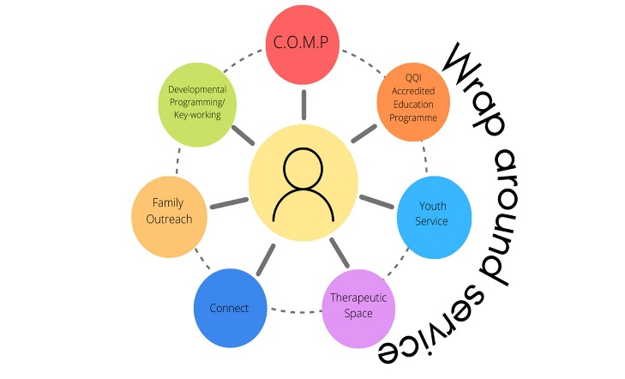At Candle young people are at the heart of everything we do, their voice and their needs are central in the planning of services and we believe that young people can reach their full potential when provided with the right opportunities. At Candle we offer a wide range of services including a full time Training Programme, Connect project, Youth Service, Therapeutic Space, Family Outreach, Developmental Programming, Keyworking, Outreach Mentoring Programme. Each young person can access any of the services offered in Candle as part of our wraparound approach.

Candle is a progressive organisation that has pioneered the integration of the Trauma Recovery Model, Restorative Practices, and an Empowerment Model in our approach to working with young people and their families. Staff are fully trained in trauma informed practice and our key methodologies and the organisation commits to the professional development of staff through ongoing training and development opportunities.

The work base for this role is at the Candle Campus, Ballyfermot.

**Role Description**

The project worker role is a position within the Connect Project within Candle. This dynamic role requires an enthusiastic individual with a passion for supporting young people to reach their full potential. Young people will be referred to the service from the Young Person’s Probation Service and will be from the Dublin Area. The role will involve on the ground direct work with young people who are engaged in offending behaviour, building relationships and encouraging pro social behaviour. The role will require flexibility and a commitment to working alongside the young person to motivate and support them to reach their goals. Identifying and addressing the needs of the young person will be fundamental to the work combined with providing opportunities for learning and development. The project worker will also collaborate with parents/carers, Probation officers and other agencies to promote better outcomes for the young person. The project worker will take an active role in the young person’s life to support them to engage with court processes and achieve the conditions linked to their Probation order. The role will require an individual who is non-judgemental, responsive and strengths based in their approach. The role will include evening and occasional weekend work.

**Website:** [www.candletrust.ie](http://www.candletrust.ie) **Instagram:** @candled10

Applications in the form of cover letter and CV (3 pages max.)

By email to: [info@candletrust.ie](mailto:info@candletrust.ie)

The closing date for application is the Monday 28th July 2025 at 12noon

Interviews will be held week commencing 4th August 2025.