**MONEY ADVICE & BUDGETING SERVICE**

**MONEY ADVISER**

Candidate Information Pack

July 2025

**MONEY ADVISER – Contents**

MABS Service Offer - **Page 3**

MABS Regions - **Page 4**

Job Description - **Page 5**

Person Specifications- **Page 6**

Required Competencies - **Page 7**

Terms and Conditions - **Page 9**

How to Apply **- Page 10**

**MONEY ADVICE & BUDGETING SERVICE**

The Money Advice & Budgeting Service is a free, independent, confidential and non- judgmental money advice and budgeting service for all members of the public. MABS primarily works with people experiencing over-indebtedness. MABS Money Advisers work with clients who may have difficulties with a wide range of personal debts including personal loans, mortgages, credit card debt, catalogue debts, debts to legal moneylenders and hire purchases. Money Advisers assist clients by reviewing budgets, negotiate with creditors and look at opportunities to maximise income.

MABS Money Advisers also act as Approved Intermediaries under Personal Insolvency legislation for clients availing of a Debt Relief Notice. MABS has always dealt with mortgage and housing related debt and this is treated as a priority debt in MABS. MABS has an additional panel of over 30 Dedicated Mortgage Arrears Advisers to work with clients on their mortgage arrears issues.

MABS acts as the gateway to advice under the Abhaile scheme, which provides vouchers for clients to see Personal Insolvency Practitioners, Legal or Financial advisers. In addition, MABS supports clients at all of the repossession court sittings in the country as Court Mentors.

MABS has a remit in Money Management Education by advising clients in relation to budgeting and debt management and facilitating group talks in schools and the community in relation to money management, good saving and spending habits, sources of credit and the avoidance of over-indebtedness.

**The Role**

The Money Adviser will provide a free, independent, confidential money advice service to facilitate clients to deal with debt problems and to become financially independent in the long term. Money Advisers also provide debt prevention education to the target group.

The Money Adviser role is based at a specified MABS location as per the contract of employment. A Money Adviser may be required to work from another MABS office or outreach within their region.

**Applicants**

If you are interested in working within a dynamic, face-to-face money advice service, engaging with people from diverse backgrounds who are experiencing difficulty with debt we would welcome your application for the position of Money Adviser with our service.

**MABS Regional Companies**

Each MABS employee is part of a Regional company, which covers a large geographic or urban area. The Regional Company is a registered charity and lead by a Regional Manager reporting to a voluntary board of Directors and funded through a service level agreement with the Citizens Information Board.

The eight regional MABS companies are as follows: North Dublin, Dublin South, North Connacht & Ulster, North Leinster, North Munster, South Connacht, South Leinster and South Munster, as illustrated in the map below.

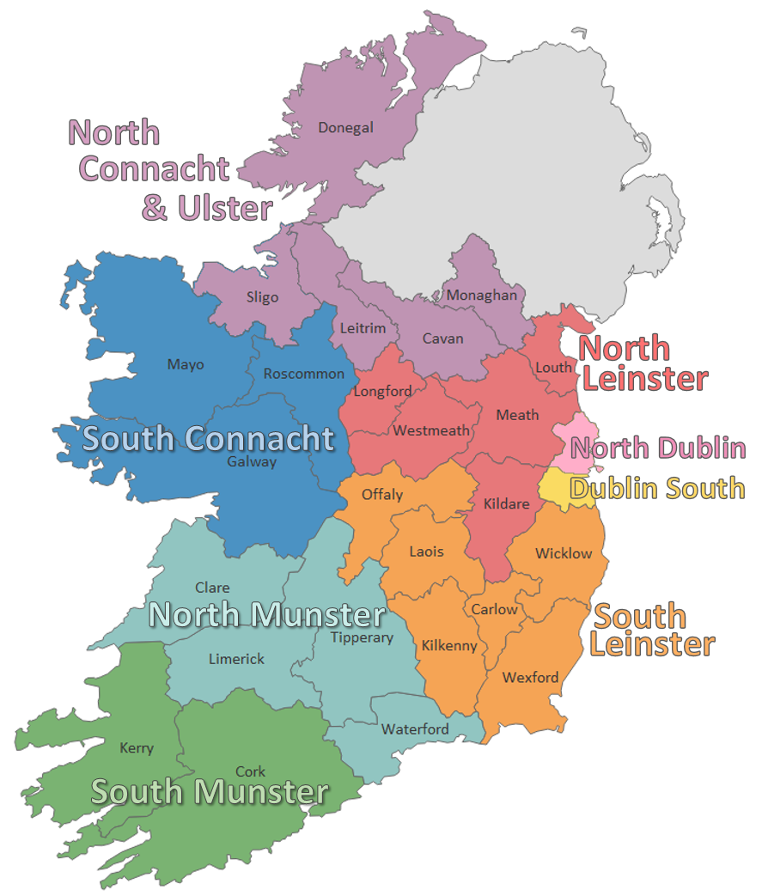

**Money Adviser - Job Description**

**Reports to:** Money Advice Co-ordinator/Service Delivery Manager

**Key Responsibilities:**

* To support the Money Advice Co-ordinator/Service Delivery Manager in the development, implementation and co-ordination of policy, best practice and procedures within the context of the aims and objectives of MABS.
* To provide advice, support and advocacy in relation to money management and consumer debt.
* To advise, on a one-to-one basis, clients who are in debt, or in danger of getting into debt.
* To negotiate with creditors on behalf of clients, where necessary.
* To maintain complete and accurate records.
* To keep up to date with legislation, policy and practice and to attend training courses, seminars and meetings as may be directed by the Money Advice Co-ordinator/Service Delivery Manager and/or Regional Manager.
* To support the Money Advice Co-ordinator/Service Delivery Manager with the preparation of reports, submissions and social policy work.
* To support the Money Advice Co-ordinator/Service Delivery Manager in the planning and implementation of a Community Education / Debt Prevention Programme.
* To support the building and maintaining of effective working relationships with other agencies and organisations for the benefit of the MABS clientele.
* To participate in the development and delivery of strategies to promote the service through the use of local media, literature, exhibitions and other appropriate channels.
* To perform other duties, including regional responsibilities, as may be required and agreed with the Manager/Co-ordinator and/or Regional Manager from time to time, and may be specific to the requirements of a particular MABS company.

**Money Adviser - Person Specifications**

**Minimum Educational Qualifications and Work Experience:**

* Hold a recognised third level qualification at a minimum of Level 7 on the National Framework of Qualifications preferably in the area of Finance, Law, Social Science or Community Development.
* 3 years relevant work experience in one or more of the following areas; consumer debt, money management, finance or advocacy.

**Essential Knowledge, Skills and Experience:**

* Knowledge and understanding of the causes and effects of debt, and the money advice process, particularly to the disadvantaged and vulnerable in society.
* An understanding of money management, consumer debt and financial services.
* Demonstrated strong communication skills, both verbal and written.
* A strong awareness of quality customer service.
* Excellent interpersonal understanding.
* Experience of working in an advice / advocacy role with a diversity of individuals and groups, and particularly with people experiencing difficulty in coping with their situation.
* Proven ability to represent and negotiate on a client’s behalf.
* Ability to work effectively both on own initiative and as a member of a small team.
* Excellent organisational, administrative and IT skills.

**Desirable Knowledge, Skills and Experience:**

* Capacity to develop and implement organisational policy.

**Successful Candidate will:**

* Be committed to the provision of a free, confidential, impartial and independent money advice service.
* Have a knowledge and understanding of the Money Advice and Budgeting Service.
* Be open to work unsocial hours as may be required from time to time and willing to attend evening and occasional week-end events.
* Be prepared to travel as required.

**Money Adviser – Required Competencies**

|  |  |
| --- | --- |
| **Competency** | **Indicators** |
| **C1**  Direct delivery of results, advocacy, representation and negotiation. | * Provides advice to a client/ customer on money management and debt, understands their issues and seeks solutions. * Represents and advocates on behalf of clients to achieve best possible outcome for client. * Negotiates successful outcomes with client creditors and service providers in a positive, assertive manner. * Demonstrates initiative and creative thinking in finding solutions for clients. |
| **C2**  Effective Communication & Interpersonal Skills | * Ability to explain, advocate and express facts and ideas in a convincing way. * Listens to customers and seeks to identify and meet their needs. * Expresses self clearly and confidently in both written (email/letter) and oral communication (telephone/in person). * Presents to different community and other groups on money management or community education related topics. * Relates well to a wide range of customers from diverse backgrounds and particularly understands people experiencing difficulty coping with their situation. * Builds and maintains good working relationships with colleagues and other external stakeholders. * Is an effective team member and collaborates, supports and works effectively with colleagues and management to achieve organisational goals. |
| **C3**  Quality Client Service | * Is responsive to client needs reacting quickly and delivering a quality end service. * Demonstrates a clear commitment to organisational protocols on quality and client service including policies, procedures and reviews. * Deals with all people in a helpful and professional manner, displaying empathy, diplomacy and tact particularly in difficult situations. * Builds client and stakeholder confidence in the service provided by continually seeking to meet expectations and improve the level of service offered. |

|  |  |
| --- | --- |
| **Competency** | **Indicators** |
| **C4**  Case File Management & Organisational skills. | * Inputs and maintains complete and accurate records of casework in a Case Management System complying with all relevant organisational policies and Data Protection legislation. * Organises and prioritises workload effectively through, appointment scheduling, meeting deadlines and time management. * Provides accurate and timely reports to management on activities and updates statistical reports as requested. |
| **C5**  Analysis & Decision Making | * Effectively deals with a wide range of information sources, investigating all relevant issues. * Correctly extracts & interprets numerical information, conducting accurate numerical calculations. * Confidently analyses and assesses a client’s personal financial situation. * Draws accurate conclusions & makes balanced and fair recommendations backed up with evidence. * Identifies gaps or anomalies in social policy and assists with the preparation of reports and submissions. |
| **C6**  Specialist knowledge &  Self-Development | * Knowledge and experience of over-indebtedness, its causes and effects and the money advice process. * Knowledge of the legislative, policy and regulatory framework in relation to consumer debt. * Develops and maintains skills and expertise to perform the role effectively e.g. relevant software and IT systems, organisational policies & procedures and the relevant legislative, policy and regulatory framework. * Constantly learns from experience and takes the initiative to develop new skills and expertise through research, learning and training. * Shares work-related knowledge and expertise with colleagues. |

**Money Adviser – Terms and Conditions**

**Full Salary:** Salary range of €38,773, €40,483, €42,796, €44,467, €46,166, €47,700, €49,234, €50,769, €52,302, Long Service Increment (LSI) 1 €54,079, LSI 2 €55,855 – Pro-rata for part time staff **.**

**Incremental Credit:** It is expected, that all new entrants to MABS will be appointed at point one of the salary scale. However, South Connacht MABS Service operates an incremental credit process for appointments higher than point one. This process is applicable to new entrants into South Connacht MABS. Incremental credit criteria, based on the competencies for the role, are assessed against employment history as laid out in the application form only. A request for incremental credit from a successful candidate must be made within the first 3 months of employment. The decision on whether or not to award an incremental credit is a decision made by the Board and is subject to the availability of funding*.*

**Pension**: A company pension scheme is in place, and membership is obligatory upon commencement. Employee contribution; 5% of salary, Employer contribution; 7% of salary.

**Annual Leave:** Calculated on a pro rata basis for part year and part time as follows:

26 days

After 5 years’ service = 29 days

**Full Terms and Conditions are contained in the MABS Staff Handbook which is issued with and forms part of an employee contract with the Money Advice & Budgeting Service (MABS) companies.**

**Money Adviser – How to Apply**

* A relevant application form can be accessed at [www.mabs.ie](http://www.mabs.ie)
* Applicants must meet the minimum criteria for the role set out in the person specification and possess all required competencies and will be shortlisted solely on the basis of information provided in their completed application form.
* Curriculum Vitae (CVs), late, incomplete or hand-written applications ***will not*** be considered.
* Please contact [**recruitment.southconnacht@mabs.ie**](mailto:recruitment.southconnacht@mabs.ie)if you have any special requirements in relation to completing the application form.
* **Closing date: 4pm on Wednesday 23 July 205**
* **Please email application form to:** [**recruitment.southconnacht@mabs.ie**](mailto:recruitment.southconnacht@mabs.ie)
* Successful applicants may be required to complete an assessment on the day of interview, which may be an IT or written skills test, case study and or presentation, you will be advised in advance.
* A panel of qualified candidates may be formed from which permanent, full-time MA posts which arise in a specified period, up to a maximum of 12 months, will be filled. Posts will be located in the MABS region applied for.
* For information on how your personal data will be used as part of this process please refer to our Data Protection Notice for Job Applicants, available at the following link:

<http://www.citizensinformationboard.ie/en/data_protection/mabs.html>

***Money Advice & Budgeting Services are equal opportunities employers.***