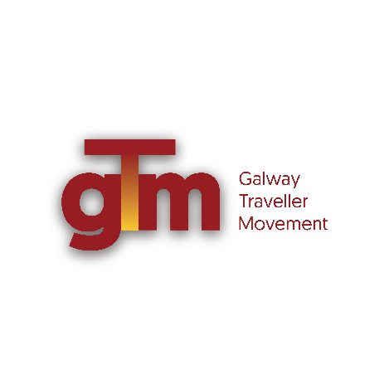

Position: Coordinator of the GTM South East Galway, Peer led Primary Health Care

Programme to work across the social determinants of health, working from

community work and human rights-based approaches.
Place of work: GTM, Floor 2, Ballinasloe Enterprise Centre, Parkmore Ballinasloe, Co
Galway - H53 E9R2
GTM Unit 1 ,The Plaza, Headford Road, Galway.

___________________________________________________________________________
Key areas of work:
- Coordinate and manage the Peer led Primary Health Care Programme in Southeast Galway in line with the National Traveller Health Action Plan, GTM Strategic plan and the Traveller Health Unit, Community Healthcare West Regional Plan.
- Develop appropriate responses to the health and wellbeing needs of the Traveller community.
- Develop and implement the Galway Southeast Galway peer led primary health care outreach programme and ensure effective recording systems that monitor the quality of the programme.
- Direct work with the local Health Services with the view to building strong working relationships with same.
- Promote the Right to Health and human rights-based approaches to getting equality outcomes and an improved health status for the Traveller community.
- Supervise and support the Traveller Community Health Workers working in Southeast Galway.
- Coordinate the development and roll out of the Galway City Local Traveller Action groups building Traveller participation at a local level particularly the Young Traveller Action Group using empowering community work methodologies.
- Promotion and dissemination of Health messages and work using multimedia formats.
- Direct advocacy and media work as needed.
- Work with the Traveller Health Unit and the Western Regional Traveller Health Network. Develop collective Traveller health responses.
- Promote the provision of culturally appropriate services through the active participation of the Traveller community in decision making.
- Enable and empower meaningful Traveller participation on key committees, where Traveller representation can contribute to positive change for Travellers and keep participation under review in terms of influence achieved.
- Work with the GTM team to address barriers and gaps in the following areas: racism and discrimination, health, accommodation, education, enterprise, employment and training and administration of justice,
- Work on the GTM’s Right to Mental health, Right to Accommodation and the Right to Education Campaigns with the Traveller community health workers
- Take an active part in the promotion of Traveller culture and identity through participation in GTM’s Traveller Pride and Misleór, celebrating nomadic cultures events while claiming spaces in other cultural events in Galway City and County.
- Build strategic alliances with members of civil society groups who can support the GTM’s call for an end to the discrimination and racism experienced by the Traveller community and who actively work from and promote community work and human rights-based approaches.
- Contribute to local, regional and national policy structures and developments relating to Traveller’s health and wellbeing and social inclusion and network with other projects and organisations who actively work from and promote community work and human rights-based approaches.
- Promote the full and effective implementation by Public bodies of the public sector equality and human rights duty, provided for in the Irish Human Rights and Equality Commission Act 2014.
- Use complaints mechanisms to raise awareness of the lack of progress across services.
- Prepare reports and adhere to reporting requirements required by HSE and GTM Board of Management.
- Any other duties deemed necessary by GTM Management.

