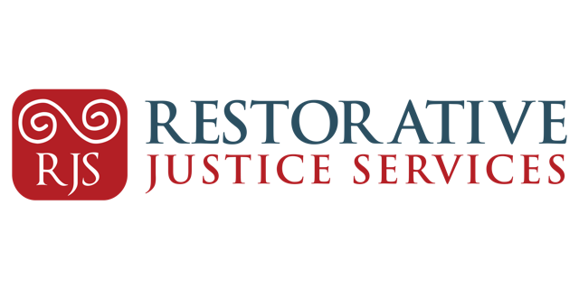**Operations and Finance Manager – Restorative Justice Services**

**Job title:** Operations and Finance Manager

**Reporting to:** Chief Executive Officer

**Location:** Marshalsea Court, Merchant’s Quay, Dublin 8 - however, travel will be associated with this post.

**Working Hours:** Full -Time (39h/week including paid and unpaid break)

**Contract Type:** Permanent subject to funding

**Salary:** 8-point PayScale starting at € 55,000

**Must be available to work between 8.00am – 18.00** based on the needs of the Organisation. Working outside of these hours may be an occasional feature of this role and will be considered to be part of normal working conditions associated with the post.

**Background to the Role**

The Operations and Finance Manager will report directly to the CEO and will be part of the

Leadership Team. They will manage the administrative team and will be required to work closely with all teams across the organisation.

**Role Responsibilities**

(Please note: these tasks may be undertaken with the support of the Administrative Team)

**Organisational Leadership**

* Contribute to organisational strategy and decision-making including working together with

the Board as part of the Leadership Team to deliver Restorative Justice Services’ Strategic Plan 2026-2029.

* Nurture good relationships between Restorative Justice Services’ Teams, coordination of work and promote cross team collaboration.
* Represent the organisation’s values and professional standards in all arenas.

**Finance**

* Oversee the running of the month end process to include cash management, banking on

line, accounts payable, accounts receivable, credit control, payroll and petty cash.

* Maintain the financial systems for the range of funding streams.
* Prepare annual financial budgeting and forecasting.
* Contribute the financial elements of all funding applications and business cases.
* Provide information required to support all aspects of financial forecasting/modelling,

identification of new sources of income.

* Work with the CEO to ensure that all financial and governance matters in relation to the funders and the related service level agreements or annual contracts are maintained.
* Prepare all supporting financial information and liaise with the Board of Directors as

required.

* Manage of the Annual Audit process and associated monitoring requirements.HR
* Oversee all administrative tasks relevant to recruitment and induction of staff;
* Support members of the Leadership Team with management of leave (annual leave,

maternity leave, sick leave, etc…) and taking corrective actions where necessary.

**Governance**

* Provide administrative support to RJS Board of Directors; including scheduling meeting, circulating papers and taking minutes.
* Support the Board Company Secretary, to fulfil their role and obligations; including returns to CRA and CRO.
* Manage and maintain the governance policies folder and schedule regular reviews.
* Support Board sub-committees to fulfil their role and obligations as required.

**Facilities**

* Oversee management of RJS premise (s), including responding to emergencies as required.
* Coordinate maintenance of RJS premise (s) including oversight of the cleaner.
* Oversee Lease/Licence agreements.
* Oversee management of all utilities.
* Ensure that all premise (s) are fit for purpose and maintain to required standards.
* Support in the sourcing and project management of any new premises, including moves, fit

out, etc.

* Oversight of IT and CRM systems
* Manage organisations physical assets and resources.

**Compliance & Health and Safety**

* Oversee IT processes across the organisation
* Oversee and manage RJS policies database, ensuring reviews take place as required.
* Oversee and manage Insurance including ongoing reviews and regular communication.
* Responsible for data protection and GDPR policy, ensure monitoring and adherence across the organisation and regular reviews of data disposal. Act as the organisation Data protection Officer.
* Responsible for H&S policy, ensuring monitoring and adherence across the organisation and regular reviews. Act as the Health and Safety Officer.

**Line Management**

* Responsible for the line management of the Administrative Officer and any other

personnel appointed in an administrative role.

* Comply with HR best practice and Employment Law.
* Provide regular support and supervision to direct report (s) as per RJS Supervision Policy.
* Conduct Annual Performance review as per RJS Policy
* Oversee administrative personnel’s assigned and delegated duties.

**Communication**

* Oversee Management of RJS Website and Social Media.

**General Restorative Justice Services Responsibilities**

* Be familiar with and abide by the organisation’s policies and procedures.
* Assist with the running of any of the other Organisation’s activities as required.
* Engage in training and development opportunities and actively engage with supervision

process.

* Contribute to the wider strategic development of the organisation and play an active role.
* Ensure that the vision and values of the organisation are reflected in a consistent manner in

all activities.

***Note:*** *The duties listed in the job description are not exhaustive and you may be expected to*

*perform other duties as are reasonable in the course of your work with Restorative Justice*

*Services.*

**Person Specification**

**Essential**

* **Accounting Technician qualification or equivalent recognised in the republic of Ireland with minimum of 5 years post qualification professional experience.**
* **Minimum 5 years of experience of general operations management with financial administration and accounting experience.**
* Experience of manual and computerised accounting systems
* Excellent administration skills and attention to detail with a thorough knowledge of MS suite.
* Proven experience of leading, managing and developing a multi-disciplinary team.
* Experience in facilities management and managing health and safety requirements
* Working knowledge of Health and Safety guidelines as per Safety, Health and Welfare Act 2005.
* Working knowledge of GDPR as Data Protection Act 2018.
* Ability to think strategically, and to formulate and implement strategic initiatives
* Excellent interpersonal skills and strong verbal and written communication skills.
* Ability to work on own initiative, be self-motivated and flexible, ability to meet deadlines in a busy environment.
* Respect for self and others at all times and possess a high level of skill in building effective relationships across all levels and sectors.
* Full Driver Licence and access to a car
* Eligible to work in Ireland – RJS may not be able to support new Work Permit application.

**Desirable**

* Experience of working in the voluntary / community sector.
* Experience in maintaining Website and Social Media.