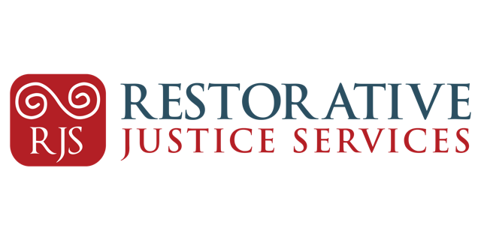

**Restorative and Community Justice Officer -Restorative Justice Services**

**Job title:** Restorative and Community Justice Officer

**Reporting to:** Service Manager

**Location:** Marshalsea Court, Merchant’s Quay, Dublin 8 - however, travel will be associated with this post.

**Working Hours:** Full -Time (39h/week including paid and unpaid break)

**Contract Type:** Permanent subject to funding or Fixed Term

**Salary:** 8-point PayScale starting at € 36,500

**Must be available to work between 8.00am – 18.00** based on the needs of the Organisation. Working outside of these hours may be an occasional feature of this role and will be considered to be part of normal working conditions associated with the post.

**Background to the Role**

The Restorative and Community Justice Officer will report directly to the Service Manager and will be part of the Service Team. They will also be required to work closely with all teams across the organisation.

**Job Purpose**

To facilitate restorative interventions that focus on meeting the needs of victims of crime whilst challenging the behaviour of those who have caused harm. While facilitating the process the Restorative and Community Justice Officer will support the needs of all parties to ensure the process is fair, safe and empowering.

*Restorative Justice Services and its employees do not provide legal advice on any criminal matters as part of their engagement with victims of crime and individuals who have caused harm.*

**Key Responsibilities**

**Service Delivery**

* Work as part of team to deliver an efficient and high quality service to those engaging with our organisation.
* Facilitate restorative and community justice interventions in our office and in the community as per our model of practice.
* Work with victims of crime, harm doers, families, community representatives and statutory agencies with regard to their participation in restorative and community justice interventions.
* Progress all aspects of referrals for interventions as per allocated to the Service Manager.
* Liaise with voluntary and statutory bodies as per requirement of the referrals.

**Communication and Administration**

* Actively participate in organisational meetings.
* Maintain participants data and information as per required by the organisation and legislation.
* Participate in training and organised support as required.
* To participate in the induction and on-going training, support of Volunteers and new employees of RJS.

**Service Development**

* Contribute to the development and review of the service in line with RJS Strategic Plan.
* Contribute to policy development and review within the organisation.
* Support and participate in research and evaluation of the service.

**Networking and Representation**

* Establish and maintain positive and effective working relationships with organisations, working closely with RJS.
* Represent RJS to events as required.

**Team**

* Actively participate in team work, discussion of issues within the service and support colleagues.
* Perform as a team member to ensure effective and quality service delivery. respectfully and collaboratively with all RJS employees, volunteers and Directors as required.

***Note:****The duties listed in the job description are not exhaustive and you may be expected to perform other duties as are reasonable in the course of your work with Restorative Justice Services.*

**Person Specification**

**Essential**

* **Min two years of direct professional experience working with people (over 18 experience is required) affected by crime, victims and/or harm doers - (Relevant volunteering and internship experience may be considered).**
* Relevant Third Level qualification
* Ability to demonstrate a clear understanding of Restorative Justice principles.
* Working knowledge of the Irish Criminal Justice system.
* Excellent communication skills, both verbal and written.
* Excellent IT skills
* Ability to work with internal and external stakeholders in a respectful, constructive and approachable manner.
* Ability to work as part of a team and from own initiative.
* Positive attitude to work and responsibilities associated to the role.
* Openness to feedback and appraisal from colleagues and management.
* Full driving licence and access to a car.
* Eligible to work in Ireland – RJS may not be able to support new Work Permit application.

**Desirable**

* Recognised qualification/training in Restorative Justice and/or Practice, mediation and/or conflict resolution.