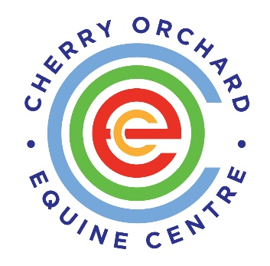

**YOUTH JUSTICE WORKER**

**CODY Youth Diversion Project (YDP)**

**Full and part time role available**

We are very excited to be running a recruitment process to appoint new team members to our CODY Youth Diversion Project. This is an excellent opportunity for a hardworking, experienced professional who is passionate about making a difference in the lives of young people and committed to designing and implementing meaningful interventions in line with the Youth Diversion Programme operational guidelines.

Our Youth Diversion Project works closely with our other services particularly Cherry Orchard Youth Service.

The Youth Justice Worker will report to the Project Leader and is expected to collaborate with team members within the YDP and across the organisation to ensure that each young person is afforded the best possible outcomes from their interaction and engagement with Cherry Orchard Equine Centre CLG.

These vacancies are fulltime and part-time and offer a generous salary package based on experience and in line with the CDYS Youth Worker pay scale as well as other company benefits.

The Youth Justice Worker will engage with the project committee in conjunction with existing staff. It will be the responsibility of the Youth Justice Worker to:

* Identify, engage and work directly with project participants selected from the primary and secondary project target group;
* Implement programmes and activities in the catchment area in line with the YDP guidelines and approved by the project committee;
* Report to the project committee and attend the project and referral assessment committee meetings;
* Act as a link between the participants and agencies and work with local agencies in developing appropriate responses to participants’ needs;
* Keep project records and provide updates and reports as requested;
* Take part in ongoing approved training for developing the Youth Diversion Project.
* Engage in outreach work to identify young people for inclusion in the project through the referral committee, and
* Carry out any other duties deemed necessary by the employer / youth organisation, Gardaí or project committee for the development of the project.

**Person Specification**

* Good interpersonal skills, including ability to liaise with a wide range of contacts and build and maintain effective working relationships.
* Excellent standards of accuracy and attention to detail.
* Ability to be proactive, use own initiative and work effectively within a pressurised environment.
* Positive and flexible approach to team working.
* Excellent written communications skills, including ability to draft summary information and correspondence.
* Excellent computer skills, including Word processing, Excel and Internet.
* Ability to maintain strong boundaries and act professionally at all times
* Commitment to working within the values, mission and vision of the organisation

**Qualifications**

* A third level qualification (QQI Level 7 / 8) in social work, social care, youth work/community work, education or related discipline is highly desirable.
* Three years’ experience of working with vulnerable and at-risk young people is highly desirable
* An understanding of issues affecting marginalised youth and dedication to being a positive advocate for same is essential.
* A full clean driving licence is desirable

**Requirement of all COEC staff**

* Commitment to the purpose of COEC and work within values, policies and procedures of the organisation and in the context of current legislation and regulations.
* Identify training needs through your supervision and participate in training opportunities appropriate to the role.
* To be vigilant to any Health and Safety and Welfare risks in the workplace and bring any concerns to your line manager or Health and Safety officer.
* To undertake other duties as may be requested by the line manager from time to time.
* To undertake your work in a manner that is friendly, flexible and professional.

**Applications**

* Application is by CV and detailed covering letter outlining your suitability for the role.

• Email address: cfinlay@cherryorchard.ie

• Closing date: Open till position is filled

* Enquiries to: Carol Finlay, CODY Manager, 083 4700933

Canvassing will disqualify.

This role is subject to reference check and Garda Vetting

This position is funded by the Department of Justice and co-funded by the European Union under the EU Structural Investment Funds Programme.

