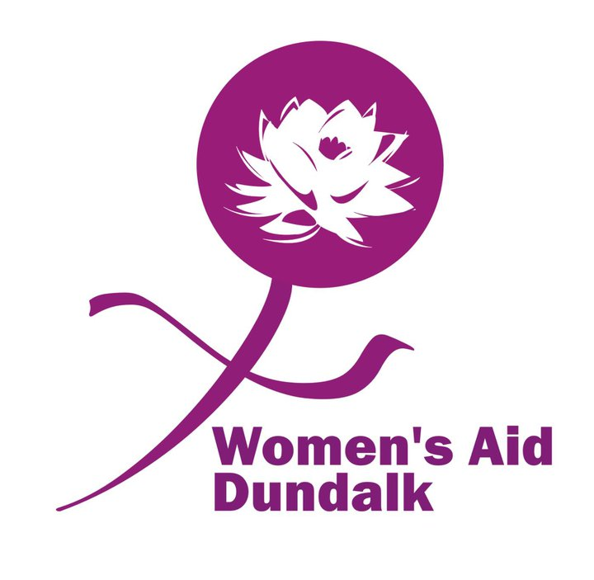

Women’s Aid Dundalk CLG

Strategic Work Plan 2026 – 2030
Tender Brief

Background
Women’s Aid Dundalk is a limited company with charitable status. It was founded in 1994 by volunteers in response to the identified need for a dedicated service for women and children experiencing Domestic Violence. Initially providing a part-time helpline and drop-in service, it has grown to become the organisation that it is today. We are an organisation of 79 people, including staff, management, volunteers and Council of Management members providing a diverse range of services for Women and Children impacted by Domestic Abuse/Coercive Control, and to the wider community.
Women’s Aid Dundalk CLG is a member service of Safe Ireland National Social Change Agency on Domestic Sexual and Gender Based Violence. We are registered with the Charities Regulator, the Voluntary Regulation Code for Approved Housing Bodies and are almost fully compliant with the Governance Code.
Women’s Aid Dundalk is also one of the prioritised 18 refuge developments in the country. This development is currently at stage 3 of the 4 stage CAS application process with an expected completion date of June 2027.

Women’s Aid Dundalk Mission Statement
Women’s Aid Dundalk seeks to work towards the elimination of violence against women and their children in their own homes. Such violence occurs due to women’s unequal position in society and is a violation of women’s human rights.
The guiding principles of Women’s Aid Dundalk are that the organisation is non-sectarian and non-racist regardless of class, creed, sexual orientation or physical ability.
Our stated values include:
- Feminist approach and philosophy informing practice
- Respect for the individual
- Human Rights protection
- Freedom of expression
- Mutual Aid and self-help approach
- Non- judgmental service provision
- Recognising power inequalities in society

A true strength of Women’s Aid Dundalk is that regardless of status that there is a shared compassion and concern for one another at the centre of the expertise in the organisation and this is inherent in all the services it provides.
©Women’s Aid Dundalk 1998 Updated 2003

Aims & Objectives

Aim:

To provide safe secure and acceptable accommodation for women and their children who are victims of domestic violence and to provide an ongoing support network to these women and children.

Objectives:
▪To receive training which will enable us to assist women.
▪To provide a telephone Helpline for this area, this will enable women at risk to seek help if they wish to do so.
▪To provide Refuge or alternative accommodation, for as often or as long as is required by women and children who are at risk.
▪To raise public awareness, mindful of the fact that abuse mental, physical, sexual and emotional is the result of the position of women in society.
▪To promote education, and to inform the community and their representatives with respect to violence against women and children.
▪To liaise with existing statutory and voluntary agencies, to encourage them to recognise their obligation, legal and otherwise, towards women who are victims of violence, committed by men known to them.
▪To establish a network of support.
▪To provide training and information for future volunteers, staff and professionals.
▪To provide opportunities for the education, and emotional needs of women and children to be met, particularly those resident in the refuge.
▪To raise funds to help support these aims

This is achieved via the following services:
- Refuge & Support Services
- Child & Youth Support Services
- The Playroom Project
- #11 Accessible

Current Services
Refuge & Support Services | Funders | Catchment Area | Description of Service
Emergency Refuge Accommodation | CUAN | Based in Dundalk but is available to women and children from other counties also. | Provides 24-hour refuge, keyworking, safety & support planning for women and children experiencing domestic violence and coercive control.  Currently have six units of accommodation, 2 on site and 4 in the community.
24 Hour Helpline | CUAN | As above | Providing emotional support, information and referral to women experiencing domestic abuse, to professionals engaged with women and children who have/are experiencing domestic abuse and to the wider community.
One-to -One Support | CUAN | Dundalk and surrounding areas. | Providing emotional support information and referral, this is an in-person service.
Supported Housing | CUAN | Dundalk and surrounding areas. | Providing accommodation, safety & support planning, emotional support, information, accompaniment & advocacy.
Court based Drop - In Support Service | CUAN | Dundalk and surrounding areas. | Providing court-based drop-in support service, court accompaniment, emotional support, information, referral & advocacy.
Outreach Clinics & Awareness Raising  Support Groups:  1. Power to Change  2.Parenting Through Trauma DV | CUAN  CUAN | Dundalk and surrounding areas.  Dundalk and surrounding areas. | Providing 1-2-1 outreach clinics in Ardee, Carlingford, Omeath, Dunleer & CIC Dundalk also on request from other areas or wherever a woman feels is safest for her to meet.  Providing education, information and awareness raising workshops and presentations on request.  Power to Change for women out of the crisis of DV and beginning their journey to reclaiming and rebuilding their lives and their children.  Parenting Through Trauma DV for mothers who have experienced DV explore the impact on their parenting capacity.
Child & Youth Support Services
 | Funders | Catchment Area | Descriptions of Service
Life story & Direct  1-2-1 Support | CUAN | Dundalk and surrounding areas. | Providing non-therapeutic interventions for children and young people for 4-18 years.
Play Therapy | CUAN | Dundalk and surrounding areas. | Providing therapeutic interventions for children from 4-12 years.
Side by Side | Pilot programme | Dundalk and surrounding areas. | Family Therapy intervention with both the mother/caregiver and child/children.
Schools Programmes | CUAN | North Louth area. | Providing information/education re healthy relationships at secondary school level and helping children understand relate to their feelings and emotions and safety at primary school level.
The Playroom Project | Pobal | Dundalk | Full-time community childcare service for 1–6-year-olds.
#11 Accessible by Women’s Aid Dundalk | Self-funding | Dundalk | Making the organisation and its services visible in the community and providing employment and a positive environmental impact.
Governance
Women’s Aid Dundalk CLG is a “not for profit” organisation, a company limited by guarantee, registered charity and an Approved Housing Body. We are almost compliant with the charity’s governance code, have excellent financial management and a strong history of inter-agency collaboration.
Purpose of this piece of work
Women’s Aid Dundalk is 30 years in existence. It has grown and expanded significantly over the years to incorporate a team of 55 staff, 14 CE & Tús participants and 10 volunteers. It manages a substantial budget and delivers services to just over a 1000 individual women annually.
As an organisation we believe it is time to evaluate and review the vision, mission and values of the organisation to ensure that it is robust, ready to continue its work and to plan as the organisation undertakes major development in the coming 4 years.

Objective
The overall objective of this body of work is to develop a 4-year Strategic Plan for the organisation.
Specific Objectives
- To involve staff, management and service users to re-visit the vision, mission and values of the organisation, to plan for its future and to consider renaming it.
- To plan for the transition of the organisation from its traditional charity perception to the professional specialist service provider it is now.
- To plan for the transition of services from the existing two sites to the one new purpose-built centre at the Newry Road.
- To consult with stakeholders and funding agencies.
- To review the organisational structure to provide sustainability, particularly in terms of staffing levels, roles and responsibilities.
- To ensure that Women’s Aid Dundalk remains committed to its core values.
- To review funding to maintain current service levels and remain viable into the future.
- To set clear strategic goals for the next 4 years with clear actions and timeframes
- It is hoped through a facilitated process to end up with a document, outlining the vision, mission, values of Women’s Aid Dundalk and strategic goals for the next 4 years with clear actions and timeframes. This will also incorporate a review of the organisational structure.

Process
The above objectives will be carried out through
- Facilitated sessions with staff.
- Consultation with stakeholders, management, staff, service users etc.
- Facilitated process with Management on review of the organisational structure
- The outcome will be a document outlining the vision, mission and values of Women’s Aid Dundalk and a plan to achieve this vision over the next four years with implementable, measurable and actionable goals.
Project Requirements
The successful contractor will work closely with the CEO, Finance & Compliance Manager, Change Management Facilitator and sub-committee of the Board of Management to deliver on the process outlined above.
We are seeking an individual or an organisation who can,
- Develop and agree a clear methodology for this piece of work.
- Outline a project plan including a projected timeline.
- Have relevant experience in facilitation and process work.
- Provide a full succinct document written in accessible plain English outlining the vision, mission and values of Women’s Aid Dundalk, developing clear goals for the next 4 years, conscious of further developments in the sector in accordance with Zero Tolerance, the National Strategy on Domestic Sexual & Gender Based Violence.
Timelines
Description | Deadline Date & Time
Deadline for receipt of Tenders | Friday 25th July 2025
Interview date for prospective Tenders | Interviews – provisionally week of the 18th August 2025
Anticipated contract start date | Monday 22nd September 2025
Project completion and publication | Friday 12th December 2025

Budget
An amount of circa €7,000 is available for the completion of this Project, inclusive of VAT and all expenses. Payment will be phased and linked to progress. Prices and rates quoted shall be expressed in Euro (€) and exclusive of VAT. The VAT rate(s) applicable shall be indicated separately.
Women’s Aid Dundalk reserves the right to with-hold payment where a contractor has failed to meet its contractual obligations in relation to the delivery of goods/services to an acceptable level of quality. Women’s Aid Dundalk will remain the sole and exclusive owner of all end products and of all intellectual property rights in the products supplied to and from Women’s Aid Dundalk during this contract, irrespective of whether the contract has been terminated prior to its completion.
Tax
The successful contractor will be required to produce a current TCC. If the contractors TCC expires within the course of this contract Women’s Aid Dundalk reserves the right to require a new TCC.
Insurance
Proof of Professional Indemnity shall be provided with application for this contract.
Assessment of Contract Award
All completed Tender documentation to be submitted to adrianna@womensaiddlk.net by 5pm Friday 25th July 2025.
Only Tender submissions which include all the criteria set out below shall be considered. Women’s Aid Dundalk will consider all submissions equally, scoring them based on the following criteria.
Criteria | Note | Weighting | Max Score | Min Score Require
Project Approach | Proposed Methodology | 20% | 200 | 120
Ability to deliver Project | Details of relevant experience, qualification & credentials. Details of related work & provision of previous client’s names. Name & contact for 2 referees. | 20% | 200 | 120
Value for money | Breakdown of costs, including daily rates. | 30% | 300 | 180
Overall sustainability | Understanding of the Domestic, Sexual & Gender Based Violence sector, and the issues faced. | 30% | 300 | 180
Total |  | 100% | 100% | 100%

