

Tosú is a national organisation that works with State agencies in the development and delivery of services to marginalised groups, enabling communities to become more socially inclusive through best practice service provision. Tosú’s current operational scope includes three national Services and two smaller projects: The Linkage Service, the Gate Service, the Resettlement Service; and The Community Support Scheme and The Supported Employment Service.

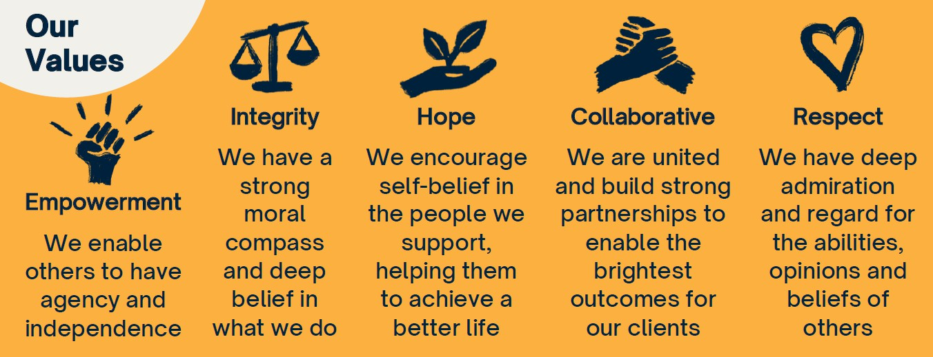

Main Aims and Objectives of the Resettlement Service
The main objective of the Resettlement Service is to promote desistance through the provision of support and access to essential services identified through the resettlement process. The focus is holistic but in each case is adapted to the needs of individual prisoners. Prior to release Resettlement Coordinators support the ex-prisoners access to housing, addiction, medical, social welfare and any other required services, while at the same time offer continued personal support. The ultimate aim is the ex-prisoners desistance and independence.

Job Title: | Resettlement Coordinator (Resettlement Service)
Job Purpose: | Work in a prison setting with referred prisoners prior to release in order to facilitate their resettlement back into the community.  Provide a range of supports to prisoners who have come into conflict with the law, to assist these persons to access social welfare, housing, medical card, addiction support services and other relevant services required to enable resettlement back into the community.  Empower offenders to take responsibility for their life choices, and explore future directions.
Reporting to: | Prison Supervisor.
Travel/ Full Driving License Requirements: | Vehicle and full driving license desirable but not essential.
Security Clearance: | Posts are subject to initial and ongoing Irish Prison Service Security Clearance and Garda Vetting.

JOB DESCRIPTION

Reporting to the Prison Supervisor the Resettlement Coordinator will provide a range of supports to offenders/prisoners properly referred to the programme:

Primary Responsibilities:
- Developing pre-release relationships with prisoners referred to the Programme
- Manage referrals for prisoners who require resettlement support
- Assist prison-based agencies and their staff by assessing and addressing the resettlement needs of referred offenders

- Develop an individualised and realistic resettlement plan with the ultimate aim of promoting social integration, which may involve post-release placement with community and voluntary groups
- Assess housing needs, welfare needs and post release medical card access
- Liaise and advocate with Housing, Social Welfare and Medical Card agencies/personnel on behalf of the prisoner as required
- Maintain accurate case management notes on the Irish Prison Service Prisoner Information Management System
- Contribute to prison based multi-disciplinary meetings as part of the Irish Prison Service Integrated Sentence Management process
- Provide post-release support to clients and service providers in the community
- Liaise with existing agencies e.g. the Health Service Executive, Area Partnerships, Local Authorities among others to complement those services and avoid replication
- Develop service provider and community based networks, and a directory of supports for each catchment area
- Maintain a detailed file on all clients
- Effectively manage a caseload
- Furnish reports to the line manager and attend meetings when required
- To actively participate in conjunction with your line manager in your own training and development needs and appropriate training and development activities
- To perform such other duties as appropriate to the post that may be assigned to you by your line manager from time to time
- Ensure resources are used efficiently, effectively and economically
- Monitor own performance; trends analysis / internal controls
- Provide timely and comprehensive management information, statistics and reports
- Observe the requirements of the Prison Rules, 2007 and Governors Orders as issued from time to time
- Observe all requirements of the General Data Protection Regulations and Data Protection Acts
- Observe all requirements of the Tosú Child Protection Policy
- Observe the new legislative requirements as relevant and necessary

Secondary Responsibilities:
- Assist in the development and implementation of strategic plans
- Assist in the development of new projects

PERSON SPECIFICATION

Essential Qualifications and Knowledge:
The ideal candidate will have:
- A relevant third level qualification while not essential is desirable;
- A thorough understanding of the Target Groups needs and issues;
- A good understanding of the Irish Prison Service and the Resettlement and Reintegration process
- Must meet the security and health and safety requirements for working within a prison environment

A good general knowledge of:
- Tosú and its range of services
- The Irish Criminal Justice system
- Prisoner Resettlement Work
- Desistance Processes
- Community based Addiction Services
- Homeless Services
- Primary Needs
- Department of Social Protection schemes
- Community and Voluntary Groups
- The Irish employment market and training & education opportunities
- Semi-state and other agencies, including services providing support and/or training and educational services for marginalised groups

Experience
- One or more years’ experience of working with the Target Group or similar groups
- Teamwork experience

Competencies/ Personal Attributes

Interpersonal Effectiveness: Managing for Results:
Confidence Concern for clarity and quality
Initiative Meeting target outcomes
Communication Setting realistic targets for clients Empathy

Group & Interprofessional Skills: Thinking & Problem Solving:
Influencing / Negotiation Analytical Thinking
Understanding Stakeholder Needs Conceptual Thinking
Relationship Development / Networking Practical Thinking
Facilitation Innovative Thinking
Understanding Group Dynamics Decision Making / Judgment

Desired Knowledge
Criminal Justice System/Agencies Key agency personnel
Target Group Needs Employers issues and concerns
Criminal Justice Perspectives Labour Market Forecasts
Adult Guidance Theories & Practice Information Technology (IT)
Health & Safety Legislation Children First Guidelines

