Tosú is a national organisation that works with State agencies in the development and delivery of services to marginalised groups, enabling communities to become more socially inclusive through best practice service provision. Tosú’s current operational scope includes three national Services and two smaller projects: The Linkage Service, the Gate Service, the Resettlement Service; and The Community Support Scheme and The Supported Employment Service.

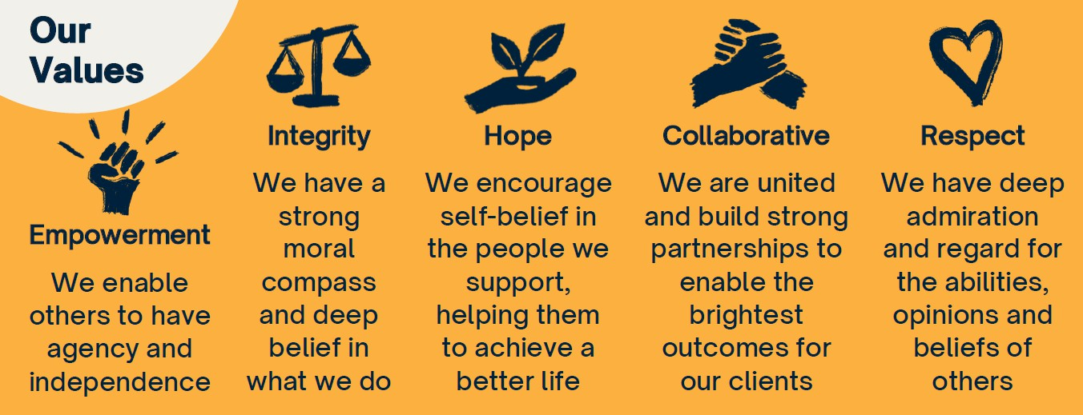

**Main Aims and Objectives of the GATE Service**

The aim of the **Gate Service** is to promote desistance from criminal activity through its innovative guidance and placement service. Its Training & Employment Officers (TEO’S) are located in the following prisons – Mountjoy Prison Campus, The Dóchas Centre, Wheatfield Prison, Cloverhill Remand Center, and the Midlands and Portlaoise Prison Complex. The ultimate goal of the GATE Service is to provide meaningful employment for former offenders.

|  |  |
| --- | --- |
| **Job Title:** | Training & Employment Officer. |
| **Job Purpose:** | Place referred offenders into training / employment according to individual needs, abilities & aspirations.  Provide a range of services to persons who have come into conflict with the law, to assist these persons to undertake/avail of the educational, rehabilitative, and training services required to contribute to society in a positive manner.  Empower offenders to take responsibility for their life choices and explore future directions. |
| **Reporting to:** | Prison Supervisor. |
| **Travel/ Full Driving License Requirements:** | Vehicle and full driving license desirable but not essential. |
| **Security Clearance:** | Posts are subject to initial and ongoing Irish Prison Service Security Clearance and Garda Vetting. |

**JOB DESCRIPTION**

**Reporting to the Line Manager, the Training and Employment Officer (TEO) will provide the following range of individual supports to prisoners and ex-prisoners properly referred to the Service**

**Primary Responsibilities:**

* Assist prison-based agencies by assessing the employment needs of referred offenders
* Offer a one-to-one client-centered guidance practice to those referred
* Develop an individualised and realistic career path plan with the ultimate aim of securing employment for clients post release
* Liaise with existing education & training programmes in a variety of settings to provide progression placement for offenders pre and post release
* Canvass appropriate employers/training agencies to place offenders in situ
* Provide after-placement support to employers and clients placed in jobs
* Liaise with existing agencies including Intreo, DSP, Local Employment Services, Area Partnerships, ETB’s, to complement those services and avoid undue replication
* Develop employer networks and a directory of placement opportunities
* Maintain an up-to-date detailed file on all clients
* Furnish reports to your Line Manager and attend all meetings when required
* Ensure resources are used efficiently, effectively and economically
* Monitor own performance, trends analysis / internal controls
* Provide timely and comprehensive management information and statistics
* Actively participate in approved training based on professional development needs analysis and development activities
* Perform such other duties as appropriate to the post that may be assigned to you by your Line Manager from time to time.
* Observe the requirements of the Prison Rules, 2007 and Governors Orders as issued from time to time
* Observe all requirements of the General Data Protection Regulations and Data Protection Acts
* Observe all requirements of the Tosú Child Protection Policy
* Observe the new legislative requirements as relevant and necessary

**Secondary Responsibilities:**

* Assist in the development and implementation of strategic plans as required
* Assist in the development of new projects for client group
* Facilitate in client group work as required
* Remain up to date with current thinking and practice relevant to your role

**PERSON SPECIFICATION**

**Essential Qualifications and Knowledge:**

The ideal candidate will have:

* + A Diploma or Higher in Adult Guidance & Counseling or relevant Third Level qualification leading to membership of the Institute of Guidance Counsellors with;
  + A thorough understanding of the Target Groups needs and issues
  + A good understanding of the Irish Prison Service and the Resettlement and Reintegration process
  + Must meet the security and health and safety requirements for working within a prison environment.

A good general knowledge of:

* + Tosú and its range of programmes
  + The Irish Criminal Justice system
  + The Irish employment market and training & education opportunities
  + Semi-state and other agencies, including services providing support and/or training and educational services for marginalised groups
  + The issues and concerns for employers

**Experience**

* + One or more years’ experience of working with the Target Group
  + Teamwork experience

**Competencies/ Personal Attributes**

**Interpersonal Effectiveness**: **Managing for Results:**

Confidence Concern for clarity and quality

Initiative Meeting target outcomes

Communication Setting realistic targets for clients Empathy

**Group & Interprofessional Skills: Thinking Style & Problem Solving:**

Influencing / Negotiation Analytical Thinking

Understanding Stakeholder Needs Conceptual Thinking

Relationship Development / Networking Practical Thinking

Facilitation Innovative Thinking

Understanding Group Dynamics Decision Making / Judgment

**Desired Knowledge**

Criminal Justice System/Agencies Key agency personnel

Target Group Needs Employers issues and concerns

Criminal Justice Perspectives Labour Market Forecasts

Adult Guidance Theories & Practice Information Technology (IT)

Health & Safety Legislation Children First Guidelines