

Candle Community Trust

Youth Educator

Candle Community Trust invites applications for the post of Youth Educator. The successful candidate will work as part of our Training Programme where educational and developmental programmes are delivered in a dynamic learning environment in our purpose-built, newly developed campus.

This post may be offered on a full time or part time basis in consultation with the successful candidate.

We would be interested to hear from candidates who can deliver *one or more* of the following subjects: **Personal Effectiveness, Work Experience, Mathematics and Health Related Fitness** at QQI Levels 3, 4 and 5.

At Candle

* Young people are at the heart of everything
* Their voice and their needs have been central in shaping services.
* Every young person can reach their potential once they are provided with the right opportunities.  Candle is that opportunity:

-an opportunity to learn, to be creative, to have fun and to grow

-a safe and nurturing place where everyone is welcome

-where everyone is equally cherished for the gifts they bring to our community

-a space to find your inner resilience and build for the future

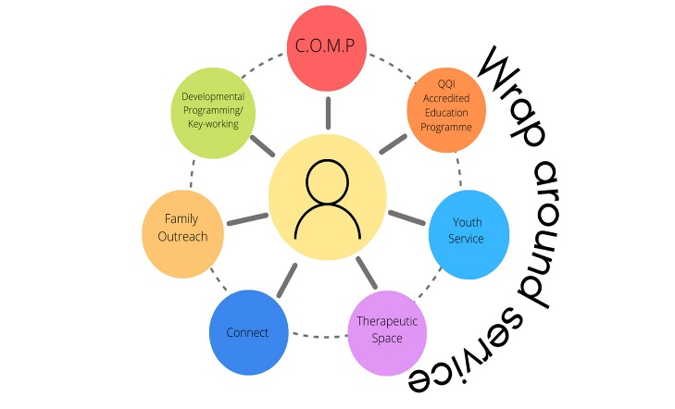We offer a wide range of services including a full time Training Programme, Connect project, Youth Service, Therapeutic Space, Family Outreach, Developmental Programming, Keyworking and an Outreach Mentoring Programme. Each young person can access the services offered in Candle as part of our wraparound approach.

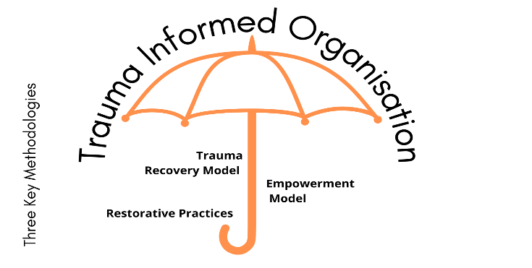

About Candle Community Trust

Candle Community Trust provides educational, developmental, and therapeutic programmes for young people. We are committed to creating and delivering a comprehensive best practice service to meet the needs of young people and their families who experience disadvantage and marginalisation. Candle aims to provide a context for the physical, emotional, intellectual, social, and spiritual growth of the person.

Candle is a progressive organisation that has pioneered the integration of the Trauma Recovery Model, Restorative Practices, and an Empowerment Model in our approach to working with young people and their families. This approach aims to address any underlying trauma or issues presenting and interventions are supported by Candle’s in-house therapeutic services.

Often described as an ‘oasis of calm’, the Candle educational, developmental and therapeutic programmes are necessarily underpinned by the establishment of a safe, nurturing and relaxed environment.

Candle is respected for its work in the area of trauma, and all staff are trained in trauma informed practice and methodologies. Accessing support through a range of therapies including counselling, mindfulness practice, acupuncture, reflexology and yoga is now as “normal” for participants as engaging in the educational curriculum. Caring for positive mental health is as much a priority for all at Candle as is nurturing physical, social and educational wellbeing.

Over the past 5 years the Candle campus has undergone a significant redevelopment. This redevelopment led to a beautifully constructed award-winning building and therapeutic garden which support the vision of Candle services as a space for nurture, growth, healing and transformation.

**Website:** [www.candletrust.ie](http://www.candletrust.ie) **Instagram:** @candled10

Role Description

The Youth Educator will work in the development and delivery of education and developmental programmes to young people aged 15-21 years. At Candle we deliver programmes at **QQI Levels 3, 4 and 5.** It is important that the candidate has the skills and commitment to work with our target group, to support the personal and educational development of our learners.

Youth Educators are responsible for the training and development of Learners in accordance with the agreed local training programme specifications, together with contributing to other aspects of the programme throughout the day. We deliver our education programmes in a supportive environment with small class sizes.

*Please note: the Training Programme in Candle has a rolling intake of Learners and classes run 48 weeks out of the year.*

Candidate Profile

The ideal candidate will have the following:

Essential:

* Third level qualification in a relevant area.
* A relevant pedagogical/training or facilitation qualification - Train the Trainer QQI Level 6 or previous teaching experience.
* Experience of delivering creative educational programmes.
* Competent and confident to deliver educational programmes at Levels 3, 4 and 5 on the National Framework of Qualifications.
* Knowledge of child protection legislation and associated procedures; must have up to date child protection training and/or be willing to complete child protection training in line with Candle’s Child Protection Policy and Safeguarding Statement.

Other requirements:

* Experience of working with vulnerable and at-risk people.
* Ability to engage with learners, to build and maintain a good working relationship within a professional setting.
* An ability to effectively and sensitively manage difficult situations.
* Working creatively and imaginatively with learners in formal and informal educational and developmental contexts.
* Excellent interpersonal skills and an ability to work effectively as a team member.
* Sound ethical boundaries.
* A flexible and creative approach.
* I.T. experience and competence.
* An understanding of and commitment to promoting positive mental health and wellbeing.

**What we offer:**

* Competitive salary, commensurate with experience (salary scale for this post is €34,085- €60,813)
* Professional development opportunities
* A supportive, vibrant, and progressive work environment

Application

Please send a cover letter and your CV (max 3 pages) to [info@candletrust.ie](mailto:info@candletrust.ie), with ‘Youth Educator’ in the subject line.

Closing date for receipt of application is **5pm on Monday 2nd June 2025.** Interviews will be held the week of 9th June 2025.

Applications received after this deadline will not be accepted.

Informal enquires about the role can be made to Clare Mander [cmander@candletrust.ie](mailto:cmander@candletrust.ie)

**Garda Vetting applies to this position.**

***A panel will be formed from which future positions may be filled. Candle Community Trust is an Equal Opportunities Employer***