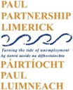 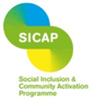

**Job description**

**SICAP Community Outreach & Wellbeing Worker**

PAUL Partnership is establishing a panel of Community Outreach & Wellbeing Workers to fill upcoming vacancies. A Community Outreach & Wellbeing Worker identifies community needs, develops and implements programmes, builds relationships, facilitates engagement, secures funding, and monitors and evaluates projects to enhance community and individual well-being.

In this pivotal role, you will support the development and delivery of high-impact projects and capacity-building initiatives for community groups across Limerick City, in addition you will engage with people on a one-to-one basis to support their wellbeing and development. This position is initially offered as a 12-month fixed-term contract under the Social Inclusion and Community Activation Programme (SICAP).

**Job Description & Advert:**

Join Our Team as a Community Outreach & Wellbeing Worker

**Location:** Limerick City, Ireland

**Contract Type:** Creation of Panel - Full and Part time positions may become available (Subject to successful completion of a 6-month probation period)

**Working Hours:** Full-Time( 35 hours per week) and Part time positions may become available.

**Salary:** €40,759 - €49,769 per annum (pro rata for part-time positions)

**Annual Leave:** 25 days plus Good Friday

**Application Deadline:** Friday the 6th of June 2025

**Apply via:** [recruitment@paulpartnership.ie](mailto:recruitment@paulpartnership.ie)

Only completed application forms will be accepted. CVs are not accepted.

**About Us:**  
At PAUL Partnership, we are dedicated to fostering social inclusion and empowering communities that have historically been left behind. As a dynamic and innovative organization, we collaborate with communities, state agencies, social partners, and voluntary groups to create meaningful, lasting change in Limerick City. We believe in the power of diversity and are committed to creating an inclusive workplace where everyone can thrive.

**About the Role:**  
We are seeking a panel of passionate and proactive Community Outreach & Wellbeing Workers to join our team. This role is central to driving impactful community development initiatives while providing direct support to individuals from marginalised communities, helping them access opportunities to improve their lives.

**Key Responsibilities:**

* **Community Engagement & Outreach:**  
  Engage with hard-to-reach groups and individuals, particularly those in extremely disadvantaged communities. Lead outreach activities to build trust and encourage participation in programmes that lead to improved quality of life for individuals and communities. Coordination and project management of SICAP community events .
* **Capacity Building & Support:**  
  Provide one-on-one mentoring, advice, and support to individuals, to build capacity, & enhance wellbeing. Take a creative approach to engagement with communities and individuals to assist them in developing their confidence. Support individuals to create personal action plans, and navigate services related to education, employment, wellbeing and welfare.
* **Programme Development & Delivery:**  
  Design and implement community development projects. Support community groups in identifying needs, developing community plans, and accessing funding opportunities.
* **Education & Training:**  
  Coordinate and deliver training sessions tailored to the needs of community members. Work with individuals to identify and access current progression opportunities that best suit their needs.
* **Advocacy & Networking:**  
  Advocate for the needs of marginalised communities and individuals at local and regional levels. Collaborate with stakeholders, including employers, educational institutions, and statutory agencies, to create pathways to education and employment.
* **Monitoring & Reporting:**  
  Regularly assess the impact of community initiatives, ensuring they meet objectives. Compile reports for stakeholders and funders, ensuring transparency and accountability. Caseload management to meet agreed targets.

**What We’re Looking For:**

* Proven ability to build relationships and work collaboratively with a diverse range of stakeholders.
* Demonstrated experience in community development, especially in social inclusion and working with disadvantaged groups and individuals.
* Excellent organisational skills with a track record of delivering projects on time and within budget.
* Proven ability to coordinate community events.
* Strong communication skills with the ability to present complex information in an accessible way.
* A relevant third-level or professional qualification and minimum of 2 years’ experience in a similar role.
* A commitment to PAUL Partnership’s vision and values, with a passion for social justice and equality.

**Why Join Us?**

* **Market-Leading Salary**: Enjoy a competitive salary package, reflecting the value we place on your expertise and commitment.
* **Top-Tier Pension Scheme:** Benefit from a robust, defined contributory group pension plan, available after the successful completion of your probation period.
* **35-Hour Workweek:** Achieve work-life balance with a full-time position that requires 35 hours per week.
* **Generous Annual Leave:** Enjoy 25 days of annual leave plus Good Friday, ensuring you have ample time to rest and recharge.
* **Impactful Work:** Make a real difference in the lives of individuals and communities that need it most.
* **Dynamic Environment:** Work in a supportive and collaborative team that values innovation and creativity.
* **Professional Growth:** Gain access to training and development opportunities to enhance your skills and career prospects.
* **Inclusive Culture:** Be part of a workplace that embraces diversity and is committed to equality.

**How to Apply:**  
Interested candidates are invited to apply via [recruitment@paulpartnership.ie](mailto:recruitment@paulpartnership.ie)

Only completed application forms will be accepted. CVs are not accepted. Please ensure your application is submitted by the deadline. Shortlisting will apply.

*PAUL Partnership is an equal-opportunity employer. We strongly encourage applications from all sectors of society. If you require any accommodations during the application process, please let us know.*

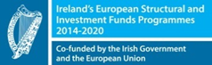 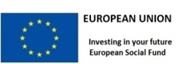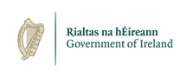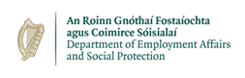

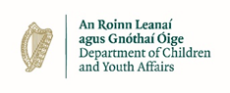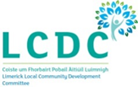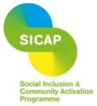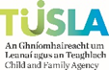

*The Social Inclusion and Community Activation Programme (SICAP) is co-funded by the Government of Ireland, through the Department of Rural and Community Development, and the European Union.*