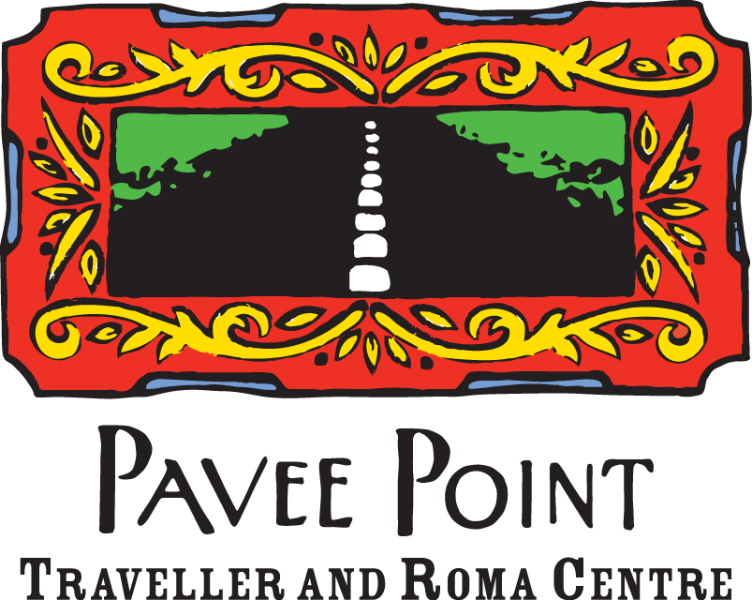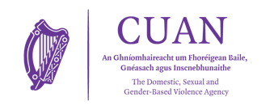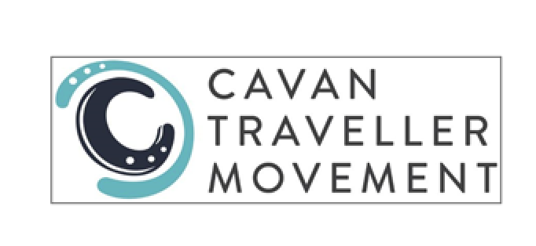

**Traveller Domestic, Sexual and Gender-based Violence (DSGBV) Project**

## 

## **Job title: Traveller Women’s Awareness Worker (DSGBV Community Worker) – Cavan**

**Job Overview**

Are you interested in Traveller women’s rights? Do you want to work towards ending violence against women and girls?

The Traveller DSGBV Project aims to address barriers to safety and protection for Traveller women and girls in relation to domestic and sexual violence. This is a peer-led project which employs Travellers to work with local/regional service providers and Travellers in the local/regional area. The Traveller Women’s Awareness Worker will work to raise awareness and prevent domestic and sexual violence with the Traveller community, and work with services to ensure that they meet the needs of Traveller women and promote and protect the rights of Traveller women and girls. The project is funded by Cuan, the DSGBV Agency.

**Reports To**

The Traveller Women’s Awareness Worker will report to the Manager in Cavan Traveller Movement and the project lead in Pavee Point Traveller and Roma Centre. The Traveller Women’s Awareness Worker will work as part of the overall Project with the Project Workers in Pavee Point who provide ongoing support with the work.

**Place of Work**

The Traveller Women’s Awareness Worker will cover the whole of Co. Cavan and will be based in:

**Cavan Traveller Movement Offices (Unit 9 New Court, Cavan Town, Co. Cavan H12Y320**)**.** Some travel will be required.

**Contract/Salary Scale**

This position is for 20 hours per week and are flexible. The position is on a community/youth work salary scale 3. The contract is subject to funding and a probation period.

**Duties and responsibilities:**

1. Identify and record barriers and experiences for Traveller women and girls in relation to domestic and sexual violence
2. Promote change for Traveller women and girls to address domestic and sexual violence
3. Work with local service providers, projects, networks, groups, clinics etc.
4. Organise and deliver information and training sessions for local/regional service providers on Travellers (including anti-racism/discrimination/interculturalism)
5. Respond to queries by service providers and support services with good practice when working with Traveller women and girls
6. Represent Traveller women and girls on local and regional committees, meetings, networks, etc.
7. Raise awareness with the Traveller community about domestic and sexual violence and services and supports
8. Undertake prevention work with the community (women, men and young people) on domestic and sexual violence
9. Take part in training as organised by the Project lead and Cavan Traveller Movement
10. Consider the safety, welfare and health of women and children impacted by domestic and sexual violence and refer women and girls to services and supports

**Ideal candidates would:**

* Have knowledge, training, education or work experience in one or more of these areas:
  + women’s rights
  + domestic and sexual violence
  + Primary Health Care
  + community development
  + or any other relevant area with a focus on improving the quality of life of Travellers or other marginalised groups
* Have a keen interest to work in the area of domestic and sexual violence
* Have a keen interest to advocate/speak on behalf of Traveller women, girls and community
* Have strong knowledge of the issues that Traveller women and girls experience
* Have an understanding of domestic and sexual violence and women’s rights issues
* Have good communication skills
* Be able to build good working relations with services and the Traveller community
* Have experience in organising and delivering groups, presentations and/or training sessions
* Be able to attend local, regional and national meetings to represent Travellers
* Be able to be sensitive and respectful towards women who experience domestic and sexual violence
* Be reliable, and willing and able to work on own and as part of a team
* Have a full and clean driving license, or be willing to travel to take part in meetings and training sessions
* Have computer skills

**To apply**

Please **email or post a CV and a short letter** stating why you would be a good candidate for the

position.

**Email:** [bridget.winters@pavee.ie](mailto:bridget.winters@pavee.ie)

**Post:** Bridget Winters, Pavee Point Traveller & Roma Centre, 46 Charles St. Great, Dublin 1

For further information, please contact Bridget Winters in Pavee Point on 085 787 8734, or Chrissie O’Sullivan on 087 175 3007.

**Closing date**

The closing date is Tuesday 3 June, 2025, by 5pm. Interviews will take place the following week.

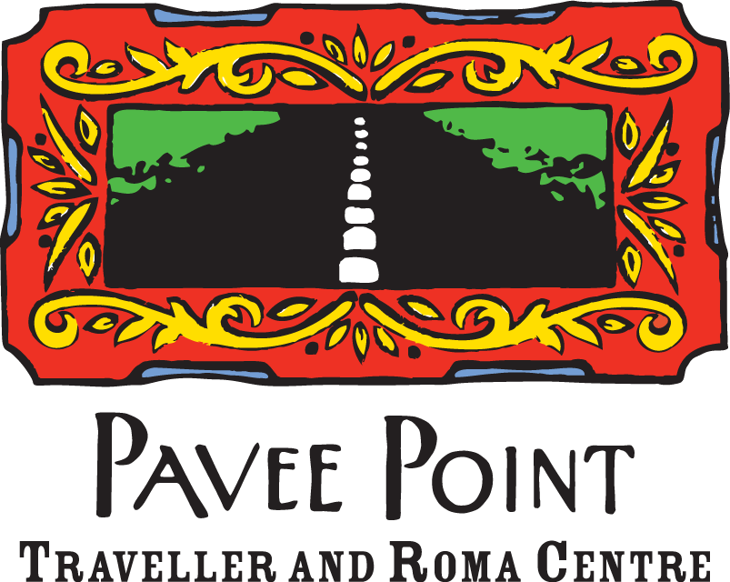Applications from Travellers, Roma and other minority groups are welcomed.