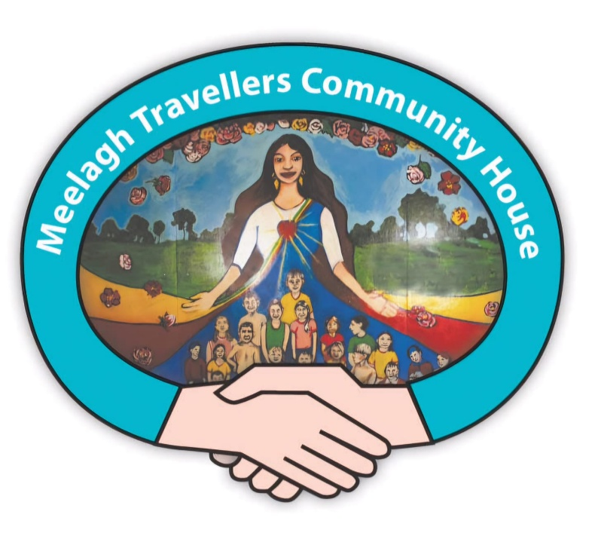

Meelagh community development worker
Background
Meelagh community development project provides a range of culturally appropriate family supports and programmes for the families of Meelagh Traveller group housing scheme. The project, which has run since 2010 is located in a Traveller led community centre in Mahon, Cork city. Worker employed by Cork Traveller Women’s Network.
Duties & Job Description
Purpose of Job: To plan for and support the development of the local community centre, advocate for Traveller rights, empower residents of Meelagh in organising local activities/groups and participate in local decision making.

Salary €36,153 per annum for 25 hours per week. (Role funded through the HSE Cork Kerry Traveller Health Unit.)

Main Duties:
Duties will include the following:.
- Support the development of Meelagh community centre
- Manage & co-ordinate the family support services in Meelagh
- Manage the day to day running of the centre including programme planning, financial management and tutor support, supervision & training.
- Set up relevant health, education & cultural programmes & activities in response to identified needs through community outreach & consultation
- Encourage and support Traveller representation on centre management through a mentoring & leadership programme
- Support the community reps to advocate for their needs in key decision making fora
- Encourage & support a sense of ownership & pride in the Meelagh centre in all our community including children & youth
- Advocate for the rights of Travellers and provide support and signposting to services to individuals and families around issues that affect their lives.
- Develop funding applications to implement programme of activities key activities in Meelagh: • After School Programme • Youth drop-in • Young Girls Group • Women’s Group • Health Events • Cultural Events
- Network with and work with key agencies committed to supporting our overall aim & key objectives to secure resources.
- Link with and report to Cork Traveller Women’s Network.

Person specification:

- Experience of working with Traveller projects/families and young people
- Awareness of Traveller culture and traditions
- Be able to manage personal and professional boundaries including maintaining confidentiality and always showing respect
- Committed to social inclusion and equality of outcomes
- Completed or open to completing Traveller Cultural Awareness Training (TCAT)
- Completed or open to completing Trauma informed work practices
- Willing to work flexibly and be responsive to individual support needs
- Proficient admin skills: writing reports, keeping accounts, maintaining budgets, using MS office applications and ability to write funding applications
- Hold a drivers licence and have access to a car for work purposes
- Have excellent communication skills
- Qualifications in community development or related education and/or significant community work experience

Please apply by:

Sending your CV and a cover letter telling us why you are interested in this post via email to – corktravellerwomen@hotmail.com

Please mark the subject box "Meelagh - Application"

Closing date: 5pm June 1st 2025

Interviews planned for Wed June 18th at Meelagh Community House, Mahon.

Employment will officially commence on September 1st 2025

