HSE Health & Wellbeing IHA Dublin North City & West Expression of Interest- Blakestown/Mulhuddart/Corduff

We Can Quit and Healthy Food Made Easy Programme
HSE funded programmes - Sláintecare Healthy Communities Programme
The Sláintecare Healthy Communities Programme is a cross-government initiative that adopts a place-based approach to addressing health inequalities. The programme is designed to improve the long-term health and wellbeing of people living in communities across Ireland where health inequalities are most evident. HSE Health & Wellbeing, Integrated Healthcare Area of Dublin North City & West are inviting Expressions of Interest from organisations with a track record of working with disadvantaged to deliver programmes to improve their physical and emotional health and wellbeing to coordinate and deliver two community-based programmes in the area of Blakestown/Mulhuddart/Corduff:
- Community-led Stop Smoking Support Programme - We Can Quit
- Community Cooking Programme – Healthy Food Made Easy

Successful organisations will be contracted by HSE via Section 39 Grant Agreement (Health Act 2004) to deliver a specified level of service as part of the Sláintecare Healthy Communities Programme.
Previous experience in delivering one or other of the programmes will be an advantage but is not essential.

Expressions of interest are now being invited for the establishment of a new Sláintecare Healthy Communities area, covering Blakestown, Mulhuddart, and Corduff. (See image below with map.)

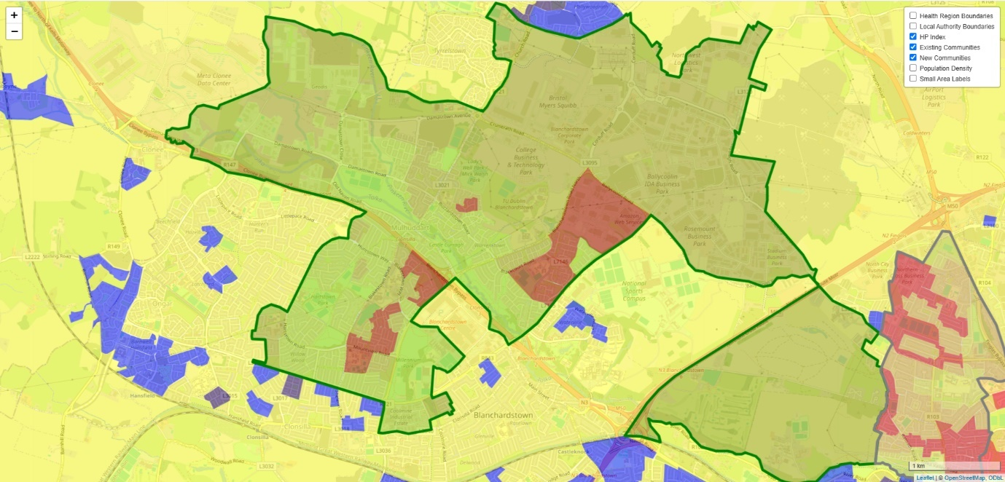

Community-led Stop Smoking Service – We Can Quit Description
The Community-led Stop Smoking Service – We Can Quit is a group programme delivered over 12 weeks by trained facilitators. The programme uses a structured evidence-based smoking cessation approach, a supportive peer group environment with access to evidence-based stop smoking medication provided free of charge to support individuals to quit smoking.
The coordination and delivery of the service by a community organisation will involve a partnership approach with the community and voluntary sector, the HSE and other health care providers.
Community organisations will be required to:
- Recruit and employ a panel of Stop Smoking community facilitators. The community organisation is required to follow up with clients at 12-, 26- and 52-weeks call backs.
- Advertise and recruit into the We Can Quit stop smoking groups.
- Manage the logistics to support operation of the groups e.g. venues, insurance, participant reminders, budget management.
- Liaise with partner pharmacies for additional support for stop smoking medication for group participants and administer payment in line with local and national arrangements.
- Participate in local coordination governance groups with all stakeholders, identifying and responding to gaps and local need.
- Ensure facilitators and staff involved in programme co-ordination have access to IT equipment and internet access to enable use of the HSE’s standardised patient management system for the delivery and recording of the stop smoking service.
- Ensure required monitoring and evaluation processes are in place and be open to external monitoring and auditing of client records by the Tobacco Free Ireland programme for quality assurance purposes. This is a standardised process for all stop smoking services regardless of whether they are internal to the HSE or contracted providers.
- Complete and return reports, including financial reporting in a timely manner, to facilitate monitoring and evaluation the programme by HSE.
- Maintain supply of relevant materials and resources to support programme delivery.
The HSE will provide the following support to the community organisation:
- Funding to provide the agreed quantum of service, in line with nationally agreed funding model.
- Access to accredited training for Smoking Cessation Facilitators and refresher/upskilling on an annual basis.
- Access to training and support to use the standardised patient management system.
- Funding to provide access to free stop smoking medication for participants who choose to use it as part of the programme.
- Access to materials and resources to support programme delivery.
*Note: The Revenue Commissioners have published a Code of Practice for Determining Employment or Self-Employment Status of Individuals. It is the responsibility of the organisation contracted to provide a service to HSE to ensure that their HR and employment practices are compliant with relevant employment and tax law.

Community Cooking Programme - Healthy Food Made Easy Description
The Healthy Food Made Easy Programme is a 6-week nutrition and cooking skills course delivered by trained facilitators in the community. The programme is primarily targeted at socio-economic disadvantaged groups but is suitable for a wide range of audiences including parents of young children, teenagers, Travellers, families living in homeless hubs, and those attending family support services.

The coordination and delivery of the service by a community organisation will involve a partnership approach with the community and voluntary sector, the HSE and other health care providers.
Community organisations will be required to:
- Recruit and employ a panel of Healthy Food Made Easy community facilitators*.
- Advertise and recruit into the Healthy Food Made Easy groups.
- Manage the logistics to support operation of the groups such as venues, insurance, participant reminders, purchase of ingredients, budget management.
- Participate in local coordination governance groups with all stakeholders, identifying and responding to gaps and local need.
- Liaise with HSE Community Dietitians to coordinate group input, training and annual refresher/update for community facilitators.
- Ensure facilitators and staff involved in programme coordination have access to IT equipment, confidential client data storage, and internet access to enable data collection, monitoring and reporting.
- Ensure required monitoring and evaluation processes are in place.
- Complete and return reports, including financial reporting in a timely manner, to facilitate monitoring and evaluation the programme by HSE.
- Maintain supply of relevant materials and resources to support programme delivery.

The HSE will provide the following support to the community organisation:
- Funding to provide the agreed quantum of service, in line with nationally agreed funding model.
- Access to a HSE Dietitian to provide training for Healthy Food Made Easy facilitators and refresher/upskilling on an annual basis.
- Access to materials and resources to support programme delivery.

*Note: The Revenue Commissioners have published a Code of Practice for Determining Employment or Self-Employment Status of Individuals. It is the responsibility of the organisation contracted to provide a service to HSE to ensure that their HR and employment practices are compliant with relevant employment and tax law.

Timeframe:

Successful organisations will commence delivery by quarter 4 of 2025.

Tender requirements:
Your completed application form should ensure the following application form:
- Organisation details and contacts
- Criteria for selection
- Current Tax Clearance Detail
- Cost of service and an outline of any added value or additional information you think is relevant

Successful organisations should have the following:
- An interest and passion for delivering health and wellbeing projects for disadvantaged communities
- Experience using a range of research methods, including evaluation research methods, qualitative and quantitative research methods
- Knowledge and experience of working with multi-agency groups and stakeholders
- Exceptional attention to detail and ability to adhere to strict reporting and budgetary requirements.
- Ability to deliver 14 Community Cooking Programmes (Heathy Food Made Easy) and 2 Community-led Stop Smoking Service Programmes (We Can Quit) over a 12-month period.

Assessment of Tender
Each tender received will be assessed on the basis of:
- Track record of working effectively with disadvantaged communities to deliver programmes that improve health and wellbeing (30%)
- Evidence of working in partnership with the HSE and relevant community groups and organisations (30%)
- Evidence of organisational capacity to deliver the commissioned service (20%)
- Examples of the ability to provide timely and accurate data to facilitate monitoring and evaluation of the programme (20%)

To note: Additional information may be sought at the assessment phase. A short listed number of the most competitive tenders may be invited for further discussions/interview on their proposal.

Closing Date for receipt of applications: Friday 30 May 2025
Applications to: hwb.dncc@hse.ie

Further enquiries can be sought in advance of submission from:
seamus.hogan@hse.ie

Application Form

Section 1: Organisation details
Organisation Details & Contacts
(Items shaded yellow are compulsory entry)
If compulsory entries are not completed, the entry cannot be made on SPG Online.
Name of Organisation
(This should be the official or Registered Legal Entity name)
Trading Name (known as)
(if different from above)
Address of Organisation  (This should not contain the  personal name or address of  an individual e.g. secretary) |  |  | Line 1
 |  |  | Line 2
 |  |  | Line 3
 |  |  | Town
 |  |  | County
 |  |  | Eircode
Telephone Number |  | Fax Number |  |  |  |  | Contact e-mail |  |  | Website
Other organisational detail – if relevant |  |  |  | Name |  |  |  |  | Address
Parent Organisation Details
(where your organisation is a subsidiary of a national organisation)
Franchise Organisation Details
(where your agency is operating as a franchise)
Affiliation Organisation Details
(where your organisation is affiliated to other agencies / bodies)
Application Contact Details
Organisation Key / Main Contact Details (This should be the person who has overall responsibility for this application and resultant funding arrangement and will act as key contact person with the Executive)
Title
Name
Address

Email
Phone |  |  |  |  |  | Mobile
Authorised Signatory Contact Details
(The person authorised by your organisation to sign the Funding Arrangement should this application be successful) – Chairperson or Equivalent
Title
Name
Address

Email
Phone |  |  |  |  |  |  | Mobile

Organisation Overview
Status /Structure of Organisation
 | Yes | No | Tick Yes / No as Appropriate
Is your Organisation a registered Charity? |  |  | If Yes please provide Charity Regulatory Authority Number >
Is your Organisation registered with Revenue for Charity Tax Exemption? |  |  | Please provide Revenue CHY Number >
Is your Organisation a registered Company? |  |  | If Yes please provide Company Number (CRO Number) >
Is your Organisation a Statutory body?
Is your Organisation a voluntary or community “Not for Profit” organisation? |  |  | If No please describe your organisation >
 |  |  | If Yes & you are neither a Registered Charity / Company or Statutory Body please give details of your organisations structure/status >

Organisation Aims & Objectives
(Please provide an overview of your Organisation’s aims & objectives referring to Articles of Association where applicable)

Section 2: Criteria for Selection
- Track record of working effectively with disadvantaged communities to deliver programmes that improve health and wellbeing (30%)
- Evidence of working in partnership with the HSE and relevant community groups and organisations (30%)
- Evidence of organisational capacity to deliver the commissioned service (20%)
- Examples of the ability to provide timely and accurate data to facilitate monitoring and evaluation of the programme (20%)
Responses to the following questions will inform the assessment by the panel against the criteria listed above.
Background Question: Does your organisation currently provide services in the areas of Blakestown, Mulhuddart or Corduff?
Yes [ ] No [ ]

- Track record of working effectively with communities to deliver programmes that improve their physical health and emotional wellbeing (30%).
Provide 3 examples to illustrate your organisations track record of working effectively with communities to improve their physical health and emotional wellbeing. Clearly describe the situation, task, action and result for each example.
Example 1:

Example 2:

Example 3:

- Evidence of working in partnership with the HSE (30%).
Provide 2 examples of partnership working with the HSE including liaising with key stakeholders from clinical services.
Example 1:

Example 1:

Example 2:

- Evidence of organisational capacity to deliver the commissioned service (20%).

3.1 Has your organisation experience of delivering the following programmes in the past 5 years?
Community-led Stop Smoking Support Programme - We Can Quit YES NO
Community Cooking Programme - Healthy Food Made Easy YES NO

3.2 Please select the statement that best describes how your organisation currently delivers programmes that support physical and emotional health and wellbeing
Descriptor | Yes | Comment
Suitably qualified staff are employed on a full/part-time basis with delivery of programmes a core part of their job description
Suitably qualified tutors/facilitators are contracted on a sessional basis to deliver programmes
Staff members who have been trained as facilitators deliver programmes in addition to their core roles
We don’t currently deliver health & wellbeing programmes

3.3 Please provide details of the number of WTE available in your organisation to support delivery This is for information only and will not be scored
 | No. |  | %
Full-time employees |  | % of WTE time that is dedicated to delivery of health & wellbeing programmes
Part-time employees |  | % of WTE time that is dedicated to delivery of Health & wellbeing programmes
Sessional tutors |  | Number of tutors available

  - There will be a requirement for delivery of programmes and to be responsive to community need, this means that programme delivery may be required outside of 9:00 – 17:00 period.
Do you have the capacity to accommodate this?
Yes [ ]
No [ ]
Comment if required:

3.5 Please provide a description of your organisation’s experience in recruitment and supervision of staff?
Response:

  - Please provide a description of the administrative and technical supports available to a Stop Smoking Community facilitator and Healthy Food Made Easy facilitator.
(Please note access to a suitable room to accommodate a group of around 15 people while will be required for delivery of We Can Quit. Access to an online platform such as MS teams, webex or zoom will be required should any of the groups need to be delivered online instead of face to face. Access to a suitable room to accommodate a group of around 15 people will also be required for delivery of Healthy Food Made Easy)

Response:

- Evidence of organisational capacity to deliver the commissioned service (20%).

4. The successful organisation will be required to provide timely and accurate datasets to facilitate monitoring and evaluation of the Community-led Stop Smoking Support Programme (We Can Quit) and Community Cooking Programme (Healthy Food Made Easy). Please provide or detail examples of the data capture, evaluation and reporting your organisation currently undertakes in relation to similar programmes.
Response:

Section 3: please include current tax clearance certificate

Closing Date for receipt of applications: Friday 30 May 2025
Applications to: hwb.dncc@hse.ie
Further enquiries can be sought in advance of submission from:
seamus.hogan@hse.ie

