HSE Health & Wellbeing IHA Dublin North City & West Expression of Interest- Blakestown/Mulhuddart/Corduff

Community-led Social Prescribing Service
HSE funded programmes - Sláintecare Healthy Communities Programme

The Sláintecare Healthy Communities Programme is a cross-government initiative that adopts a place-based approach to addressing health inequalities. The programme is designed to improve the long-term health and wellbeing of people living in communities across Ireland where health inequalities are most evident. HSE Health & Wellbeing, Integrated Healthcare Area of Dublin North City & West are inviting Expressions of Interest from organisations with a track record of working with disadvantaged communities delivering programmes to improve their physical and emotional health and wellbeing to coordinate and deliver the roll out of a social prescribing service. This will involve a partnership approach between the Community and Voluntary sector and the health sector (HSE and General Practice) to connect a wide range of adults with sources of support within their community. Previous experience in delivering a social prescribing project is desirable but not essential.

Expressions of interest are now being invited for the establishment of a new Sláintecare Healthy Communities area, covering Blakestown, Mulhuddart, and Corduff. (See image below with map.)

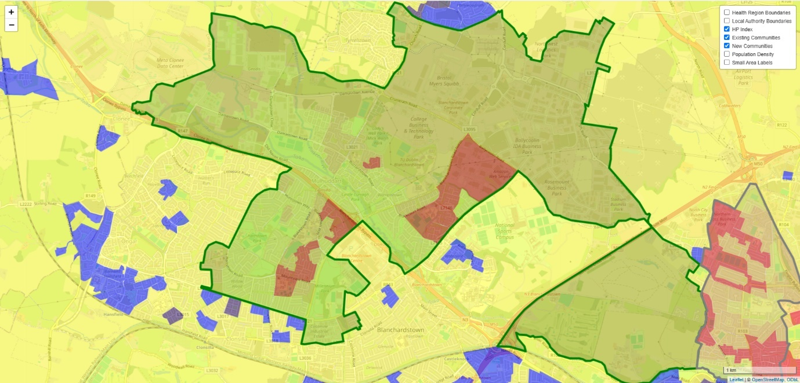

Background:
Organisations selected to deliver the social prescribing programme as part of the Healthy Communities Initiative will be funded to deliver a contracted level of service in line with the existing S39 Health Act 2004 Service Arrangement with HSE, and will include:
- Roll out of a social prescribing service in partnership with the HSE and other key stakeholders targeting a defined area of social deprivation and a wider Community Healthcare Network (CHN) area
- Recruitment, employment and line management of Social Prescribing Link Worker/s
- The Social Prescribing Link Worker may be required to support the development of other health and wellbeing/social prescribing roles within the geographical area
- Provision of administration/technical support e.g. IT equipment, confidential client data storage etc.
- Ensuring required monitoring and evaluation processes are in place
- Responding to gaps identified through social prescribing
- Completion of reports required under the contractual agreement with the HSE
- Financial reporting and management of budget provided

Being supplied with relevant programme materials and resources to support the delivery of prescribing programme from the HSE, which will also include core training for Social Prescribing Link Workers.

Timeframe:

Successful organisations will commence delivery by quarter 4 of 2025.

Tender requirements:

Your completed application form should ensure the following are included:

- Organisation details and contacts
- Criteria for selection
- Current Tax Clearance Detail
- Cost of service and an outline of any added value or additional information you think is relevant
Successful organisations should have the following:

- An interest and passion for delivering health and wellbeing projects for disadvantaged communities;
- Knowledge of social prescribing in the Irish context;
- Experience using a range of research methods, including evaluation research methods, qualitative and quantitative research methods;
- Knowledge and experience of working with multi-agency groups and stakeholders;
- Experience in the maintenance of detailed, accurate and fully evidenced records;
- Experience in producing high quality evaluation research reports;
- Exceptional attention to detail and ability to adhere to strict reporting and budgetary requirements.
- Ability to engage with 100 clients in a 12-month period.

Assessment of Tender

Each tender received will be assessed on the basis of:
- Track record of working effectively with disadvantaged communities to deliver programmes that improve health and wellbeing (30%)
- Evidence of working in partnership with the HSE and other health providers e.g. GPs (30%)
- Evidence of organisational capacity to deliver the commissioned service (20%)
- Examples of the ability to provide timely and accurate data to facilitate monitoring and evaluation of social prescribing (20%)
To note: Additional information may be sought at the assessment phase. Before awarding the evaluation, a short listed number of the most competitive tenders may be invited for further discussions/interview on their proposal.

Closing Date for receipt of applications: Friday 30 May 2025

Applications to: hwb.dncc@hse.ie

Further enquiries can be sought in advance of submission from:
Seamus.hogan@hse.ie

Section 1: Organisation details
Organisation Details & Contacts
(Items shaded yellow are compulsory entry)
If compulsory entries are not completed, the entry cannot be made on SPG Online.
Name of Organisation
(This should be the official or Registered Legal Entity name)
Trading Name (known as)
(if different from above)
Address of Organisation  (This should not contain the  personal name or address of  an individual e.g. secretary) |  |  | Line 1
 |  |  | Line 2
 |  |  | Line 3
 |  |  | Town
 |  |  | County
 |  |  | Eircode
Telephone Number |  | Fax Number |  |  |  |  | Contact e-mail |  |  | Website
01 8512289
Other organisational detail – if relevant |  |  |  | Name |  |  |  |  | Address
Parent Organisation Details
(where your organisation is a subsidiary of a national organisation)
Franchise Organisation Details
(where your agency is operating as a franchise)
Affiliation Organisation Details
(where your organisation is affiliated to other agencies / bodies)
Application Contact Details
Organisation Key / Main Contact Detatils (This should be the person who has overall responsibility for this application and resultant funding arrangement and will act as key contact person with the Executive)
Title
Name
Address

Email
Phone |  |  |  |  |  | Mobile
Authorised Signatory Contact Details
(The person authorised by your organisation to sign the Funding Arrangement should this application be successful) – Chairperson or Equivalent
Title
Name
Address

Email
Phone |  |  |  |  |  |  | Mobile

Organisation Overview
Status /Structure of Organisation
 | Yes | No | Tick Yes / No as Appropriate
Is your Organisation a registered Charity? |  |  | If Yes please provide Charity Regulatory Authority Number >
Is your Organisation registered with Revenue for Charity Tax Exemption? |  |  | Please provide Revenue CHY Number >
Is your Organisation a registered Company? |  |  | If Yes please provide Company Number (CRO Number) >
Is your Organisation a Statutory body?
Is your Organisation a voluntary or community “Not for Profit” organisation? |  |  | If No please describe your organisation >
 |  |  | If Yes & you are neither a Registered Charity / Company or Statutory Body please give details of your organisations structure/status >

Organisation Aims & Objectives
(Please provide an overview of your Organisation’s aims & objectives referring to Articles of Association where applicable)

Section 2: Criteria for selection
- Track record of working effectively with disadvantaged communities to deliver programmes that improve health and wellbeing (30%)
- Evidence of working in partnership with the HSE and other health providers e.g. GPs (30%)
- Evidence of organisational capacity to deliver the commissioned service (20%)
- Examples of the ability to provide timely and accurate data to facilitate monitoring and evaluation of social prescribing (20%)
Responses to the following questions will inform the assessment by the panel against the criteria listed above.

Background Question: Does your organisation currently provide services in the areas of Blakestown, Mulhuddart or Corduff?
Yes [ ] No [ ]

- Track record of working effectively with disadvantaged communities to deliver programmes that improve health and wellbeing (30%). Provide 3 examples to illustrate your organisation’s track record of working effectively with disadvantaged communities in a co-production capacity to improve their health and wellbeing. Clearly describe the situation, task, needs assessment, action and outcome for each example
- Example 1

- Example 2

- Example 3

- Evidence of relevant experience (30%)
2a. Evidence of working in partnership with the HSE and other health providers e.g. GPs.
Provide 2 examples of partnership working with the HSE including liaising with key stakeholders
from clinical services (20%)
2a. Example 1

2a. Example 2

2.b Has your organisation experience of delivering a social prescribing programme? (10%):
Yes [ ] No [ ]

- Evidence of organisational capacity to deliver the commissioned service (20%)
3a. Please provide a description of your organisation’s experience in recruitment, line management and supervision of staff:
Descriptor | Y/N | Comment
Limited experience in recruiting, line managing and providing supervision of staff. Less than 2 paid staff in the organisation.
Experience in recruiting, line managing and providing supervision of staff. More than 2 paid staff in the organisation.
Experience in recruiting, line managing and providing supervision of staff. More than 2 paid staff in the organisation. Experience of line managing staff of various grades.
Experience in recruiting, line managing and providing supervision of staff. More than 2 paid staff in the organisation. Experience of managing staff at Grade V equivalent. HR structure in place.

3b. Please provide a description of the administrative and technical supports available to a Social Prescribing Link Worker
Descriptor | Y/N | Comment
Limited availability, shared office space, hot desk, internet

Shared office, own desk, landline phone number, internet and filing cabinet.
Shared office, own desk, landline phone number, internet and filing cabinet. Access to single office (on booking basis) to meet clients confidentially.
Single office, own desk, landline phone number, internet and filing cabinet.

- The successful organisation will be required to provide timely and accurate data to facilitate monitoring and evaluation of social prescribing (20%)
Please provide example of the data capture, evaluation and reporting your organisation currently undertakes in relation to programmes, social prescribing or otherwise.
4. Example

Section 3: please include current tax clearance certificate
Closing Date for receipt of applications: Friday 30 May 2025
Applications to: hwb.dncc@hse.ie

Further enquiries can be sought in advance of submission from: seamus.hogan@hse.ie

