HSE Health & Wellbeing IHA Dublin North City & West Expression of Interest- Blakestown/Mulhuddart/Corduff

Community Food & Nutrition Workers
HSE funded programmes - Sláintecare Healthy Communities Programme

The Sláintecare Healthy Communities Programme is a cross-government initiative that adopts a place-based approach to addressing health inequalities. The programme is designed to improve the long-term health and wellbeing of people living in communities across Ireland where health inequalities are most evident. HSE Health & Wellbeing, Integrated Healthcare Area of Dublin North City & West are inviting Expressions of Interest from organisations with a track record of working with disadvantaged communities delivering programmes to improve their physical and emotional health and wellbeing to coordinate and deliver a programme to build nutrition capacity, knowledge and skills across disadvantaged communities. Previous experience in delivering healthy eating related programmes is essential.

Expressions of interest are now being invited for the establishment of a new Sláintecare Healthy Communities area, covering Blakestown, Mulhuddart, and Corduff. (See image below with map.)

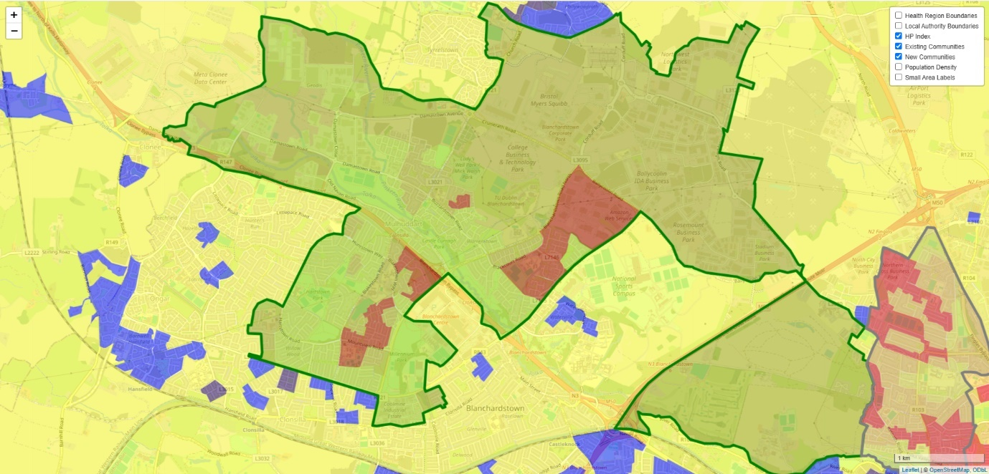

Organisations selected to deliver the programme as part of the Sláintecare Healthy Communities Initiative will be funded to deliver a contracted level of service in line with the existing Section 39 Health Act 2004 Service Arrangement with HSE, and will include:
- Recruitment, employment and line management of Community Food & Nutrition Worker(s)
- Supporting the delivery programmes (e.g. workshops, education, training, support, food clubs) to a range of key targeted groups in the community, based on the national Healthy Eating Guidelines targeting a defined area of social deprivation and a wider Community Healthcare Network (CHN) area
- Supporting individuals accessing food supports
- Mapping of food environment in the Sláintecare Healthy Communities area
- Coordinating the activation of agreed national campaigns that address healthy lifestyles and Healthy Food for Life guidelines targeting a defined area of social deprivation and a wider Community Healthcare Network (CHN) area
- Provision of administration/technical support etc.
- Ensuring required monitoring and evaluation processes are in place
- Completion of reports required under the contractual agreement with the HSE
- Financial reporting and management of budget provided

Timeframe:

Successful organisations will commence delivery by quarter 4 of 2025.

Tender requirements:
Your completed application form should ensure the following application form:
- Organisation details and contacts
- Criteria for selection
- Current Tax Clearance Detail
- Cost of service and an outline of any added value or additional information you think is relevant

Successful organisations should have the following:
- An interest and passion for delivering health and wellbeing projects for disadvantaged communities
- Knowledge of delivery of healthy eating related programmes
- Experience using a range of research methods, including evaluation research methods, qualitative and quantitative research methods
- Knowledge and experience of working with multi-agency groups and stakeholders
- Exceptional attention to detail and ability to adhere to strict reporting and budgetary requirements.

Assessment of Tender
Each tender received will be assessed on the basis of:
- Track record of working effectively with disadvantaged communities to deliver programmes that improve health and wellbeing (30%)
- Evidence of working in partnership with the HSE and relevant community groups and organisations (30%)
- Evidence of organisational capacity to deliver the commissioned service (20%)
- Examples of the ability to provide timely and accurate data to facilitate monitoring and evaluation of the programme (20%)

To note: Additional information may be sought at the assessment phase. A short listed number of the most competitive tenders may be invited for further discussions/interview on their proposal.

Closing Date for receipt of applications: Friday 30 May 2025
Applications to: hwb.dncc@hse.ie

Further enquiries can be sought in advance of submission from:
seamus.hogan@hse.ie

Application Form

Section 1: Organisation details
Organisation Details & Contacts
(Items shaded yellow are compulsory entry)
If compulsory entries are not completed, the entry cannot be made on SPG Online.
Name of Organisation
(This should be the official or Registered Legal Entity name)
Trading Name (known as)
(if different from above)
Address of Organisation  (This should not contain the  personal name or address of  an individual e.g. secretary) |  |  | Line 1
 |  |  | Line 2
 |  |  | Line 3
 |  |  | Town
 |  |  | County
 |  |  | Eircode
Telephone Number |  | Fax Number |  |  |  |  | Contact e-mail |  |  | Website
Other organisational detail – if relevant |  |  |  | Name |  |  |  |  | Address
Parent Organisation Details
(where your organisation is a subsidiary of a national organisation)
Franchise Organisation Details
(where your agency is operating as a franchise)
Affiliation Organisation Details
(where your organisation is affiliated to other agencies / bodies)
Application Contact Details
Organisation Key / Main Contact Details (This should be the person who has overall responsibility for this application and resultant funding arrangement and will act as key contact person with the Executive)
Title
Name
Address

Email
Phone |  |  |  |  |  | Mobile
Authorised Signatory Contact Details
(The person authorised by your organisation to sign the Funding Arrangement should this application be sucessful) – Chairperson or Equivalent
Title
Name
Address

Email
Phone |  |  |  |  |  |  | Mobile

Organisation Overview
Status /Structure of Organisation
 | Yes | No | Tick Yes / No as Appropriate
Is your Organisation a registered Charity? |  |  | If Yes please provide Charity Regulatory Authority Number >
Is your Organisation registered with Revenue for Charity Tax Exemption? |  |  | Please provide Revenue CHY Number >
Is your Organisation a registered Company? |  |  | If Yes please provide Company Number (CRO Number) >
Is your Organisation a Statutory body?
Is your Organisation a voluntary or community “Not for Profit” organisation? |  |  | If No please describe your organisation >
 |  |  | If Yes & you are neither a Registered Charity / Company or Statutory Body please give details of your organisations structure/status >

Organisation Aims & Objectives
(Please provide an overview of your Organisation’s aims & objectives referring to Articles of Association where applicable)

Section 2: Criteria for selection
- Track record of working effectively with disadvantaged communities to deliver programmes that improve health and wellbeing (30%)
- Evidence of working in partnership with the HSE and relevant community groups and organisations (30%)
- Evidence of organisational capacity to deliver the commissioned service (20%)
- Examples of the ability to provide timely and accurate data to facilitate monitoring and evaluation of the programme (20%)

Responses to the following questions will inform the assessment by the panel against the criteria listed above.
Background Question: Does your organisation currently provide services in the areas of Blakestown, Mulhuddart or Corduff?
Yes [ ] No [ ]

- Evidence of track record of working effectively with disadvantaged communities to deliver programmes that improve health and wellbeing (30%)
Example 1

Provide 3 examples to illustrate your organisation’s track record of working effectively with disadvantaged communities in a co-production capacity to improve their health and wellbeing. Clearly describe the situation, task, needs assessment, action and outcome for each example

Example 2

Example 3

- Evidence of working in partnership with the HSE and relevant community groups and organisations (30% total)
(a) Provide 2 examples to illustrate evidence of your organisation working in partnership with the HSE and relevant community groups and organisations (15%)
2a. Example 1

2a. Example 2

(b) Has your organisation experience of delivering healthy eating related programmes? (15%)
Yes [ ] No [ ]

- Evidence of organisational capacity to deliver the commissioned service (20%)
3a. Please provide a description of your organisation’s experience in recruitment, line management and supervision of staff:
Descriptor | Y/N | Comment
Limited experience in recruiting, line managing and providing supervision of staff. Less than 2 paid staff in the organisation.
Experience in recruiting, line managing and providing supervision of staff. More than 2 paid staff in the organisation.
Experience in recruiting, line managing and providing supervision pf staff. More than 2 paid staff in the organisation. Experience of line managing staff of various grades.
Experience in recruiting, line managing and providing supervision of staff. More than 2 paid staff in the organisation. Experience of managing staff at Grade V equivalent. HR structure in place.

3b. Please provide a description of the administrative and technical supports available to a Community Food & Nutrition Worker
Descriptor | Y/N | Comment
Limited availability, shared office space, hot desk, internet
Shared office, own desk, landline phone number, internet and filing cabinet.
Shared office, own desk, landline phone number, internet and filing cabinet. Access to single office (on booking basis) to meet clients confidentially.
Single office, own desk, landline phone number, internet and filing cabinet.

- The successful organisation will be required to provide timely and accurate data to facilitate monitoring and evaluation of the programme (20%)
Please provide example of the data capture, evaluation and reporting your organisation currently undertakes in relation to programmes (healthy eating or otherwise).
Example

Section 3: please include current tax clearance certificate

Closing Date for receipt of applications: Friday 30 May 2025
Applications to: hwb.dncc@hse.ie

Further enquiries can be sought in advance of submission from:
seamus.hogan@hse.ie

