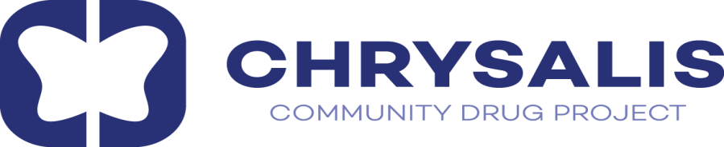

Chrysalis Community Drug Project CLG wishes to recruit for the following position:

Project Worker Full-Time Position
Hours: 35 hours per week

The successful candidate will be responsible for the delivery of Chrysalis services. They will ensure that the needs of our service users are efficiently and effectively met enabling them to move through the recovery process. The position will be based in Dublin City Centre.

This position is a permanent position - after completion of a minimum 6-month probation period, verification of references and Garda Vetting.

Key Duties

Duties will include but not exclusively:

- Assess service users’ needs, including assessing level of drug and/or alcohol use to enable development of appropriate support using the HSE Initial & Comprehensive Needs Assessment Tool
- Maintain an active caseload and all related record keeping (HRB/eCASS)
- Provide crisis intervention, keyworking, case management and group work
- Co-facilitate groups
- Maintain all relevant documentation
- Attend and participate in relevant case management/interagency meetings
- Attend training as required
- Engage in reflective and evidence based practice
- Attend monthly individual supervision
- Undertake other duties as and when requested.
- Work from a person-centred and harm reduction approach

Person Specification

Qualifications

- A minimum of a Level 7 qualification or Third Level qualification in the field of addiction, rehabilitation, social care and/or equivalent
- Training/qualification in addiction studies
- Evidence of continuous professional development

Experience

- Minimum of 3 years’ experience of working in an addiction service or similar service
- Substantial experience of interagency and multi-disciplinary work

Knowledge

- Substantial knowledge of the approaches and interventions available to support people with lived experience of addiction
- Good understanding of drug related issues impacting people with lived experience of addiction
- Knowledge of relevant community, voluntary and statutory services
- Knowledge of eCASS/HRB

Skills

- Clear and effective communication and interpersonal skills
- Competence in the use of IT systems
- Strong administrative and reporting skills
- Interagency skills
- Strong facilitation skills

Personal Attributes

- Committed to the ethos, mission and values of Chrysalis CDP
- Committed to the needs of excluded and marginalised people
- Positive and solution-focused approach
- Team player
- Strong boundaries
- High degree of personal resilience and self-care

Benefits Offered

- Salary Range - €36,091 - €38,978
- 25 days annual leave
- EAP accessibility
- Continuing Professional Development
- Paid Maternity & Paternity Leave
- Paid Sick Leave
- Paid Study Leave subject to terms
- Optional Unpaid Leave and Career Breaks subject to terms

All interested candidates should forward by email - with the subject matter titled “Project Worker”- a short cover letter and an up-to-date CV for the attention of the CEO to the following email address passerose@chrysalisproject.ie by closing day of Friday, 23rd of May, 2025. The interviews will take place on Friday, 6th of June, 2025.

This job advert/description is not an exhaustive list of duties and responsibilities. The Board of Management may review this position from time to time.

Chrysalis Community Drug Project CLG is an Equal Opportunities Employer. The organisation provides equal employment opportunities regardless of ethnic origin, gender, nationality, religion, physical ability, sexual orientation, marital status, parental status, or medical history,

