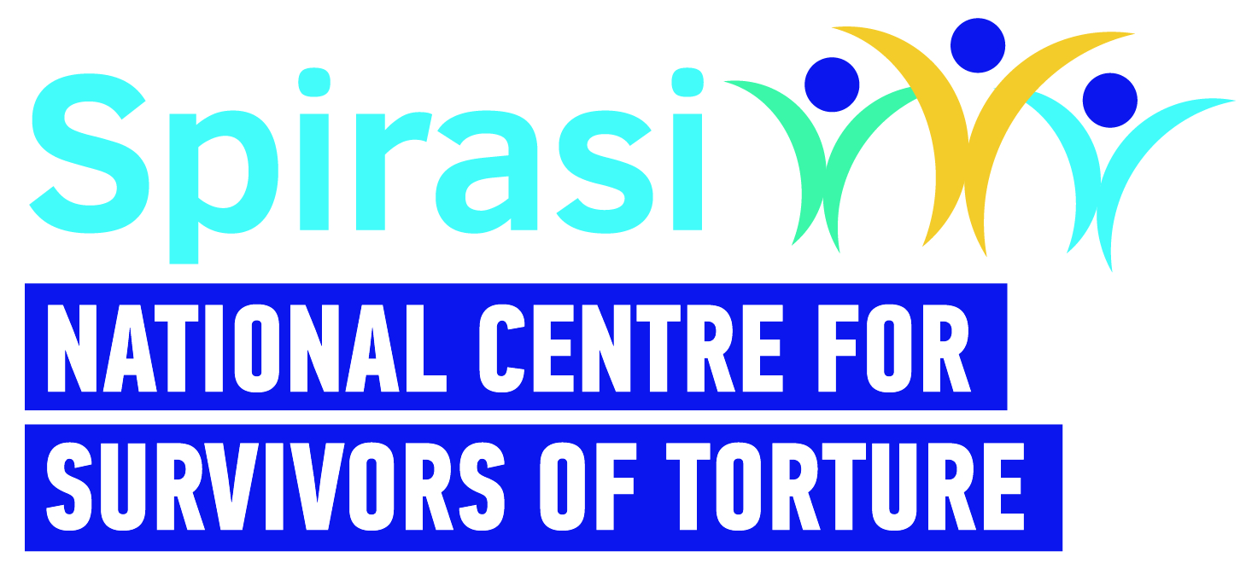

**PSYCHOTHERAPIST**

**Spirasi: A Place of Healing, Hope, and Impact**

At Spirasi, we are dedicated to healing survivors of torture and empowering them to rebuild their lives. Through our therapeutic, rehabilitative, and educational services — delivered from our national centre in Dublin — we provide holistic support which helps individuals restore a more integrated sense of self and become active contributors to a better Ireland.

**Our Impact**

Since our founding, Spirasi has made a tangible difference:

* **Over 7,100 survivors of torture** have accessed our rehabilitation services.
* **More than 2,800 English language students** have graduated, gaining confidence and skills to integrate and thrive.

Our work is driven by the belief that every person deserves dignity, healing, and a chance to rebuild. Our team of 40 staff shares this commitment, making Spirasi a truly meaningful place to work.  
  
**Why Work With Us?**

At Spirasi, you’ll join a passionate and skilled team dedicated to creating lasting change. You’ll contribute to a mission that transforms lives and helps shape a more inclusive, compassionate Ireland.

We now invite applications from suitably qualified and experienced psychotherapists and/or psychologists to provide therapeutic interventions to survivors of torture.

**Position summary:**

Spirasi therapists offer individual and group therapeutic supports to individuals over 18 years of age who are survivors of torture. All our clinicians share the same scope of practice to support the goals of our clients in a collaborative, respectful, evidence-based, trauma-informed and culturally appropriate manner while drawing on their own unique training,

This position is based in Dublin with some potential for remote work. The successful candidate will adopt a blended working approach, providing both individual and group interventions—both in person and online—to survivors of torture from diverse cultural backgrounds. When necessary, this work will involve collaboration with interpreters.

**A recruitment panel will be formed.**A recruitment panel is a list of candidates who have been successful at the selection or interview stages. Candidates are placed in order of merit. The highest-scoring candidate is first on the panel; the candidate with the second highest mark is second and so on. The Psychotherapist Panel will be in place for one year after which it will be reviewed based on the following criteria:

1. Is the panel exhausted i.e. is the panel empty? Have all vacancies been filled?;
2. Is there a material change(s) in the initial recruitment process?

**Candidates may request to be removed from a panel. This will need to be done in writing to the original recruitment contact in Spirasi.**

**Person Specification and Job description below:**

Please send a CV and a brief letter of motivation (no more than 1 page) – both of which should show how your skills and experience match the requirements of the post via email to **recruitment@spirasi.ie** with ‘Spirasi Therapist and *your name*’ in the subject of the email. Please make sure that both your CV and cover letter are saved under your name and include the position for which you are applying e.g. *First name Last Name Spirasi Therapist*

**Enquiries:** Spirasi recruitment - [recruitment@spirasi.ie](mailto:recruitment@spirasi.ie)

**Closing Date:** **Friday May 16 at 5pm**

**Interview Date:** TBC

**Remuneration:** €53,152 (pro-rata)

**Contract:** 12-18 months fixed-term

**Hours of work:** 28 hours per week

**Hybrid Model:** Work remotely and in the office (must be available for minimum 2 days per week on site in Dublin 7).

**Benefits:** EAP with HSF Assist

Cycle to work scheme

Enhanced Annual leave

Enhanced paid sick leave (after 13 weeks)

|  |  |
| --- | --- |
|  | **Therapist - Job Description** |
| **Title:** | Psychotherapist |
| **Work Schedule:** | 4 days a week - 28 hours: Monday - Thursday |
| **Contract Type:** | 12 -18 months Fixed, Term Part-Time |
| **Rate of Pay:** | €53,152 (pro-rata) |
| **Location:** | Spirasi, 213 North Circular Road, Phibsboro, Dublin 7 with hybrid working in accordance with Spirasi Hybrid working policy. |
| **Main Purpose of Role** | |
| Spirasi is seeking a psychotherapist to provide individual and group therapeutic interventions — both online and in person — for survivors of torture from diverse cultural backgrounds. The role also involves conducting client assessments, administering psychological scales, and preparing clinical reports. In addition, the psychotherapist will co-ordinate referrals within Spirasi to ensure clients receive any additional support they may need. | |
| **Main Responsibilities** | |
| **Client Work & Interventions**   * To undertake initial consultations/assessments with survivors of torture, focusing on both strengths and difficulties. * To carry out clinical assessments, including the use of psychological scales. * To conduct risk assessments and implement risk management plans as appropriate. * To provide evidence-informed therapeutic interventions, both individual and group, to adult survivors of torture. * To provide crisis intervention when necessary. * To have a minimum of four client contact hours per day, either as individual sessions, group sessions, or initial consultations.   **Documentation & Reporting**   * To document client progress in case files, maintaining accurate and confidential records using Spirasi’s CRM, and to comply with all reporting requirements. * To provide written reports/letters to other services as necessary.   **Collaboration & Meetings**   * To liaise and consult with other professionals in supporting clients attending Spirasi. * To participate in multidisciplinary team (MDT) supervision, group clinical supervision, and line management for support and guidance. * To participate in monthly case management meetings, team meetings, clinical team meetings, all-staff meetings, and other necessary meetings.   **Professional Standards & Compliance**   * To adhere to all agreed organisational policies, processes, procedures, and guidelines. * To comply with responsibilities under the Data Protection Acts 1988, 2003 & 2018 (GDPR). * To maintain professional and personal boundaries.   **Development & Training**   * To undertake regular external supervision. * To play an active role in the development of services and contribute to evaluation processes. * To take part in organisational events, training, and planning. * To participate in continuous professional development. | |
| **Person Specification – Knowledge, Skills and Experience Required** | |
| **Essential criteria: Essential Qualifications & Accreditation**   * Doctorate or equivalent in Clinical/Counselling Psychology. Candidates qualified overseas must provide evidence of validation by the Department of Health at the time of application. * Psychotherapist accredited by the Irish Council for Psychotherapy (ICP) or the Irish Association for Counselling and Psychotherapy (IACP) with a minimum of three years’ experience post-accreditation. * Fully insured. * Able to speak and write English to IELTS Level 8 (Expert User).   **Clinical Experience & Skills**   * Minimum of three years’ experience working with complex trauma. * Proficient in a trauma-focused approach. * Able to provide a range of therapeutic modalities. * Experience providing therapeutic interventions both individually and in groups. * Experience working remotely via phone and online platforms. * Experience writing reports and clinical letters. * Experience working effectively both independently and as part of a multidisciplinary team.   **Additional Skills & Attributes**   * Possesses experience and understanding of cross-cultural work in therapy. * Proficient in IT (client management systems, Word, Excel, PowerPoint, Email). * Excellent self-care practices.   **Desirable criteria:**   * Experience working with asylum seekers and refugees * Experience using Salesforce * Experience working with interpreters * Knowledge of the international protection system in Ireland * Ability to speak another language, e.g. Arabic, French. | |
| **Please note**   * This job description is not exhaustive; the post holder may be required to take on additional duties relevant to the role and contribute to its development. * Applicants with qualifications obtained outside the Republic of Ireland must provide evidence of validation by the Irish Department of Health at the time of application. * Garda clearance is a requirement for all Spirasi staff, both upon hiring and throughout employment. * Candidates must have the right to work in Ireland at the time of application and for the duration of employment. * Remote work requires a designated, single workspace in the home or an alternative office. * All personal data received will be processed in accordance with the Data Protection Acts 1988, 2003, and GDPR (2018) and used solely for recruitment and administrative purposes. * Spirasi is an equal opportunities employer. Recruitment decisions are based on merit, aligned with job and skill requirements. | |