Closing date for receipt of form 12/04/2025
 | 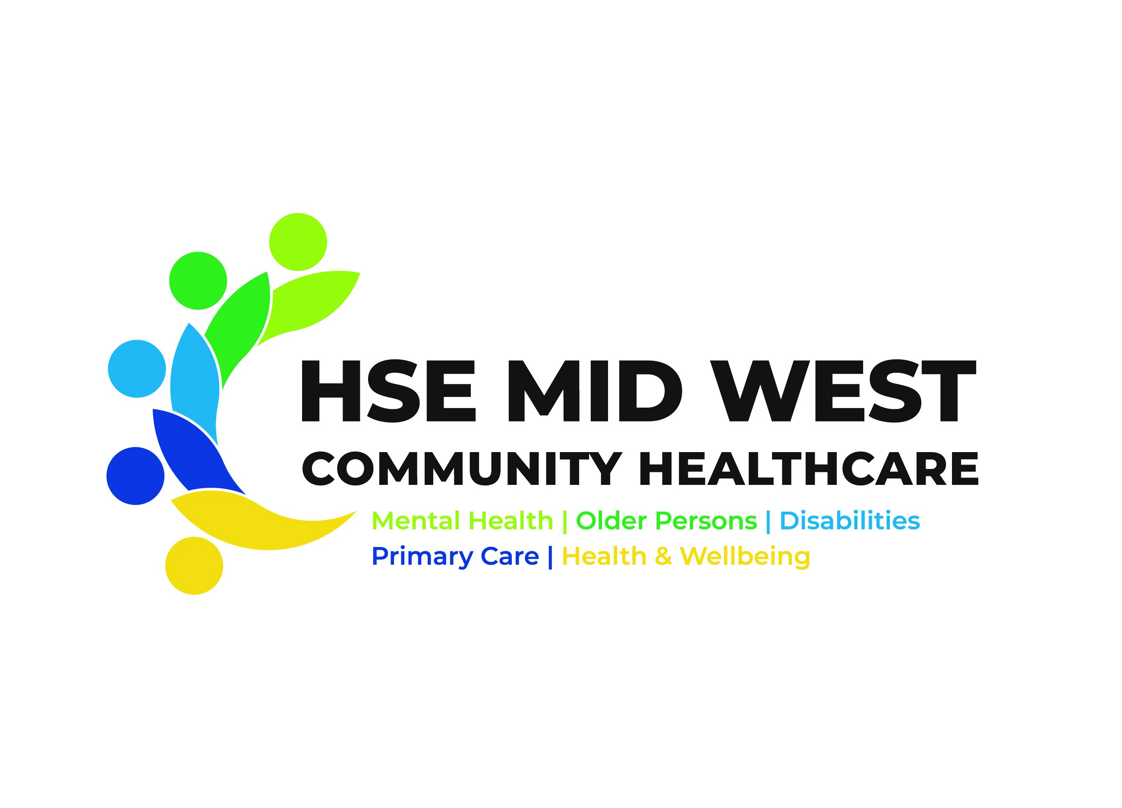 |  | 

Application Form
Foundation Programme in Sexual Health Promotion (FPSHP)

Name:

Job Title:

Organisation:

Work Address:

Email address (please print):

Contact telephone number (mobile number preferable):

Please detail the target group(s) with whom you intend to use the skills and information from this programme:

Please outline in less than 200 words what prompted you to apply for this course and how you will utilise the learning in your work setting. Please note that this will be used to shortlist prospective participants. Note that your application will not be processed unless this section is completed. (Please continue overleaf if required.)

Please continue (using a separate sheet if necessary):

Please give brief details of any previous sexual health promotion experience if any:

Are you a line manager: Yes No (If no, please ensure that your line manager completes the section below as approval for you to attend the programme for the 6 days.)

Manager’s Name:
Manager’s Email Address:
Manager’s Telephone Number:
Manager’s Signature:
Do you have any special access or dietary requirements? Yes No

Please detail:

Where did you see the Foundation Programme in Sexual Health Promotion advertised?

Please specify below : e.g. Twitter, Staff App, Active Link, email,

Signing this form is giving permission for you to be contacted in the future with regard to other related trainings or sexual health related updates and news. If you do not wish to be contacted please tick here

Please return completed form by 12/04/2025 to: | Daniel Butler, Health Promotion and Improvement Officer, Health Promotion & Improvement, HSE, Unit 2 Pearse House, Raheen Business Park, Raheen, Limerick, V94 1R71.  Or  Email: healthandwellbeing.training@hse.ie
(For office use only)
Date received:

