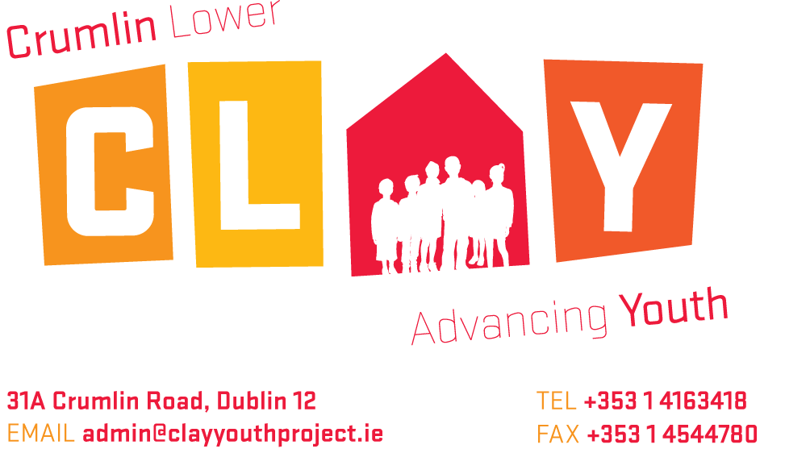

Employment Application Form

Answer all questions, incomplete application may be rejected. Please also submit a cover letter and CV (no more than 3 pages) with this completed form

Position Applied For:

Personal Details
First Name:
Surname:
Name you prefer to be known as (if different from your first name
Address
Phone Number
Email:

I hereby certify that all information provided on this application form is true and correct.

Signature:

Date:

NB: A CURRICULUM VITAE (3 PAGES MAX) AND COVER LETTER MUST BE SUBMITTED WITH THIS APPLICATION FORM BY
Friday 4th April 2025 @5pm
Return address: rosie@clayproject.ie

General Information

I already have the legal right to work in Ireland | Yes No
I will require a work permit | Yes No
If successful in the position, when would you be able to start?

Education Record

Second Level
School attended | From | To | Highest exam taken | Year

Education and Training
Please give details of course(s) undertaken, relevant education and other qualifications obtained (including any in house training, short course etc) that are relevant to this post.
From | To | Name & Address of Institution  / Provider | Details of Course | Duration of course & qualification received
Other relevant training

EMPLOYMENT RECORD
(add additional rows as required)

Name/address of Employer | From  mm/yy | To  Mm/yy | Position  (Indicate full/part time) | Reason for leaving

Please explain any gaps in employment history (e.g., travel, career breaks etc)

Relevant Experience

Describe your experience in the field of youth work or working with young people/families in a young people’s setting.

Present or most current job/ placement/ voluntary position

Position Held/ Job Title
Employers name/ Address
Start Date
Reason for leaving
Period of notice required

Please give a brief description of the duties and responsibilities you undertook in this position

- SUPPLEMENTARY INFORMATION.
This space may be used by the candidate to amplify information, or to give additional information relevant to the application for the position with the organisation.

OTHER INTERESTS:

References
Please give us details below of two professional referees.
The selection board will require a report on your work experience etc. Please name below two professional contacts who have first-hand knowledge of your work. The first should be your current or most recent employer

Reference 1 (current or most recent employer)

Name
Address
Position
Phone
Email
Relationship

Reference 2

Name
Address
Position
Phone
Email
Relationship

DATA PROTECTION

All personal information provided on this application form will be stored securely by CLAY Youth Project and will be used for the purposes of the recruitment process. Application forms will be retained for a period of 6 months, and in the case of a successful candidate, for the duration of employment and a minimum of one year thereafter. By submitting this application form, you consent to your information being submitted to and processed by CLAY Youth Project. Following completion of the selection process, all personal information will be retained only by CLAY Youth Project and this information will not be disclosed to any other external third party without your consent, except where necessary to comply with statutory requirements or seeking references.

As a matter of policy for all youth work employees at CLAY Youth Project undergo Garda Vetting prior to starting in their roles

