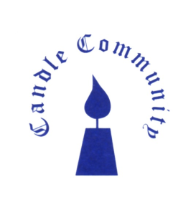

Candle Community Trust
Youth Worker
Candle Community Trust welcomes applications for the position of Youth Worker. This is an exciting role working in our dynamic, vibrant, inclusive and trauma informed youth service.
This youth work role involves the development and delivery of programmes and activities that aim to meet the needs of the young people aged 11-18 years of age. Candle Community Trust aims to work with young people from marginalised backgrounds who are at risk of social exclusion. It is important that the Youth Worker has the skill set and commitment to work with our target group and to support their personal/educational development. The service will be delivered in accordance with best practice and will provide a safe environment for young people.
If you are passionate about working with young people, this could be the role for you.
At Candle:
- Young people are at the heart of everything.
- Their voice and their needs have been central in shaping services.
- Every young person can reach their potential once they are provided with the right opportunities. Candle is that opportunity:
-an opportunity to learn, to be creative, to have fun and to grow
-a safe and nurturing place where everyone is welcome
-where everyone is equally cherished for the gifts, they bring to our community
-a space to find your inner resilience and build for the future
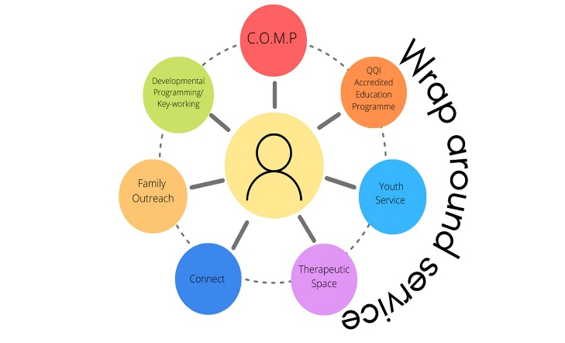
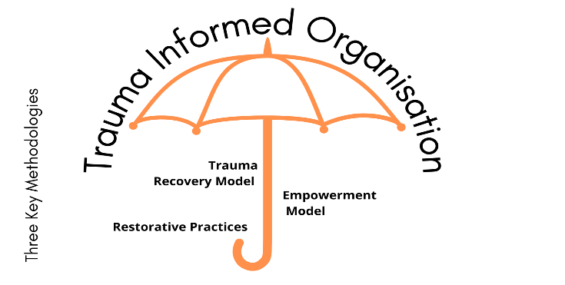
We offer a wide range of services including a full time Training Programme, Connect project, Youth Service, Therapeutic Space, Family Outreach, Developmental Programming, Key working, Outreach Mentoring Programme. Each young person can access the services offered in Candle as part of our wraparound approach.
About Candle Community Trust
Candle Community Trust provides educational, developmental, and therapeutic programmes for young people. We are committed to creating and delivering a comprehensive best practice service to meet the needs of young people and their families who experience disadvantage and marginalisation. Candle aims to provide a context for the physical, emotional, intellectual, social, and spiritual growth of the person.
Candle is a progressive organisation that has pioneered the integration of the Trauma Recovery Model, Restorative Practices, and an Empowerment Model in our approach to working with young people and their families. This approach aims to address any underlying trauma or issues presenting, and interventions are supported by Candle’s in-house therapeutic services.
Often described as an ‘oasis of calm’, the Candle educational, developmental, and therapeutic programmes are necessarily underpinned by the establishment of a safe, nurturing and relaxed environment.
Candle is respected for its work in the area of trauma, and all staff are trained in trauma informed practice and methodologies. Accessing support through a range of therapies including counselling, mindfulness practice, acupuncture, reflexology, and yoga is now as “normal” for participants as engaging in the educational curriculum. Caring for positive mental health is as much a priority for all at Candle as is nurturing physical, social, and educational wellbeing.
Over the past 5 years the Candle campus, in Ballyfermot, has undergone a significant redevelopment. This redevelopment led to a beautifully constructed award-winning building and therapeutic garden which support the vision of Candle services as a space for nurture, growth, healing, and transformation.
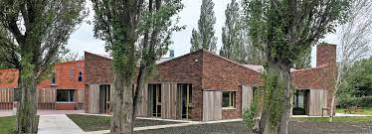
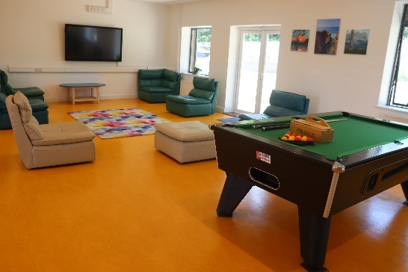

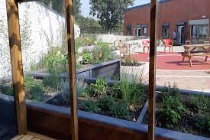

Role Description
Key Responsibilities
- To empower young people to achieve their full potential in life.
- To meet the needs of young people through youth work methodologies
- To engage with young people; build and maintain good boundary relationships within a professional setting.
- To plan, deliver and facilitate non-formal educational and personal development programmes.
- The Youth Worker will have shared responsibility for connecting young people and families into the service.
- To work with identified young people and their families experiencing significant trauma and complexity including health, social, emotional, and behavioural difficulties and/or at risk of social exclusion.
- Keep project records and provide updates and reports as requested, attend regular meetings.
- To always ensure that the values and ethos of Candle Community Trust are respected and maintained.
- To undertake other appropriate and relevant tasks as directed by the Director.
- This role involves evening work and at times may involve activities that require overnight and weekend work.

The ideal candidate will have the following:

- Experience and knowledge of youth work methodologies.
- Knowledge of child protection legislation and associated procedures; must have up to date child protection training and/or be willing to complete child protection training in line with Candle’s Child Protection Policy and Safeguarding Statement
- Ability to engage with young people and to build and maintain a good working relationship within a professional setting.
- An ability to effectively and sensitively manage difficult situations.
- Work creatively and imaginatively with young people in informal education and developmental context.
- Experience of planning, implementing, and reviewing programmes and programme participation.
- Excellent interpersonal skills and an ability to work effectively as a team member.
- Knowledge and understanding of UBU framework.
- Sound ethical boundaries.
- Ability to liaise effectively with appropriate agencies.
- Good report writing skills and ability to maintain records.
- A flexible and creative approach.
- I.T. experience and competence.

Desirable:
- An understanding of and commitment to promoting positive mental health and wellbeing
- Experience of inter-agency working

Website: www.candletrust.ie Instagram: @candled10
Applications in the form of cover letter and CV (3 pages max.)
By email to: info@candletrust.ie

The closing date for application is the Monday 13th May 2024 at 12 noon.
Interviews will be held on week commencing 20th May 2024.

Garda Vetting applies to this position.
A panel will be formed from which future positions may be filled.
Candle Community Trust is an Equal Opportunities Employer

