Manager CDYS Family Support Services
Cloyne Diocesan Youth Services
Youth and Community Services
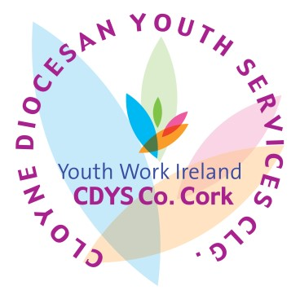
_____________________________________________________________________________________________________

JOB DESCRIPTION

Title of Post: | Manager for CDYS Family Support Services  (CCA , PPFS, Family Support Services, Independent CCA Workers,  Therapeutic Services across Cork City and County)
Location: | The post will be based in Mallow.
Reports to: | CEO / Line Manager
Main Purpose of the Role | The purpose of the role is to manage a team in their delivery of intensive one to one supports to individual young people and families to prevent young people being placed in residential care and/or to support them to re-enter the community and family environment. To lead on the relationship with Tusla services and provide all reporting, statistical and other reporting requirements.
Essential Qualifications / Experience: | - Minimum Level 8 Degree in youth work / social work or related  field.  - Will have at least 3 years’ experience in managing staff in a dedicated youth and/or community services/family support services.  - Demonstrable evidence of case management experience and working creatively in partnership with Tusla.  - Experience of managing a team working in a targeted manner with young people and families.  - Experience of working in a community setting with issues such as alcohol and drug misuse, behavioural challenges, low motivation and low engagement.

Job Summary
To manage, coordinate and develop the provision of one to one specialist interventions and supports to young people and family members with complex needs as referred from Tusla.

Principle Role and Responsibilities 1. To operate to CDYS Core Values:
- Young people and communities at the heart of everything we do.
- Concern for the young person’ personal, social, educational and spiritual development.
- Commitment to partnership with young people, volunteers, communities, families and funders.
- Upholding quality standards of integrity and professionalism.

- To participate fully and work effectively in supporting a dedicated CDYS staff team.
- To manage a staff team to deliver services, in line with service level agreements.
- Liaise and lead referral meetings with Social Workers and Meitheal Coordinators across Tusla.
- To provide support, motivation and guidance to support workers and family support workers offering individual young people at risk of entering into or exiting from the residential care system and families referred.
- Provide support to families whose young people are at risk of entering into/or exiting from the residential care system.
- To coordinate collaborative working relationship with relevant organisations and key persons to deliver care plans and specific supports to individual young people and families as agreed.
- To be flexible and proactive in engaging with social, educational and peer supports in the community for the wellbeing of young people and families.
- To provide leadership, line management and supervision of staff members to meet the objectives and requirements of the project.
- To keep adequate case notes and records while providing accurate reports in a timely manner.
- To work to and within all policy and procedural frameworks within CDYS.
- To ensure that all professional standards and practices are adhered to and implemented in daily work.
- To lead the development and continuous improvement of the role, project and initiative.
- To develop and contribute to cultural and team cohesion across a diverse range of CDYS youth and community services.
- Any other reasonable duties relevant to the post assigned by the Chief Executive.

Person Specification

Essential Criteria
- Minimum Level 8 Degree in youth work, social work or related field.
- Minimum 3 years’ experience in managing staff in a youth and/or community services/family support services, including service planning, evaluation, staff management and coordination.
- Demonstrable evidence of case management and working creatively in partnership with a range of organisations, including Tusla.
- Experience of working in a targeted and creative manner with complex young people and families.
- Experience of working in a community setting with issues such as alcohol and drug misuse, mental health and behavioural challenges, low motivation and low engagement.

Must be able to evidence skills in:
- A high degree of problem solving and motivation.
- Experience of line management and / or project coordination.
- Ability to use own initiative and work autonomously.
- Work from a strengths-based perspective to address needs through the delivery of intensive one to one support and case management with the young person and their family.
- Experience in managing multiple time demands and deadlines, exercising judgement on time management & level of attention to detail.
- Analytical skills with the capacity to absorb/organise new information to ensure well briefed on new topics.
- Comfortable giving and receiving direction and decision making within a clear framework of delegation.
- A high level of interpersonal and communication skills , both written and verbal, applicable to a range of audiences.
- Leadership, line management and staff coordination across large geographical areas.
- Must be enthusiastic, flexible and committed.
- Demonstrable experience in a similar role is essential.

Core Competencies
- Change Orientation: Ability to work flexibly in a changing environment.
- Continuous Development: Drive to achieve excellence and continuously develop oneself, one’s team, the organisation and the Young People on the Programme through learning and knowledge sharing.
- Valuing Diversity: Openness to working effectively with diverse ideas and people.
- Organisation Commitment: Meets the standards of behaviour and professionalism required to operate effectively in CDYS.
- Analytical Thinking & Decision Making: Think logically, analyse complex information, identify key issues and make effective decisions, taking accountability for decisions made.
- Communication & Interpersonal Skills: Conveying information clearly in both oral and written form, effectively communicating one’s views by negotiating and influencing others at all levels.
- Resilience: Demonstrating the confidence and ability necessary to cope with challenging situations.
- Task Management: Ability to prioritise and manage tasks effectively so as to deliver required outcomes to agreed standard.
- Team Work: Ability to work effectively & co-operatively as part of a team and demonstrating commitment towards team goals.
- Management: Ability to work in a fair and objective manner consistent with the values and ethos of CDYS.

Health
A candidate for and any person holding office must be fully competent and capable of undertaking the duties attached to the office and be in a state of health such as would indicate a reasonable prospect of ability to render regular and efficient service.
Character
Each candidate for and any person holding the office must be of good character.

Other
Car Owner with full clean driver’s license.
Requirements of all CDYS Staff:
- Commitment to the purpose of CDYS and to work within the values, policies and procedures of the organisation and in the context of current legislation and regulations.
- To report any area of concern to your line manager in a timely fashion.
- To show flexibility in relation to hours of attendance to meeting the need of the work.
- Have a flexible approach to the work in response to organisational change, development and review of best practice.
- Identify training needs through your supervision and participate in training opportunities appropriate to the role.
- To be vigilant to any Health, Safety and Welfare risks in the workplace and bring any concerns to your line manager or Health & Safety representative.
- To undertake other duties as may be requested by the line manager from time to time.
- To undertake your work in a manner that is friendly, flexible and professional.

Terms & Conditions of Employment
Tenure | Permanent
Working Hours | 39 hours per week
Remuneration | A competitive package is available for the suitable candidate
Other | Own car required and full clean driving licence

Application

Application for the position must be made by submitting the completed application form and a copy of your CV.

Closing date for applications is 12 noon on Wednesday 24th April by email to reception@cdys.ie

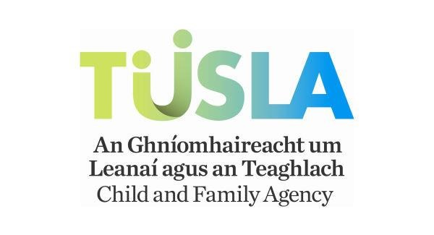

This project is funded by Tulsa

