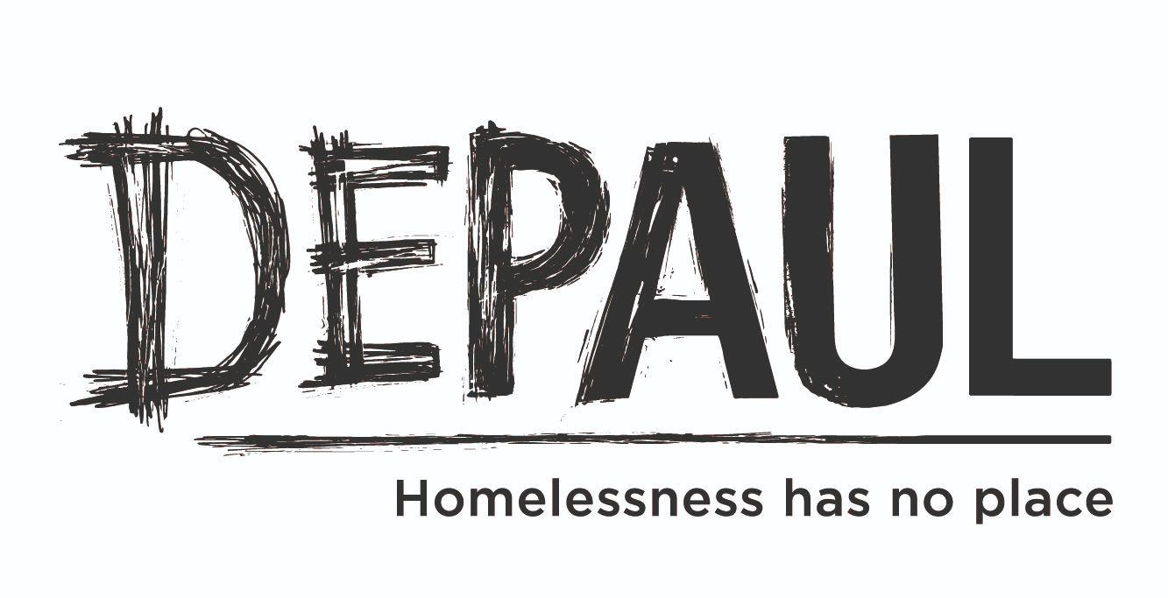
Depaul
Invitation to Tender – Homelessness & Mental Health Research
Depaul are seeking to appoint an independent external research partner to undertake a comprehensive evaluation of the current landscape as it relates to the mental health of people who experience homelessness, at both an organisational and national level including prevalence, service accessibility and gaps in service provision.
Background:
Homelessness in Ireland
In February 2024 there were 13,531 people in temporary accommodation, with a 21% increase in the number of homeless families (1,940) in 12 months and a 17% increase in the number of homeless children.
- 60,000+ on social housing waiting list
- Unprecedented numbers in temporary accommodation
- Hidden homelessness
- Cost of living crisis

Mental Health in Ireland
- It is reported that people in Ireland have the third highest level among EU citizens of experiencing emotional or psychosocial difficulties in the previous 12 months.
- People living in Ireland experience the highest level of difficulty in accessing mental health services among citizens of the 27 European Union member states, according to the findings of a major new EU-wide survey.
- Over 40% of adults living in Ireland have a mental health disorder
- 1 in 10 have attempted suicide – MU, NCI and Trinity College research
Mental Health in homelessness
- Myriad of complex and competing needs
- Factors include: childhood trauma, family breakdown, poverty, adverse life events, institutional care, limited social support, maladaptive coping mechanisms
- Common mental health difficulties: depression, anxiety disorders, suicidal thoughts and self harming behaviour, personality disorder and PTSD
About Depaul
Depaul is a leading charity operating across the Republic of Ireland and Northern Ireland supporting some of the most marginalised individuals, couples and families experiencing homelessness.

Depaul works across 5 main areas of service provision;
- Prevention
- Families & Young People
- High Support Accommodation
- Health & Rehabilitation
- Housing
Our focus is upon those experiencing homelessness and marginalisation, who need vital support and the opportunity to realise their true potential. We offer support and guidance to break the cycle of homelessness, and assist our service users in making positive choices for their future.

Objectives (Terms of Reference):
- To gain an understanding of the prevalence of mental health difficulties amongst people experiencing homelessness, at a local (organisational) and national level
- To evaluate the accessibility, effectiveness, and utilisation of mental health support services available to people experiencing homelessness.
- To assess gaps in and barriers to accessing services
- To develop evidence-based recommendations for policymakers and other stakeholders to enhance mental health promotion, prevention and support services for the target population

Timeframe: 4 Months from the formal acceptance of the contract offer.
Allocated Budget: Up to and not exceeding the value of €16k.
Expression of Interest requirements:
Your completed application should include the following:
- Organisation details and contacts.
- A summarised overview of the intended approach
- Current Tax Clearance information.
- Cost of service and an outline of any added value or additional information you deem is relevant.
- Contact information for two references who can attest to the evaluators relevant experience and expertise.
Successful organisations should have the following:
- An interest and passion for delivering services for disadvantaged communities, in particular in the area of homelessness and mental health;
- Experience using a range of research methods, including evaluation research methods, qualitative and quantitative research methods;
- Knowledge and experience of working with multi-agency groups and stakeholders;
- Experience in the maintenance of detailed, accurate and fully evidenced records;
- Experience in producing high quality research reports;
- Exceptional attention to detail and ability to adhere to strict reporting and budgetary requirements;
- Clear understanding of requirements in regards to GDPR.
*It should be noted that a final report will be expected within the time frame and must be signed off by the steering group. The report will be the prosperity of Depaul for their use.

Assessment of Tender
Queries and Submissions to: noirin.byrne@depaulcharity.net
Last Queries / Questions accepted: 23rd April 2024
Closing Date for Tender will be: 14th May 2024
Criteria for selection
Methodology = 45%, Overall Cost = 25%, Experience = 20%, Quality = 10%

