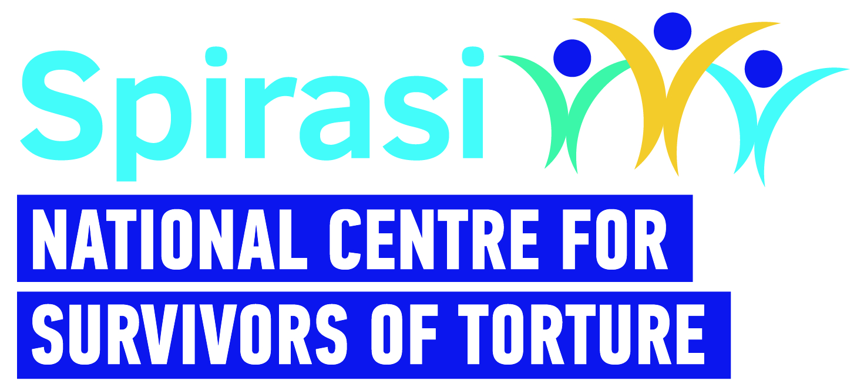

Spirasi – 35 Hours a week/ Full Time- CEO Required
Spirasi is an NGO that provides holistic rehabilitation services for survivors of torture in Ireland. We are looking to recruit a CEO to provide visionary leadership and strategic direction to Spirasi, ensuring the effective delivery of services and advancement of our mission.
The Chief Executive Officer (CEO) will be an experienced leader with a strong management skillset, a strategic mindset and experience working in a multifaceted role alongside boards or committees.
Person Specification and Job description below.
Please send a CV and a brief letter of motivation (Word or PDF format) – both of which should show how your skills and experience match the requirements of the post via email to recruitment@spirasi.ie with ‘CEO and your name’ in the subject of the email.

Inquiries: Magda Carrara, phone: 083 143-2331, Email recruitment@spirasi.ie
Closing Date: 5pm on Sunday April 28th 2024
Interview Date: First round: week commencing May 13th,
Second round: week commencing May 27th
Start Date: Immediate (subject to pre-employment checks & Garda Vetting)
Remuneration: €75,000 with a 3% pension contribution
Contract: Full time, permanent

Website: www.spirasi.ie

To request a Candidate Information Pack please email recruitment@spirasi.ie.

CEO - Job Description
Title: |  | Chief Executive Officer (CEO)
Reports to: |  | - Reporting to the Chairperson of the Board of Spirasi
Level of Authority and Relationship to other roles: |  | - Line Manage the SMT
Work Schedule: |  | 35 hours a week (Mon-Fri, 9-5)
Contract Type: |  | Permanent contract, subject to a 6-month probation period
Rate of Pay: |  | Competitive, commensurate with experience
Location: |  | 213 North Circular Road, Dublin 7 (after probation, we operate a hybrid working policy)*
Main Purpose of Role
Under the direction of the Board of Spirasi and reporting to the Chairperson, the CEO is responsible for the leadership and development of Spirasi and for ensuring that day-to-day operational management is carried out in a professional, effective and efficient manner. The CEO is responsible for management of all staff, directly and indirectly, and also responsible for the general direction and ongoing management of the work of the organisation.
The CEO will oversee all aspects of organisational management, including strategic planning, operations, fundraising, advocacy, and stakeholder engagement. The CEO will have a strong understanding of research, public policy, strategic communications and fundraising. They will be comfortable managing a broad range of stakeholders and will have a passion for Spirasi’s mission to lead in rehabilitating Asylum Seekers and Refugees who are survivors of torture through models of care, training programmes and alliances. Outreach and advocacy on behalf of the mission is essential and the CEO is expected to create a robust programme of issues on which Spirasi will advocate.

Duties and Responsibilities (Include, but not limited to)

Leadership and Management |  | - Lead implementation of the strategic plan and annual business plans as approved by the Board.  - Lead the implementation of strategic initiatives to enhance the impact and reach of our services, ensuring alignment with the needs of our beneficiaries and the broader community.  - Responsible for leading a strong management team, for ensuring the oversight of Spirasi staff and supporting their performance in the workplace.  - Provide effective leadership and management oversight to all departments and programmes within the organisation.  - Ensure that the organisational structures and systems are fit for purpose to deliver on Spirasi’s strategic plan.  - Ensure the efficient and accountable use of resources, including budgeting, financial management, and risk mitigation, ensuring that systems, procedures and practices are in place for evaluating the effectiveness of operations.  - Foster a culture of innovation, collaboration, and continuous improvement throughout the organisation.  - Lead the Spirasi team in a visionary, ethical and legal manner, fostering a performance-oriented culture, a strong work ethic and a motivated team.  - Monitor sector trends, policy developments, and best practices to inform strategic decision-making and programme development.  - Identify development opportunities and establish appropriate partnerships to achieve growth.
Fundraising and Resource Development |  | - Oversee the development and implementation of a comprehensive fundraising strategy to diversify revenue streams and ensure the financial sustainability of the organisation.  - Cultivate relationships with donors, funding agencies, corporate partners, and other stakeholders to secure funding and support for our programmes and initiatives.  - Oversee grant writing, donor stewardship, and fundraising events to meet annual fundraising targets.
Advocacy and External Relations |  | - Build strategic partnerships with government agencies, NGOs, international organisations, and other stakeholders to advance our advocacy goals and influence policy change.  - Represent the organisation at conferences, forums, and media engagements to promote our mission and amplify the voices of torture survivors.  - Serve as the principal spokesperson and advocate to raise awareness of torture survivors' rights and needs
Communication |  | - Represent Spirasi in public and the media in accordance with brand values.  - Agree performance expectations with all direct reports and provide feedback (at least quarterly) on performance against expectations.  - Maintain an openness to feedback on one’s own performanceand a commitment to implementing agreed performance/behavioural changes.  - Ensure the Board has timely and accurate information on the organisation’s performance against annual business plan, financial performance, risk identification and mitigating strategies.
Relationship Management |  | - Build and maintain positive relationships with a wide-range of stakeholders in areas key to Spirasi’s work, both nationally and internationally.  - Follow the highest ethical standards when dealing with the Board, colleagues and clients.
Governance |  | - To ensure compliance by Spirasi with statutory requirements across all relevant areas including health and safety, employment law, charities regulation and company legislation.  - Approve company operational procedures, policies and standards.  - Support the Chairperson in fulfilling their role and keep them informed of all material matters on an ongoing basis.  - Accompany Chairperson/Board members on key external stakeholder meetings as appropriate.  - Support all Board members in fulfilling their roles.  - Ensure fiduciary and governance protocols are addressed and keep the Board appraised of regulatory changes and governance best practice.  - Report to the Board at each meeting on the business of the organisation, including periodic reports on performance against the annual business plan and bringing to the attention of the Board material matters that impact on the organisation.  - Undertake any other duties that are assigned to you by the Board and for which you have been provided with reasonable knowledge and training in respect of such tasks.
Person Specification- Qualifications and Experience:
- Proven experience (minimum 7 years) in senior leadership roles, preferably in organisations serving vulnerable populations or human rights. Experience within the non-profit sector is desirable.
- Strong strategic planning and organisational development skills, with the ability to translate vision into action and drive results.
- Demonstrated experience in fundraising, grant writing, and donor relations, with a track record of securing significant funding from diverse sources.
- Excellent communication and interpersonal skills, with the ability to engage and inspire a wide range of stakeholders, including staff, donors, volunteers, and clients.
- Knowledge of torture rehabilitation, trauma-informed care, and human rights principles is highly desirable.
- Knowledge of the International Protection System
- Master's degree in non-profit management, public administration, social work, international relations, or a related field is preferred.
- Familiarity with the compliance and regulatory landscape governing the charity sector in Ireland.
- Excellent sense of self care.
- Proficient in IT (using client management systems, Word, Excel, PowerPoint, Email).
- Able to speak and write English to IELTS Level 8 (Expert User).

Health & Safety
- Adhere to safety, health and welfare at policies and procedures and all relevant legislation.

These duties are a guide to the general range of responsibilities and are neither definitive nor restrictive. The post-holder may from time-to-time be required to undertake other duties
commensurate with the post.

Benefits: | - 35 Hour per week (full time)  - Company Sick Pay  - Access to Employee Assistance Programme (EAP) with HSF  - Bike to Work Scheme  - Enhanced Annual leave, 30 days per annum (plus closure for Easter and Christmas week)

Spirasi is an equal opportunities employer. Recruitment and selection decisions are made on merit - in line with the job and skills requirements set for the vacancy.

No late applications will be accepted, and canvassing will lead to disqualification. Any offer will be subject to satisfactory references, Garda Vetting and verification of qualifications.

*For a remote work arrangement to operate effectively, a single, specific workspace must be available and designated in the home or other office.

Spirasi is committed to offering support and making reasonable adjustments to allow full participation in the recruitment process. It is important that you let the Recruitment team know of any requirements you have. We will consider any reasonable adjustments needed.

