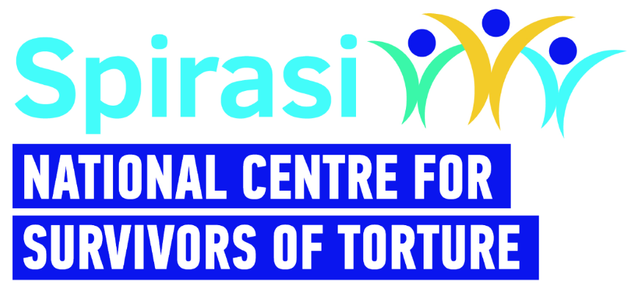

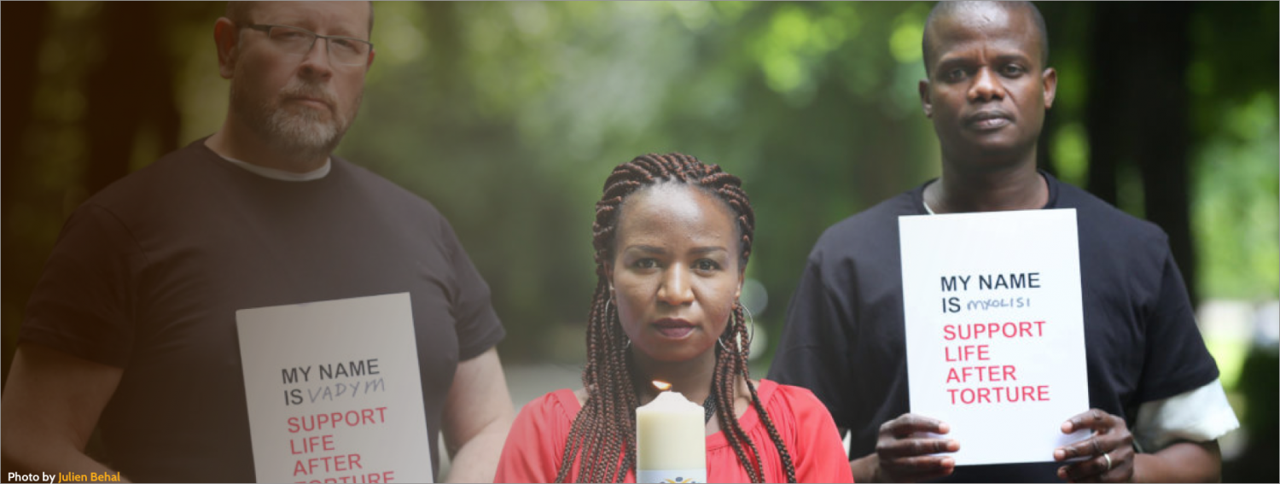
Candidate Information Pack

Chief Executive Officer

About Spirasi
Founded by the Spiritans in response to the rapidly evolving migration and asylum situation in Ireland, Spirasi (Spiritan Asylum Services Initiative) has been active in Ireland since 1999, the same year in which Ireland signed the United Nations Convention Against Torture (UNCAT) which, in 2000, was ratified through the Criminal Justice (United Nations Convention Against Torture) Act. Article 14 of UNCAT affirms that each state must provide for “as full a rehabilitation as possible” for victims of torture within their jurisdiction. This applies to all persons, regardless of residency status. Spirasi is the primary organisation in Ireland implementing the obligations of the Irish State under Article 14.

Torture is used to instil fear and to control. It has been proved to be highly effective in controlling behaviour through fear. According to Amnesty International, 141 countries throughout the world continue to use torture.

The personal implications of torture are always devastating. Those who have been tortured are physically, psychologically, socially and spiritually broken, the extend of which depends on several factors including the severity and duration of torture, and the individual’s resilience. The whole person is affected and the whole person needs to be healed.

Spirasi began its life as a place of welcome for vulnerable asylum seekers and refugees at 213 North Circular Road, in addition to the provision of basic English classes. Over time, it became clear that the extent of the issues facing people who are dealing with and recovering from severe trauma required a shift in focus, and Spirasi’s services expanded to include more specialist services to survivors of torture, cruel, inhumane or degrading treatment.

Along with English teachers, Spirasi employs physicians, psychotherapists and psychosocial workers to provide Initial Assessments, ongoing psychotherapeutic and psychosocial supports, and Medico Legal Reports for the International Protection Process. Currently, Spirasi employs approx. 20 FTE staff.

Spirasi’s work is dedicated to healing survivors of torture and towards helping them to rebuild their lives. Since the organisation was established, Spirasi has focused on the provision of rehabilitation supports for survivors of torture in Ireland. From our national centre in Dublin, remotely, and regionally we provide rehabilitative, therapeutic, and educational services.
Impact
To date, Spirasi has offered rehabilitation services to over 6,800 survivors of torture and has seen over 2,500 English language students graduate. The holistic rehabilitation envisaged and practised by Spirasi helps to restore torture survivors and recover a positive sense of self, and ultimately to contribute to a better Ireland.

What Spirasi does

Spirasi’s Vision is to support Survivors of Torture to rebuild their lives in Ireland.

Our Mission is to lead in rehabilitating Asylum Seekers and Refugees who are survivors of torture through our models of care, training programmes and alliances.

Psychosocial Support: The Psychosocial team provides a range of supports to enable and empower Spirasi clients to access external supports and realise their rights and entitlements. This most often involves assistance in accessing legal advice, resolving issues with accommodation, help in accessing local supports such as access to welfare benefits, health care and other suitable social and support services, and dealing with public services.

Therapy Services: Spirasi offers a number of therapeutic services for individuals and families as part of our rehabilitation programme. Clients who attend Spirasi’s services often suffer from the effects of interpersonal trauma. Spirasi’s specialised therapy service follows a holistic, phase-model approach to treatment where the focus is always on safety, empowerment and choice.

Initial Assessment: The Initial Assessment (IA) forms a key part of the rehabilitation process, and is holistic and multidisciplinary. The main purpose of the IA is to ascertain the current medical, therapeutic and psychosocial needs of the client. The ensuing Care Plan outlines the first steps to mobilise support services, internally in Spirasi and/or externally with other statutory and non-statutory bodies, to respond to those needs.

Medico Legal Reports: A medico legal report (MLR) is an important legal document which is used to support a torture survivor’s asylum claim. It is requested by the torture survivor’s legal representative. Our doctors provide expert opinion on the probable relationship between the physical and psychological findings to torture/ill treatment. The MLR uses international legal standards set out in the Istanbul Protocol. Following the evaluation the doctor completes the MLR which is then sent for independent legal review and medical review. MLRs are released within 4-6 weeks following assessment.

Education: Spirasi offers four levels of English to Speakers of Other Languages (ESOL). These QQI accredited courses form part of the integration and rehabilitation programme. Classes are offered free of charge and are funded by the City of Dublin Education and Training Board (CDETB).

Befriending: Befriending is a service offering one-to-one companionship by trained volunteer befrienders to Spirasi service users. The aim of the service is to reduce isolation and loneliness and to provide support with integration in Irish society.
Note: Spirasi is currently experiencing increased demand for all its services due to the increased numbers of refugees and asylum seekers including Ukrainians fleeing from war.

The Role
Spirasi is seeking an experienced leader with a strong management skillset, a strategic mindset and experience working in a multifaceted role alongside boards or committees. The Chief Executive Officer (CEO) will provide visionary leadership and strategic direction to Spirasi, ensuring the effective delivery of services and the advancement of our mission.

Under the direction of the Board of Spirasi and reporting to the Chairperson, the CEO is responsible for the leadership and development of Spirasi and for ensuring that day-to-day operational management is carried out in a professional, effective and efficient manner. The CEO is responsible for management of all staff, directly and indirectly, and also responsible for the general direction and ongoing management of the work of the organisation.
The CEO will oversee all aspects of organisational management, including strategic planning, operations, fundraising, advocacy, and stakeholder engagement. The incoming CEO will have a strong understanding of research, public policy, strategic communications and fundraising. They will be comfortable managing a broad range of stakeholders and will have a passion for Spirasi’s mission to lead in rehabilitating Asylum Seekers and Refugees who are survivors of torture through models of care, training programmes and alliances. Outreach and advocacy on behalf of the mission is essential and the CEO will be expected to create a robust programme of issues on which Spirasi will advocate.

The CEO will report to the Chairperson of the Board of Directors [Trustees] and will provide
regular detailed and timely information to the Board. The CEO will be responsible for a number of Direct Reports which may change depending on organisational reviews.
Key responsibilities:

Leadership and Management
- Lead implementation of the strategic plan and annual business plans as approved by
the Board.
- Lead the implementation of strategic initiatives to enhance the impact and reach of our services, ensuring alignment with the needs of our beneficiaries and the broader community.
- Provide effective leadership and management oversight to all departments and programmes within the organisation.
- Ensure that the organisational structures and systems are fit for purpose to deliver on Spirasi’s strategic plan.
- Ensure the efficient and accountable use of resources, including budgeting, financial management, and risk mitigation, ensuring that systems, procedures and practices are in place for evaluating the effectiveness of operations.
- Foster a culture of innovation, collaboration, and continuous improvement throughout the organisation.
- Lead the Spirasi team in a visionary, ethical and legal manner, fostering a performance-oriented culture, a strong work ethic and a motivated team.
- Monitor sector trends, policy developments, and best practices to inform strategic decision-making and programme development.
- Identify development opportunities and establish appropriate partnerships to achieve growth.

Fundraising and Resource Development
  - Oversee the development and implementation of a comprehensive fundraising strategy to diversify revenue streams and ensure the financial sustainability of the organisation.
  - Cultivate relationships with donors, funding agencies, corporate partners, and other stakeholders to secure funding and support for our programmes and initiatives.
  - Oversee grant writing, donor stewardship, and fundraising events to meet annual fundraising targets.

Advocacy and External Relations
- Build strategic partnerships with government agencies, NGOs, international organisations, and other stakeholders to advance our advocacy goals and influence policy change.
- Represent the organisation at conferences, forums, and media engagements to promote our mission and amplify the voices of torture survivors.
- Serve as the principal spokesperson and advocate to raise awareness of torture survivors' rights and needs.

Communication
- Represent Spirasi in public and the media in accordance with brand values.
- Agree performance expectations with all direct reports and provide feedback (at least quarterly) on performance against expectations.
- Maintain an openness to feedback on one’s own performance and a commitment to
implementing agreed performance/behavioural changes.
- Ensure the Board has timely and accurate information on the organisation’s performance against annual business plan, financial performance, risk identification and mitigating strategies.
Relationship Management
- Build and maintain positive relationships with a wide-range of stakeholders in areas key
to Spirasi’s work, both nationally and internationally.
- Follow the highest ethical standards when dealing with the Board, colleagues and
clients.

Governance
- To ensure compliance by Spirasi with statutory requirements across all relevant areas including health and safety, employment law, charities regulation and company legislation.
- Approve company operational procedures, policies and standards.
- Support the Chairperson in fulfilling their role and keep them informed of all material matters on an ongoing basis.
- Accompany Chairperson/Board members on key external stakeholder meetings as
appropriate.
- Support all Board members in fulfilling their roles.
- Ensure fiduciary and governance protocols are addressed and keep the Board appraised
of regulatory changes and governance best practice.
- Report to the Board at each meeting on the business of the organisation, including
periodic reports on performance against the annual business plan and bringing to the
attention of the Board material matters that impact on the organisation.
- Undertake any other duties that are assigned to you by the Board and for which you have
been provided with reasonable knowledge and training in respect of such tasks.

Qualifications and Experience:
- Proven experience (minimum 7 years) in senior leadership roles, preferably in organisations serving vulnerable populations or human rights. Experience within the non-profit sector is desirable.
- Strong strategic planning and organisational development skills, with the ability to translate vision into action and drive results.
- Demonstrated experience in fundraising, grant writing, and donor relations, with a track record of securing significant funding from diverse sources.
- Excellent communication and interpersonal skills, with the ability to engage and inspire a wide range of stakeholders, including staff, donors, volunteers, and clients.
- Knowledge of torture rehabilitation, trauma-informed care, and human rights principles is highly desirable.
- Knowledge of the International Protection System
- Master's degree in non-profit management, public administration, social work, international relations, or a related field is preferred.
- Familiarity with the compliance and regulatory landscape governing the charity sector in Ireland.
Additional information about this role:
- This is a full-time, permanent role with subject to the satisfactory completion of a 6-month probation period [with the option to extend by a further six months].
- A competitive salary will be offered commensurate with experience.
- The position is full time and the successful candidate may not engage in private practice or be
connected with any outside business which conflicts in any way with their official duties, impairs performance or compromises their integrity.
- Access to a car and a full driving licence would be beneficial but are not essential.

Location:
The place of work for the position of the Chief Executive Officer will be at the offices of Spirasi at 213 North Circular Road, Dublin 7. At present, Spirasi operates a Hybrid working model which requires the CEO to spend three days per week in the office, with two days working from home. At the outset, it is expected that the CEO will spend five days/week in the office until at least the probation period has passed.

Working Week:
Spirasi generally operates a 35-hour work week with office hours on Monday-Friday from 9:00 am to
5:00 pm, with one hour for lunch to be taken between 12-3 pm. On occasion, staff will be expected
to work outside of these hours to fulfil their roles and responsibilities. Any time worked outside of
the standard operating hours will be credited to be taken as time off in lieu (TOIL).
Annual Leave:
The CEO is entitled to 30 days annual leave. All employees (full-time and part-time) earn annual leave entitlements from the time work is commenced.

Sick Leave:
Sick leave will be paid based on an employee’s length of service with Spirasi as outlined in our Sick Leave Policy.

Other Conditions of Employment:
Further information on the conditions of employment will be outlined in the contract of employment
for the successful candidate.
How to Apply
To apply for the position of Chief Executive Officer at Spirasi, please email your CV and a tailored cover letter (both in Word format) with the subject line of your application as Spirasi – CEO, outlining your suitability for the role, to recruitment@spirasi.ie by 5pm on Sunday April 28 2024. Incomplete applications, postal applications or applications received after the closing date and time will not be considered.

Additional Information about the Recruitment Process:
• Applicants must be authorised to work lawfully within the EU. Spirasi will not sponsor applicants for work visas.
• Any offer of employment will be dependent on satisfactory reference checks and Garda vetting.
It is our policy to ensure that as much accommodation as possible is carried out to facilitate the participation of individuals with special needs in the recruitment process and in the workplace. If you require any specific accommodations, please let us know.
Spirasi is committed to diversity, equity, and inclusion in all aspects of employment. We encourage applications from candidates of all backgrounds, particularly those with lived experience of torture or trauma.
Spirasi is an equal opportunities employer and is committed to creating a workplace which provides for equality of opportunity for existing and potential employees and where the dignity of all is protected and respected at all times.
Data Protection:
In line with the General Data Protection Regulation (GDPR) 2018, all personal information provided on
this application form will be stored securely by the HR Department at Spirasi and will be used for the purposes of the recruitment process.

Application forms will be retained for a period of one year from the scheduled interview date, and
in the case of a successful candidate, for the duration of employment and a minimum of one year
thereafter. By submitting this application form, you consent to your information being submitted
and processed for shortlisting. The information will also be made available to the interview panel.

Following completion of the recruitment selection process, all personal information will be retained
only by Spirasi and this information will not be disclosed to any other external third party
without your consent, except where necessary to comply with statutory requirements or seeking
references. You may, at any time, make a request for access to the information held about you as
outlined. Should you wish to make any changes, or erasures to any of the information stored about
you within the one-year retention period, please contact the HR Manager at Spirasi, 213 North Circular Road, Dublin 7.

Selection Process:
Candidates will be shortlisted based on information contained within their application. Shortlisted
candidates will be contacted by Spirasi’s HR Generalist in relation to attending an interview. During
any shortlisting exercise, a board will examine the applications and assess them against predetermined criteria based on the requirements of the position. It is therefore in your own interest to provide a detailed and accurate account of your qualifications and experience within the application.
Interviews will be conducted in a face-to-face setting.

Round one interviews will explore the candidate’s skills, knowledge and experience based on the
competencies set out in this information booklet.

Candidates successful in round one interviews will move forward to a second round interview, which
will explore their skills, knowledge and experience in more detail on specific areas of the role
requirements.

The onus is on all applicants to make themselves available on the specified date(s) and make whatever arrangements are necessary to ensure they receive communications sent to them at the contact details provided in their application. Spirasi is not responsible for any expenses incurred by candidates.

Anticipated Interview Dates:
1st round interviews will take place week commencing May 13 2024.
2nd round interviews will take place week commencing May 27 2024.
If invited for an interview, the onus is on each applicant to make themselves available on the
date(s) specified. If you do not attend on the specified date/time you will be deemed withdrawn
from the competition.

Important Notice
The above represents the principal conditions of service and is not intended to be the
comprehensive list of all terms and conditions of employment which will be set out in the
employment contract to be agreed with the successful candidate(s).

Appendix 1: (CEO Key Competency Areas)
Competency Area Description
Leadership Competencies
• Strategic Thinking and Leadership
• Contextual Awareness
• Creativity and Innovation
• Initiating and Driving Change

Execute the Board's decisions and strategic objectives in a way that aligns with Spirasi’s mission and vision statements. Converts this vision into goals that are relevant and offers a structure and framework for moving forward. This field demands the ability to strike a balance between change and continuity, continuously working toward improving the delivery of services and programmes, fostering a creative work environment, and sustaining focus, intensity, and persistence in the face of ever-more complex and demanding circumstances. A strong, perceptive, and sympathetic leader is required.

Critical Analysis and Decision-Making Competencies
• Information Management and Analysis
• Judgement and Decision Making

Possesses the ability to rapidly assimilate information, discriminate between relevant and irrelevant information, and to see through to the core’s issues. It includes the capacity to acquire and to manage complex information and to base decisions on effective analysis of the data.
Central to this area is the ability to challenge information, evaluate the consequences of different approaches and use sound judgement in coming to conclusions. It also involves a willingness to take risks when appropriate to further the agenda and crucially, a willingness to make timely decisions.

Managing and Delivering Results Competencies
• Managing Performance through People
• Resource Allocation & Management
• Client Focus
• Personal Responsibility

Translates overall strategy into meaningful objectives that show a clear knowledge of what is needed in order to ensure that goals are met. Shows a thorough knowledge and awareness of the management process. Develops capability and rolls out strategies to maximise employee potential/ performance by co-ordinating resources and managing activities to achieve high standards in the delivery of objectives. Evaluates performance and outcomes and is prepared to accept personal accountability for starting projects and seeing them through to completion.

Building Relationships and Communication Competencies

• Managing relationships in a complex environment
• Influencing/Negotiating
• Networking
• Interpersonal and Communication Skills
• Advocacy

This area involves the ability to explain, advocate and express facts and ideas in a convincing manner and negotiate with individuals and groups internally and externally. It also involves the ability to
develop an expansive professional network to remain up-to-date with and influence the internal and external environment and its impact on the work of the organisation. Work co-operatively with and influence senior management colleagues to drive forward organisational objectives. Key to this is working effectively with a diverse range of internal and external stakeholders.

Personal Effectiveness Competencies

• Trustworthiness and Integrity
• Resilience
• Self-awareness and Career Development
• Empathetic
• Emotionally Intelligent

The ability to deal with challenging and sometimes difficult situations in a constructive fashion, maintaining composure when dealing with crises and keeping a sense of perspective and balance in situations that involve significant personal or work challenges. Possess a strong sense of personal self-belief and integrity and a willingness to be an independent voice and advocate. Willingness to identify opportunities for further growth and development.

