Affiliate Counsellor/Psychotherapist Application & Information Pack

Updated 15.03.2024

Unit 1, Druids Court, Kilcoole Industrial Estate, Kilcoole, Co. Wicklow
Affiliate Counsellor Intake

Name:_________________________ Address:___________________________________
Contact Phone Number:__________________ Email:________________________
Orientation of Core Training(s):___________________________________________________________________________________________________________________________________________________________
Date Graduated:________________ Name(s) of Training Provider(s):____________________
______________________________________________________________________________
Name & Address of Supervisor:___________________________________________________________________________________________________________________________________________________________
Accreditation Status: Preaccredited □ Accredited □ Are you a supervisor? Yes □ No □
Member Organisation:_________________________ Membership No.______________________
Public Liability Insurance Cover: Company Name_______________ Expiry Date:_____________
Have you received recent Garda Clearance: Yes □ No□ (If so please provide a copy)
Please confirm below the categories of clients that you work with:
Adults 1-1 □ Child and Adolescent □ Play Therapy □
Couples □ Family Therapy □ Consultancy (within organisation) □

Are there any particular presenting issues that you prefer not to work with? Please state
____________________________________________________________________________________________________________________________________________________________________
Hours of Availability- Please fill in the times you are available to take clients below:
Monday________________ Tuesday_________________ Wednesday___________________
Thursday_______________ Friday__________________ Saturday_____________________
Sunday________________ Do you work bank holidays? Yes □ No □

Role of Affiliate Counsellor within RISE Counselling and Psychotherapy
This is not a an offer of direct employment. Becoming an affiliate counsellor with RISE Counselling and Psychotherapy means that when referrals are received at the centre that match your field of expertise (e.g. child and adolescent, couples counselling or individual counselling) you may be referred these clients for assessment and on-going contact and engagement. It should be noted that affiliate counsellors of RISE are not considered to be directly employed by the practice. It is as described an affiliate relationship only.
RISE does not charge a fee for referrals. The only cost to you is the room rental which is included under the Terms and Conditions section of this document. Room rental is paid via PayPal or EFT on a weekly basis no later than the second working day of the following week. 33% of rent payments are allocated to cover admin at the centre.
The following is what we ask of you as an affiliate counsellor of RISE Counselling and Psychotherapy:
- Adhere to all terms and conditions as set out on the next page including your ethical obligations as a member of IACP. Internal policies change and evolve over time and affiliate counsellors are expected to evolve and adapt alongside these. From time to time, you will be asked to recontract your understanding.

- Uphold the general housekeeping guidelines which will be provided to you post induction interview. That is, to leave the centre neat and tidy and if you are a keyholder to ensure the premises is secured on departure, all doors and windows locked and lightswitches and appliances switched off.

- Referrals that are sent to you will vary in terms of acuity and complexity. You are required to have a strong commitment to both self care and continuous professional development. Cases including clients at risk and those with varying neurodivergent diagnoses will be frequent.

- A culture of cross-referral within RISE is encouraged among counsellors whereby a need may arise among your caseload for a specific intervention e.g. couples counselling, child counselling, individual counselling.

- The availability you provide from the outset is the minimum availability you will be expected to maintain during your time working with us at RISE. Any requests for changes to hours may be accepted or declined by management as in some cases this may not be feasible for the needs of the practice.

- Attendance of the quarterly team meeting is mandatory, usually taking place on a Saturday morning.

Terms and Conditions
The undersigned acknowledges that internal operations, business and marketing plans etc. undertaken by RISE Counselling & Psychotherapy are confidential; therefore, the undersigned agrees not to disclose the running and business within the practice without the express written permission of RISE Counselling & Psychotherapy. It is acknowledged by the undersigned that information furnished to them in the form of business plans, internal procedures etc. and client information/ storage is in all respects kept confidential, and that any disclosure or use of same by undersigned may cause serious harm or damage to RISE Counselling & Psychotherapy and its clients. Failure to uphold this boundary will result in immediate termination of the affiliate relationship without notice and further action may be considered. The only exceptions to this are in regards to information that is available in the public domain e.g. website/Facebook page and regarding client information in the event of mandatory reporting.
After 6 months, new affiliate therapists at RISE may avail of a concession through reimbursal of €100 per annum towards a CPD event of your choice. To claim this a receipt of payment to the training provider needs to be passed to management.
You are responsible for collecting payment from clients at the end of the session. As the payment is being made directly to you, it is your responsibility to provide receipts.
Payment for room rental must be made weekly and on time and must be received in the recipient bank account no later than the Monday morning of the following week in respect of usage the previous week. You will be provided separately with eft information. Failure to make payment on time may jeopardise your contract with RISE.
Housekeeping and health and safety policies are in place and affiliates must adhere to all areas of these.
The undersigned agrees to be bound by and to uphold the professional codes of practice and conduct as set out by their member organisation. In addition you agree to abide by mandatory reporting guidelines in respect of the Children First and Vulnerable Persons Acts. You agree to subscribe to and uphold all internal RISE policies.
In the event of malpractice or misconduct, or an inability to sustain the hours and scope of work agreed to, RISE Counselling and Psychotherapy reserves the right to terminate the affiliate agreement immediately and where appropriate refer the matter to your member organisation. You agree to uphold the principles of DO NO HARM in counselling and psychotherapy.
It is requested that any intention to sever the affiliate arrangement you hold with RISE Counselling and Psychotherapy be communicated with as much notice as possible. Equally, should circumstances arise whereby RISE is to cease trading, is restructuring, downgrading, relocating or discontinuing clinical practice we shall endeavour to provide you with maximum notice so that you may make alternative arrangements. In the event that you are ending your arrangement with RISE, we insist that clients be given autonomy in deciding whether they wish to remain attending the centre with an alternative therapist or to attend counselling with you at a different location.
Deliberate filtering of clients out of RISE Counselling and Psychotherapy is an absolute contraindication of this contract and where this emerges it may lead to legal action being taken.
In signing below, the undersigned acknowledges all aspects of this affiliate induction pack and its appendages.

Signed__________________________________ Signed______________________________
Affiliate Counsellor Centre Manager
Date:____________________

Internal Complaints Procedure

- Clients are invited at contract stage to bring any concerns or queries to the attention of the counsellor/psychotherapist they are assigned.
- Where concerns or complaints cannot be handled by the counsellor/psychotherapist, our terms and agreement states that the matter be referred on to the practice manager.
- Where there is a minor dispute around suitability of the therapeutic relationship, request for reallocation or other minor issues like fee or punctuality, this will be addressed between the practice manager and the counsellor/psychotherapist, action agreed and the client will be updated.
- The IACP Codes of Ethics and Practice (or equivalent for IAHIP, ICP etc) set out strict guidelines in the areas of respect for the rights and dignity of the client, professional responsibility including self care and appropriate therapeutic relationship, competence and integrity. Where these codes are seen not to be upheld by RISE management, this will be investigated with the counsellor/psychotherapist in question and depending on the severity and risks posed to vulnerable clients at RISE, action may be taken up to and including termination of the RISE affiliate counsellor contract and referral to the IACP complaints committee.
- Where it is the decision of management that gross misconduct of this nature has occurred, counsellors will not be permitted to remain engaged with clients you see at RISE. Counsellors will be required to provide management with a list of clients and their phone numbers who will arrange for re-allocation to another counsellor. See below link for the IACP complaints procedure and code of ethics.

https://iacp.ie/iacp-complaints-procedure
https://iacp.ie/iacp-code-of-ethics

R I S E
COUNSELLING & PSYCHOTHERAPY
Unit 1, Druids Court, Kilcoole Industrial Estate, Kilcoole, Co. Wicklow

Room Rental Rates

One Hour – Single Session | €12.50
Three Hour Block* | €30.00
Five Hour Block* | €50.00
Daily Room Rate (7 hour block) | €70.00

THE MINIMUM NOTICE PERIOD FOR ROOM CANCELLATION IS 24 HOURS
* When booking clients in please refer to TEAMUP app. If in doubt, contact Wayne.
Rent due by Monday of following week

IMPORTANT – INVOICING CHANGE FROM 30/09/2019
From 30/09/2019, the total amount due will be itemised by operational cost structure. That is, the total you are charged will be based on the rent accrued but what is being charged for is 2/3 rental and 1/3 administration fee.
Bank Account Details for EFT Payment
Will be provided separately

Handling of Referrals and Intake Procedure

- All new enquiries at RISE will be taken through a 10 to 15 minute ‘triage’ style questionnaire to establish details of presenting issues, risk, diagnosis and trauma history.

- The office will contact you via our GDPR approved app, ‘Slack’ with the details of new referrals including the client’s name, phone number and any info given during the triage call.

- You will liaise with the client and revert to the office via Slack with an update/booking within 24 hours if possible. You need to direct the client to the website to view the terms of agreement which is under www.risecounselling.ie/downloads and make them aware of the 24 hour cancellation policy up front.

- When contracting with new clients, please also get RISE Terms of Agreement form signed by client which includes consent for minors. Since introduction of GDPR you also need to get the intake form with details captured signed so that clients can see what data we hold.

- Intake information collected should be thorough in keeping with the clinical principles of DO NO HARM. Details on diagnosis, history of psychiatric inpatient/outpatient attendance and any psychoactive medications should be recorded.

- ONLINE: An additional online addendum form needs to be signed by the client. You must have all forms completed, signed and sent back to you by email before the first online session. See also online policy.

- Where the client is currently attending a psychiatrist, you must get consent from the psychiatrist in order to commence counselling. Where the client has been discharged over 5 years ago, GP consent will suffice.

- Contracting for weekly therapy is mandatory. It is our policy that fortnightly appointments are to be used only for winding a client down and the parameter should be set at max 4 sessions from this point.

- On a monthly basis the office will request from you the sources of referral for each referral you have been passed that month in order to measure how clients find our practice.

Endings & Feedback

Clients can review their experience at RISE online under Google or on the Facebook page but need to understand this is not anonymous.

Service Specifications for Counsellors – MDN Household Package (revised 01.01.2019)

RISE Counselling and Psychotherapy is a community orientated multi-disciplinary practice. That means that we are constantly in touch and researching within the community around what needs are presenting collectively. We offer a one stop shop for counselling and psychotherapy avoiding a need for signposting and cumbersome travel commitments to different locations and practices. Furthermore we are mindful of the fact that in some households there may be multiple needs for different types of counselling. With that in mind, we are proud to present a service exclusive to RISE called the MDN (Multi-Disciplinary Needs) Household Package.
So how does it work? Following an initial assessment we work with new clients to establish the needs of the family system as a whole. That may entail a need for a couple’s intervention and a further requirement for child and adolescent therapy. Standardly it may well be expensive to fund both of these needs but at RISE, we will offer an overall discount on services.

Example 1
Mary needs one to one counselling at a rate of €70 and counselling for her child, Lisa at a rate of €70. We will offer both of these services worth €140 (2 sessions) for a total of €120 (2 sessions). We will also match the appointment times where possible to suit schedules around school, work etc.
Example 2
John and Paula have come for couples counselling at a rate of €90 but John also has a need for one to one counselling at a rate of €60 to deal with an issue around sexual dysfunction. In addition, their son, Mark (13) is struggling with the conflicts of the household and needs adolescent counselling at a rate of €60. We will offer all three services, totalling €220 for a discounted rate of €190.

Room Rental Rates*
See Section on Room Rental

Wayne Hamilton
Practice Manager – Rise Counselling

Service Specifications for Counsellors – Reduced Cost Offer (revised 01.01.2019)
We offer a reduced cost rate for those who are unemployed, on disability, on a pension payment or students. Appointments will only be available weekday mornings 9-2 as this is where the centre can offer space and it stands to reason that these individuals should be able to attend during these times. The other option would be online.
Evidence of social welfare/student status must be obtained/cited at the 1st session.
The offer will apply to adults 1:1, couples and child and adolescent counselling.
The team have agreed a limit of weekly reduced cost clients per therapist is 2.
The offer entails a fixed fee of €40 for individuals, children and adolescents. Reduced cost couples counselling will be set at €60.

Wayne Hamilton
Practice Manager – Rise Counselling

Service Specifications for Counsellors – Employee Assistance Schemes

Over time, RISE have established collaborative relationships with many charities, organizations and employers in the Wicklow area and beyond. Some of these entities have contracted with RISE to send employees or service users to the practice to avail of counselling that the entity will fund or part fund.

Due to the fact that funding will come with some kind of limitation e.g 6 sessions/10 sessions, any short term approaches you are trained in may be used e.g. brief solution focussed therapy, CBT, Reality/Choice theory. It is not appropriate to work in a manner that is cathartic or serves to uncover material from the unconscious e.g. art/psychodynamic, so clear goals should be set over a period of 6 sessions. You may not continue work with the client beyond this as legally it creates a conflict of interest and may result in potential insurance claims being declined.
Whereby you get one of these referrals, you will be notified of the case number / individual code that you will use to bill the company. As EAPs are generally paid by the company in arrears, this is how you will be paid. We have numerous EAP and charity agreements in place and you will be sent specifics along with new referral information.

Wayne Hamilton
Practice Manager – Rise Counselling

Service Specifications for Counsellors – Skype/Online/Telephone Counselling (13.03.2020)
In response to the outbreak of COVID19, Rise is currently offering online and telephone counselling at the discretion of counsellors within the team.
Counsellors will be expected to provide a certificate of completion of the online IACP training or equivalent via other member organisations like IAHIP.
The offer will apply to adults 1:1, couples and child and adolescent counselling. As this offer may well attract a lot of attention, a waiting list system will be put in place to manage demand from the public.
As affiliate counsellors of RISE, you are not obliged to undertake these cases into your clinical caseload and may decline any referral you receive. It is however an opportunity to protect your income should clients be concerned about the virus or if you yourself have concerns or are self-isolating.

 | Reduced Cost Client paying €30/40 and any reduced cost couples paying 50€ | Part Time Workers or MDN €50  And couples paying 70 | Full Time Workers paying €60 and couples paying €80
Administration Fee applicable | €5 | €7 | €10

The administration fee is vital for the continuance of RISE as a business during this very challenging time.

Wayne Hamilton
Practice Manager – Rise Counselling

Unit 1 Druids Court,
Kilcoole Industrial Estate
Kilcoole
Co. Wicklow
Phone: 089 248 4028
Email: info@risecounselling.ie
Web: www.risecounselling.ie

INTERNAL POLICY FOR ONLINE SERVICE PROVISION

COMPTENCIES AND TRAINING

PLATFORMS AND TECHNICAL REQUIREMENTS

INSURANCE AND INTERJURISDICTIONAL PRACTICE

CONTRACTING AND CONSENT (RISE INTERNAL FORMS)

SAFETY AND RISK WHEN WORKING ONLINE WITH CLIENTS

INTRODUCTION

The Covid-19 pandemic challenged us in the profession of counselling and psychotherapy to rapidly adapt to online service provision. While online therapy has been around for some time, it is a more recent phenomenon in the Irish context. On a global scale, the research is now a lot richer in terms of the place and efficacy of this way of being with the client. What is also more visible are the pitfalls and risks involved, both to the client and you as a practitioner. It is for this reason, following the lead of the IACP, that we now have in place these internal guidelines which will ensure a safe, confidential and ethical space for our clients and to help you as a practitioner to manage risks at both a clinical/ethical level as well as to uphold the clinical principles of DO NO HARM.
The guidelines have been formed based on empirical evidence and the best global and Irish research available currently. They are also based on feedback from both clients and therapists in RISE over the past 4 years, both positive and negative in nature.
Some examples of where you can read more on this are included below:
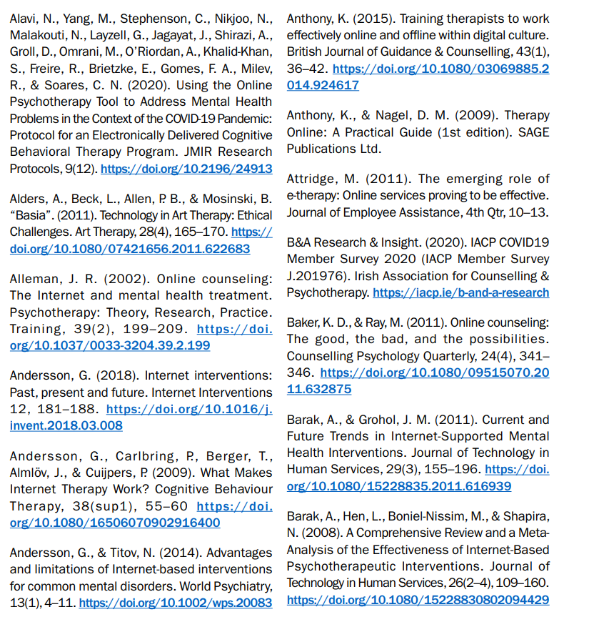

See also Online Counselling (iacp.ie) to view IACPs codes of practice and guidelines for online therapy

COMPTENCIES AND TRAINING
The IACP Practice Guidelines and Competencies for online service delivery state that training should include at a minimum the following aspects of working online:
• Understanding the various means of delivering online services
• Understand the evidence and efficacy of working therapeutically online
• Exploring the benefits and risks of therapy online for practitioners and clients/supervisees
• Evaluating whether the service provided by practitioners is suitable for therapy online
• Legal & Ethical considerations including Informed Consent, Privacy Policies / GDPR
• Technology solutions; benefits and risks and establishing safeguards
• Practical skills in working therapeutically online (including experiential learning with working online)
• Understanding and working with the differences between working in-person and online
• The role of the disinhibition effect
• Planning for technical breakdown/accident/emergency
• Delivering/Receiving supervision online
• Future Developments and importance of staying up to date with technology change

AT RISE WE ARE SETTING A MINUMUM OF 6 HOURS OF CONTINUOUS PROFESSIONAL DEVELOPMENT FOR THOSE WHO SEE CLIENTS ONLINE, EITHER AD HOC (PARENTAL INTAKES/REVIEWS) OR ON AN ONGOING BASIS. FOR IACP MEMBERS THERE IS A PRE-RECORDED TRAINING AVAILABLE IN THE MEMBERS SECTION. IF YOU ARE COMPLETING TRAINING OFFERED BY ANOTHER MEMBER ORGANISATION OR TRAINING BODY PLEASE ENSURE THAT AT A MINIMUM IT COVERS THE ABOVE OUTLINE. IF NOT, THIS COULD BE MADE UP BY MULTIPLE SHORTER COURSES OR SEMINARS. SEE ALSO THE THERAPY ACADEMY AND ESSENTIAL THERAPY TRAINING WEBSITES.
OVER TIME, AN IN HOUSE PRE-RECORDED SEMINAR DELIVERED BY WAYNE WILL BE MADE AVAILABLE TO YOU ALSO AND WILL BE AVAILABLE FROM THE OFFICE ON DEMAND.
https://www.therapyacademy.ie/details/webinar/678ake
https://iacp.ie/page/all_events/718

PLATFORMS AND TECHNICAL REQUIREMENTS

The most important aspect of any online platform is to provide online security. Online platforms should be able to demonstrate the following:
- Data protection compliance (GDPR)
- Encryption (HTTPS) and SSL certificate on the website
- Secure Facility & System Access such as HIPAA compliance and secure data storage
- Reliable customer service addressing any issues within a timely manner
- Risk Assessment Statement and Disaster Recovery Plan should be available from the provider
- Two-factor authentication required if sensitive data is stored on the platform It is important that all online security has been assessed and confirmed before the Member starts using any online portal for business. It is vital that the platform is complying with the European Data Protection law GDPR, thus it is important to confirm such compliance in advance.

THE RECOMMENDED PLATFORM FOR THERAPISTS AT RISE IS ZOOM AS IT MEETS ALL OF THE CRITERIA SET OUT IN THE IACP GUIDELINES FOR ONLINE PLATFORMS. APPS THAT ARE NOT RECOMMENDED INCLUDE VIBER, FACETIME AND TEAMS DUE TO FACTORS LIKE SERVER EXCHANGE, EASE OF ACCESS, WIFI RISK. IT IS ALSO BASED ON RELIABILITY AND CONTINUITY, THAT IS APPS THAT ARE LESS LIKELY TO CRASH DURING SESSIONS.

INSURANCE AND INTERJURISDICTIONAL PRACTICE

It is very important that therapists at RISE make sure they have appropriate cover that includes online therapy even if you only take clients online on an occasional basis. There can be vast differences between the policies on the market and sometimes the policy document can be difficult to understand. For example, OBF policy documents state that Ireland is the jurisdiction, however you are in fact insured to work with clients residing anywhere in the world with the exception of the USA and Canada. If you are a practitioner living abroad and insured with OBF then there is only limited cover available from OBF with a maximum of 90 days cover per policy term. If in doubt when checking the insurance documents you hold, please consult your insurance provider.
Where you are practicing from another jurisdiction on an ongoing basis, you need to be sure that the local regulations match the Irish context. In some cases, the local regulations may have difference standards of qualification for practicing and you need to be aware of the need to meet these standards.

 | COVER FOR ONLINE | COVER FOR WORKING WITH CLIENTS ABROAD | COVER FOR WORKING AS A THERAPIST ABROAD | EXCLUSIONS
OBF | YES | YES | LIMITED COVER – 90 DAYS PER POLICY E.G. WHEN YOU ARE ON HOLIDAYS | USA AND CANADA
PPS | YES | YES | YES – MUST COMPLY WITH LOCAL LEGISLATION | USA AND CANADA
BRIAN MULLINS | YES | YES | YES – MUST COMPLY WITH LOCAL LEGISLATION | USA AND CANADA

CONTRACTING AND CONSENT
It is important to understand that providing therapy to clients online requires additional consent to be given in a manner that is different from face to face work. It is required by RISE practitioners that before a client engages with you online you must already have the written consent on file. There are contractual items concerning online service provision that need to be acknowledged by the client and these include:
a) Information about how you work online. Is this done synchronously or asynchronously? Is it done via email, telephone, video, therapy platform etc.?
b) Details about session booking, dates and times of contact, as well as response times from practitioner to client/supervisee.
c) The duration of a typical session
d) Making security arrangements (verifying location and privacy before proceeding with each session and recording this in clinical notes)
e) The client’s responsibility in relation to electronically stored or printed material either sent to or received from the practitioner
f) The ethical framework or code of ethics that you adhere to
g) Details of fees and how payment is accepted. For example, is payment per session or payment per block of sessions, do you employ a payment processing platform or via bank transfer
h) What can realistically be expected by the client/supervisee and what may be achievable during your work together online
i) What should happen in the event of technology failure or an emergency, and what are the alternative means of contact?
j) What are the arrangements for you or the client/supervisee if either becomes ill or if someone dies?
k) The difference between communication used for making practical arrangements, and the material content sessions. For example, using a mobile phone to confirm or cancel appointments, but not for personal or confidential communication
l) Policy about sending or accepting email attachments and the use of technological resources including blogging and public forums
m) General referral procedures and procedures in the event of emergency or crisis
n) Consideration of legal / jurisdictional obligations are required prior to undertaking the delivery of services outside of the Republic of Ireland.

PRACTITIONERS AT RISE MUST GET THE RISE ONLINE ADDEDNDUM TO TERMS OF AGREEMENT FORM SIGNED IN ADVANCE OF ANY CLIENT ENGAGING WITH YOU ONLINE. IF YOU DO NOT HAVE A SOFT COPY, YOU MAY REQUEST THIS FROM THE OFFICE. IF YOU ARE USING A DIFFERENT FORM, E.G. IN THE CASE OF EXTENDED CONTRACTING FOR CHILDREN AND TEENS, IT MUST AT A MINIMUM INCLUDE WHAT IS COVERED IN THE RISE ADDENDUM. THIS IS IN ADDITION TO THE RISE TERMS OF AGREEMENT WHICH EVERY CLIENT SIGNS. ANYTHING LESS THEN THIS IS NOT CONSIDERED TO BE COMPLIANT WHEN WORKING FROM RISE. AFFILIATE THERAPISTS AT RISE ARE CONTRACTED TO OPERATE WITHIN ALL INTERNAL POLCIES FULLY.

Couples
When engaging online with couples, once more you need to have the signed contracts/consents up front prior to the first session and these must be signed by both parties. Furthermore, you must email each party individually with the contracts for reading and signing.

Children and Teens
You should check with your individual member organisation on any further items for inclusion in your contract pertaining to online service provision. In the case of IACP, the following are the guidelines and items that need to be covered at contract stage:

- Ensure the young person occupies a secure environment, prioritising confidentiality.
- Consider using headsets or earplugs to prevent inadvertent overhearing during sessions.
- Confirm the presence of a responsible adult on the premises while the young person engages in online activities.
- In the event of an interruption during the session, it is imperative for the Therapist to document such instances in their notes.
- All communication in setting up online therapy including initial contracting and future communication around sessions, is done through the consenting adult.
- Both the parents and the minor are reminded of the prohibition against recording any session.
- Verify that the space used by the young person is appropriate, and ensure suitable attire is worn during sessions.
- In cases of emergencies or signal disruptions during sessions, the Therapist will exert every effort to reach the young person via an alternate device or contact the consenting adult, as indicated in prior sections of these guidelines

SAFETY AND RISK WHEN WORKING ONLINE WITH CLIENTS

The IACP Guidelines highlight the following clinical risks when working online with clients:
• Practitioner competence (appropriate training and working within limits)
• Informed consent (risks, consequences and benefits)
• Privacy (of client/supervisee and practitioner data)
• Security limits (technology, platforms, tools, third-parties, etc.)
• Ensuring adequate emergency protocols are in place
• Effective management of the clinical and psychological contract.

Along with clinical risks, there are also some psychological and physical considerations which need to be given due attention

Setting and Clients at Risk
Sometimes clients will ask if they can connect to the session from environments which may not only be unsuitable but may compromise the physical safety of the client. Consider for example, a client with suicidal ideation logging on to the session when walking by the sea or in their car or a teen who is self harming and logging on from a room where sharps are more available e.g bathroom. Thus the importance of ensuring that the space is safe and contained.

It is not deemed safe for clients in situations of domestic abuse or indeed any abuse to engage online if they reside with the perpetrator. If face to face or onward referral is not an option, then work with your supervisor on signposting the client to a safer setting for therapy.

Disinhibition Effect
DE is a recognised psychological phenomenon that can occur when a client is engaged with online therapy. When experiencing DE, a client may reveal deep and painful emotions and memories in a way that occurs at a pace far quicker than would happen face to face in the therapy room. While for some clients this may be supportive of the therapeutic process, for other clients with a more fragile psyche, it may be damaging. You should always consult with your supervisor when working with clients of this nature and your attention is now drawn to DE as a further consideration.

Re-entry time
Consider that clients may be logging on to a session in the midst of the chaos of their lives, either at work or at home, yet in the session with you, they will go to a more vulnerable place. Assess whether grounding is needed and recommend to the client that they schedule in 10 minutes of re-entry time after their session before resuming family/work activities.

Addendum to Terms of Agreement – Online Counselling & Psychotherapy

Security & Confidentiality
We at RISE Counselling and Psychotherapy aim to provide a secure and confidential service. To this end we ensure that our computers are regularly updated with anti-virus software. All information exchange is encrypted, and all calls are carried out in a safe, uninterrupted and private setting
Clients using the services of the RISE Counselling & Psychotherapy are responsible for the maintenance and protection of their own computer and for regularly updating their security software. Clients are responsible for making the necessary arrangements to ensure confidentiality from their end during sessions and afterwards where computers may be shared.
Personal data is required for our own records and may be stored by therapists in a secure file and may not be released to a third party except under court order.
Clients accept that there are limits to confidentiality. While the content of the sessions and the client’s identity is treated with the strictest confidence, this may cease should the client disclose criminal activity, child sexual abuse, or material which leads the therapist to believe that the client poses a threat to the safety of themselves or others or where the safety of a minor is threatened. In all instances where it may be necessary to break confidentiality the client will be informed prior to any action being taken. Clients accept that in the name of best practice therapists are required to attend regular supervision and that your identity will remain confidential.
Your data rights under the GDPR (General Data Protection Regulations) are fully upheld for this form of counselling. See the terms of agreement form for more information on GDPR.

Disclaimer:
Counselling is an accompanied journey into self. While the therapist will accompany clients on their journey, clients are fully responsible for their actions, decisions and behaviours, during, between and after therapy sessions. The contract of engagement in counselling/psychotherapy with RISE Counselling & Psychotherapy is subject to acceptance by the client that the terms of agreement (see www.risecounselling.ie/downloads) and the online confidentiality and security policy herein have been accepted and understood. RISE Counselling & Psychotherapy accepts no responsibility for client’s telephone or computer systems, nor any technical difficulties occurring in connection with your online engagement with us.

Sessions:
Clients accept that during therapy unpleasant and upsetting emotions may be experienced and it is important to allow re-entry time to your home/working life. Clients accept that this is paid service, subject to the fee agreed between you and your therapist. Fees for online sessions must be made in advance of your session and verification of the transaction and remittance of the fee may be required by your therapist. Sessions are of a set time of 50/60 minutes with the final 10 minutes being used to summarise your work and provide grounding as necessary. Clients are responsible for ensuring that they are available to start the session on time. All sessions will end on time so sessions that do not begin on time will be of a reduced time but subject to the full hourly fee.
Sessions affected by technical difficulties or cancellations on behalf of the therapist will be subject to a full refund or rescheduled session. Clients may end therapy at any time but in the interest of closure all clients will be invited to complete a closing session.

Cancellations:
24 hours’ notice should be given for all cancellations by clients. Sessions missed or cancelled with less than 48 hours’ notice will incur the full cost of the session. Cancellations by therapists will result in a full refund or a rescheduled session as per the client’s request.

Conduct:
While therapy sessions provide the space for clients to work through difficult feelings and emotions, therapists will not accept threatening or abusive behaviour towards them. Such behaviour may result in the session ending and the client being liable for the full session cost.
Clients must not to attempt to damage the secure connection in any way through the introduction of viruses, Trojans, trolls, or any form of malicious or harmful technology. Details of any breach of this will be forwarded to the relevant authorities.

Payment:
All payment is through bank transfer/internet banking unless otherwise specified by your therapist.
All payments are required upfront prior to the time of the session.

Agreement:
By accepting the terms of use clients agree to comply with the following: If a client is a minor under 18, we require the consent of all legal guardians prior to engaging in online therapy. Clients accept responsibility for checking that the laws in their country of residence permit their use of this service. Clients have read the policy on confidentiality, security and the terms of use and understand their implications. Clients agree that the use of the service is for counselling services and not part of any academic study. Clients accept that the publication of details pertaining to therapy sessions must not be undertaken without the prior written consent of the therapist. Clients accept that contact between the client and therapist take place within the session, the only exceptions being for the purpose of cancellation or rescheduling or as per contracted by client and therapist. Clients agree to disclose honestly their medical history and all current medications. Clients understand that this is not a free service and that all sessions are subject to payment in advance.

I, ____________________________________________________________________have read this document and understand its contents, and agree to engage with RISE Counselling & Psychotherapy for online counselling services/ give consent for my child to attend RISE Counselling & Psychotherapy for online counselling services.
Signed: __________________________________________ Date: _______________________
Parent/Guardian Signature giving consent for minors: _________________________________________
Parent/Guardian Signature giving consent for minors: ______________________ ___________________
Counsellor Signature: __________________________________

Registered in Wicklow, Ireland. Company No. 605186

HOUSEKEEPING POLICY

While the manager accepts overall responsibility for cleaning of the practice, it is required that all affiliates give due regard to the cleanliness of the therapy rooms and the reception area. This ensures that we leave things as we found them and is a mark of respect to the next person using the facilities. On this basis, please adhere to the following:

- All cups and glasses once used should be washed and dried at the sink before being returned upstairs to the tray beside the fridge.

- Please clean up any spills around the tea and coffee area and bin also when disposing of tea bags etc.

- If you notice that the small bins are full in the therapy room please empty these into the large in in the reception area. I change the large bin regularly but if it has not been changed and you notice, then please replace the bag and leave the full bag downstairs.

- For those therapists who are using sand, please hoover the room before you leave

- Artwork is considered client information and should be retained with your case notes. Please do not throw this in the bin.

- If you notice we are running low on anything, please let me know e.g. toilet roll, tealights, water.

RISE – Health and Safety Information (amended for new premises, front of unit -1a)

- RISE Premises has two fire exits; one is the main door and one is the large window in Room 1 upstairs. Do not try to gather personal belongings or attempt to tackle the fire. When safely outside at the assembly point which is rear of Matt Britton Carpets, contact Greystones fire brigade (number below)

- In the event of a burglary, conform to any instructions or commands given by those involved, note however we do not hold cash at rise premises. In the event any information or information storage device is stolen containing information pertaining to your clients at RISE you must report this to the Data Protection Office immediately. Safety as always is top priority so do not concern yourself with this until after Gardaí have arrived and you are safe and sound.

- To improve security, high lumosity lighting has been installed outside RISE. However please take care when existing the building and going to your car. Note that Grans bakery at the front of the unit has staff present 24/7 and RISE management have made them aware of our presence and operation at the side of Unit 1. Their phone number is also included below.

- Affiliates are asked to coordinate with management and the other therapists to try to ensure that they are not going to be at the premises alone. A weekly schedule of client meetings by therapist is emailed every week. Particular emphasis will be given to this following our move to the front of the unit.

- As advised at interview and in the terms and conditions of joining, mandatory reporting is the responsibility of individual therapists. See www.tusla.ie for more info/forms regarding mandatory reporting

- Adverse weather conditions: Where a national red weather warning has issued, room cancellation fee is waivered so that you can assess conditions locally. Equally management will assess and decide on closing the centre and keep you informed.

- Coronavirus and procedure for public health warnings concerning viruses on next page.

OPENING AND CLOSING PROCEDURES
On opening up, you will need open the bolt to release the shutter as with our previous premises. The bolt can be left inside the front door to the right when you have gained access. On entering you will need to deactivate the alarm with the code 2222. Please turn on the lights and switch on the radios downstairs and upstairs in each waiting area.
When closing up, please remember to switch off all lights and appliances including radiators, fans and radios. The alarm can be set using the same code 2222. Having locked the main door taking the bolt outside with you, pull down the shutters and reapply the bolt and fasten. There is ample lighting outside for the winter months and as specified above, we do our utmost to ensure that a therapist will not be locking up on their own.
ESSENTIAL CONTACT NUMBERS (STORE IN YOUR PHONE)
Emergency Services: 999 Greystones Garda: 666 5800
Greystones Fire Service: 2861534 D&S Food/Grans Bakery: 2810013
Wayne Mobile: 0834148695 Wayne Home: 2878281
TUSLA (Child and Family Agency) Wicklow Town: 076 6958400
Data Protection Commissioner: 076 1104800

PROCEDURE FOR PUBLIC HEALTH WARNINGS (CURRENTLY COVID 19 AS AT 02.03.2020)

Coronavirus aka COVID19
As you are aware, COVID19 has now reached Ireland. The HSE have issued protocols for the general public which can be viewed in full at: https://www2.hse.ie/conditions/coronavirus/coronavirus.html
I am drawing your particular attention to the key areas of hand hygiene and social distancing.
__________________________________________________
HYGIENE
- AS MUCH AS IS POSSIBLE DON’T LET CLIENTS TOUCH ANY SURFACE OR GIVE GLOVES IF NEEDED.
- Ventilate the therapy rooms and take breaks from having the radiators on. Viruses need warmth to survive.
-Sanitise your hands immediately on entry to the practice and after touching objects and surfaces.
-Cover your mouth and nose with a tissue or your sleeve when you cough and sneeze.
-Put used tissues into a bin and wash your hands.
-Clean and disinfect frequently touched objects and surfaces especially door handles and arms of chairs. This also includes toys and figurines and we have also brought in extra supplies of sand for changing the sand trays. It is important to have a spare set of toys to bring in whilst you sterilise another set at home.
- MORE THAN EVER IT IS IMPORTANT THAT YOU EMPTY THE SMALL BINS.
SOCIAL DISTANCING

- SOCIAL DISTANCING: ENSURE AT LEAST 1 METRE BETWEEN YOU AND YOUR CLIENT. ARRANGE PROPS/TOYS ON THE TABLE AT THE FAR WALL FOR CHILDREN.

- If you develop symptoms, please contact Wayne. Do not come into RISE if you are unwell.

- If you believe that you may have come into contact with an individual who has tested positively for the virus please contact Wayne urgently.

- If you are seeing a client whom you are aware has or will be travelling to an affected area, you need to contact Wayne urgently. A list of risk areas can be viewed here:

- All rooms have been supplied with disinfectant wipes that we can each use to wipe down chairs, side tables etc after use. Please empty the small bins promptly. Gloves and extra bags have been left by the bins.

- It is advised that therapists start considering who among your client base may have an 'underlying condition'*, are pregnant or are over 65 and having an initial conversation on IF we had to close due to CV, what would the impact be on your work? For those psychologically vulnerable, what plans can you together put in place. Consider for example, Skype or telephone sessions, directing them to the Samaritan's.

- Any of you who yourselves are at additional risk will also need to consider a contingency plan should there be a localised outbreak. I am available to support you around this so do contact me as needed.

- Room cancellation policy suspended until 29th March 2020. Admin fee payable for phone/Skype.

- The website, Facebook and waiting areas have been supplied with our public statement on COVID 19.

IF A THERAPIST IS DIAGNOSED WITH COVID 19, WE WILL CLOSE FOR A DEEP CLEAN AND TRACK THOSE WHO MAY HAVE COME INTO CONTACT WITH THEM REGARDING SELF ISOLATION AND TAKING PRECAUTIONS. WE WILL BE TAKING ALL MEASURES PRESCRIBED BY THE HSE AND GOVERNMENT AS THEY ARE ISSUED. INFORMATION CORRECT AS AT 13.03.2020

Child Safeguarding Statement for RISE Counselling & Psychotherapy

- Name of service being provided: Counselling & Psychotherapy

- Nature of service and principles to safeguard children from harm

Counselling services for children and adolescents aged 6 - 17. One hour counselling sessions will take place either in the presence of a parent/guardian, or on a one to one basis. The counselling sessions may contain elements of play, drawing, writing, storytelling, role playing, music, talking and any other creative means which may be useful within the counselling process. The goal of child/adolescent counselling is to build an environment of safety and trust in which the child/adolescent can find a way to express the difficulties they are experiencing and so discover their own path to happiness and contentment. RISE are committed to best practice which involves the safety and protection of children and vulnerable adults from harm. We aim to create a safe environment within which all counsellors can work with the clear guidance around child safety and vulnerable adults whether or not they work directly with children.

3. Risk assessment
We have carried out an assessment of any potential for harm to a child while availing of our services.
Below are a list of the areas of risk identified and the list of procedures for managing these risks.
Risk identified Procedure in place to manage risk identified
Risk Identified | Procedure In Place to Manage Risk
Physical Safety Within Rise | RISE have identified and highlighted any potential risks to physical safety within the building as part of its health and safety assessment which includes fire safety, adequate lighting on stairways and in courtyard in front of premises. Potentially hazardous items such as kettles kept at safe height on counter.
One to One Contact between Counsellor and Child or Adolescent | RISE endeavours to protect the child/adolescent from any type of potential for abuse by the following measures:  - All counsellors at RISE must have current Garda vetting which is overseen by IACP.  - By ensuring the Counsellors at Rise have specific child/adolescent training and qualifications, insurance, supervision and are a member of IACP.  - Counsellors must adhere strictly to the IACP code of ethics and practice; by providing a detailed counselling contract between child/adolescent, parents/guardians and counsellor, signed by both parents/guardians and counsellor;  - By informing parents/guardians that they are required to accompany the child/adolescent to and from the building and to remain in the building during the entire counselling session; by asking p/g to be available and to fully participate as required by the child/adolescent in the counselling process;  - Keeping clear, confidential records/notes of all counselling sessions;  - Ensuring parents/guardians are aware of their responsibilities throughout the counselling process and that mutual written consent from both parents is sought prior to commencement of counselling.
Concerns about the psychological health of the child or adolescent prior to or during the counselling process and multidisciplinary interaction | As part of our intake procedure, a record of the child’s mental health history is sought, the name of their GP and any other physicians they may be attending along with details of any psychoactive medications. Where required we will seek written clarification from other mental health professionals that are treating the child or adolescent to ensure that it is clinically safe for them to commence or to continue to partake in counselling.

4..Procedures

Our Child Safeguarding Statement has been developed in line with requirements under the Children
First Act 2015, the Children First: National Guidance, and Tusla’s Child Safeguarding: A Guide
for Policy, Procedure and Practice. In addition to the procedures listed in our risk assessment, the
following procedures support our intention to safeguard children while they are availing of our service:

➪ Procedure for the management of allegations of abuse or misconduct against workers/volunteers
of a child availing of our service

➪ Procedure for the safe recruitment and selection of workers and volunteers to work with children

➪ Procedure for provision of and access to child safeguarding training and information, including
the identification of the occurrence of harm

➪ Procedure for the reporting of child protection or welfare concerns to Tusla

➪ Procedure for maintaining a list of the persons in the relevant service who are mandated
Persons (all therapists at RISE are considered mandated persons)

➪ Procedure for appointing a relevant person (all therapists are responsible for mandatory reporting)
All procedures listed are available upon request.

5. Implementation

We recognise that implementation is an on-going process and our service is committed to the
implementation of this Child Safeguarding Statement and the procedures that support our intention
to keep children safe from harm while availing of our service. This Child Safeguarding Statement
will be reviewed on 20/11/2018, or as soon as practicable after there has been a material change in any matter to which the statement refers.

Signed:__________________________________________
Wayne Hamilton, Practice Manager
RISE Counselling & Psychotherapy

For queries, please contact any therapist operating at RISE Counselling & Psychotherapy
(Relevant Persons under the Children First Act 2015)

Registered in Wicklow, Ireland. Company No. 605186

Data Protection & Privacy Policy

The General Data Protection Regulation (GDPR) will come into effect on 25th May 2018 and will replace the current data protection framework. This legislation is being introduced to enhance the rights of data subjects e.g. individuals whom organisations hold information about. It requires clear and specific preliminary information to be provided to clients prior to establishing a contract with a business so that they are informed of their data protection rights up front. The act also provides for the appointing of a Data Protection Officer (DPO) to organisations meeting certain criteria set out by the data protection office. RISE Counselling & Psychotherapy does not meet these criteria.
For the purposes of the definitions of this legislation, the practice manager and all affiliate counsellors and psychotherapists at RISE are considered data controllers in RISE. That means that in your professional standing you are responsible for deciding on the data that is collected, the rationale for this and it is your responsibility to ensure that this information is passed on to the data subject (the client) at the initial assessment when the relationship is being established. It is also important to note that on that basis, if you terminate your affiliate relationship with RISE you remain the data controller for the information you have collected from clients you undertook during your time with us and are subject to the GDPR regulations. The Data Protection website states that after 25th May 2018 there is no longer a requirement to register as a data controller and list publically the data processing activities you engage in.
Under the enhanced regulations we must be up front in providing the legal basis under which we store client data, how it is stored and for how long. It directs that we disclose any third parties we share information with and whilst this is not applicable to how we work, we must be very clear about the limitations of confidentiality; that is, mandatory reporting under the Children’s First, Vulnerable Persons and Withholding Information Acts (See amended terms of agreement and intake under Appendix 1). The GDPR legislation states that clients should be able to access, amend and request deletion of any information held on file pertaining to them. The legislation further states that where we are not in a position to uphold the rights of the data subject that we provide clear and legal rationale for this. For example, we are already legally bound to retain client information and case notes for a period of six years after the therapeutic relationship ends in the case of an adult and six years from the point that a child or adolescent client turns 18 years old. The Data Protection Office will look for evidence that to the best of our ability we try to uphold the data rights of the client. The below points outline how we at RISE intend to do this:
We will absolutely provide copies of all information held on file pertaining to a client on receipt of a signed letter addressed to the counsellor at RISE. Where the client is asking you to provide information to a 3rd party, for example an educational psychologist or other medical professional you must also get written consent and keep this on the client’s record. Where a client has viewed their notes and is unhappy about some aspect of what has been recorded, you need to decide whether or not this is a material fact, human error etc. and respond in writing to the client advising on the action to be taken. If it is a material fact that cannot be changed to your best judgement, then you can advise the client they are allowed to annotate their file. Annotation means clients can express in writing the points that they disagree with and why, and we will agree to retain this on their client record. As we are legally required by our insurers to retain copies of the client’s information and case notes e.g. a record of the working relationship for 6 years (6 years post turning 18 for minor) we cannot delete data until then. But we agree that we will destroy the data at that point in the future.
Internal communication concerning client sensitive data is completed via Slack app which is fully encrypted and password protected.

Under GDPR, children have the right of access to information held by organisations about them. The Data Protection Office confirmed that this mainly relates to social media channels like Facebook. It does not apply to the confidential case notes held by our child and adolescent psychotherapists in RISE. Data rights for this information remains with the minors parent(s). And as always both parents must sign the terms of agreement form before the minor commences therapy. So under GDPR we just need to be thorough in covering data privacy and confidentiality with the parents at the initial session.

Subject Access Requests/Data Requests
Data requests must be responded to in writing within 40 days acknowledging the clients rights under GDPR, the data held, period of time it is held for and the rationale (Sample Letter under Appendix 2).

Affiliate Counsellor Induction Information
It is RISE policy to retain affiliate counsellor induction information for an equal period of 6 years from the point that the affiliate relationship ends. This is in line with our policy on client information in that it is held for the purposes of any potential complaints or disputes. Complaints are initially handled internally by the practice manager and beyond that directed to IACP.

Training & Further Information on GDPR
In addition to this steering document being provided to you by RISE, it is also mandatory that from 25th May 2018 all therapists at RISE have watched the video seminars and Q&A session provided by the IACP online in the Members Area of www.iacp.ie. You can also review the Data Protection Commissioners website which also includes their contact information for any queries (www.dataprotection .ie)

Data Breaches
It is fully understood within RISE that data breaches must be reported within 24 hours. It is understood that if the full information required by all sections of the report on www.dataprotection.ie are not available then a second report must take place within 3 days with the remaining information. Beyond this, all counsellors understand they must contact the Data Breach Section of DPO on 057 8684800.

Risk Assessment/Checklist for Data Protection and Data Privacy (last reviewed 10.11.2018)
Affiliate Training | All affiliates are briefed on the implementation of GDPR and directed to online seminars, Q&As and information sources that fully inform them of their obligations under the new regulation.
Consent and Privacy Notice | Privacy Notice (included in our Terms of Agreement) is to be provided up front to new clients who must then sign this document to acknowledge and give consent for how their data is used prior to engaging in therapy. Therefore this needs to take place at the beginning of the contracting.  The Privacy Notice will also be available for clients to view on our website at the link: www.risecounselling.ie/downloads.
Website | The GDPR requires that a website that uses more than the basic cookies required to operate a website must inform visitors to the site on how the data relating to their usage of the site is collected.
Email | Clients who email the RISE inbox at the address info@risecounselling.ie will now receive an automatic response which will direct them to the privacy notice on our website as referred to above. Emails will be deleted once a week or as soon as the client has been placed with a therapist, whichever comes first and once again we will be transparent about this in the auto response.
Internal Communications | Once you receive a new client referral from the practice manager, you become a data controller for the information you have been given. Where information is being passed to you electronically via Slack regarding a new client referral, this will only include a name, contact number and type of therapy sought. Slack app has been rolled out to protect confidentiality and reduce the risk of electronic data breach. This app is fully encrypted and password protected, recommended by a GDPR consultant.
Documentation Being Dropped Off at RISE | It is essential that any documentation a client is dropping back to you at the centre be given to you face to face so ideally at the next scheduled therapy session. Please do not ask clients to use the post-box for this purpose.
Data Breaches | It is fully understood within RISE that data breaches must be reported within 24 hours. It is understood that if the full information required by all sections of the report on www.dataprotection.ie are not available then a second report must take place within 3 days with the remaining information. Beyond this, all counsellors understand they must contact the Data Breach Section of DPO on 057 8684800
Conflicts of Interest and Confidentiality | RISE strive to provide a safe, confidential environment at the practice and therefore we stagger appointment times to reduce crossover. In addition work was carried out early January 2019 to enhance soundproofing of the therapy rooms.
Policy Review & Reassessment | It is intended that risk assessment and a review of our data policy take place twice annually or sooner in the event of a data breach or identified risk. This will be overseen by the practice manager.

R I S E
COUNSELLING & PSYCHOTHERAPY

Data Privacy Statement in Compliance with General Data Protection Regulation, Effective May 25th 2018

How will your information be used?
Confidentiality is of primary concern to us, so to help maintain confidentiality we will use a pseudonym or initials only on documentation we hold. Your counsellor will keep confidential session notes while you are attending the centre. In addition to the information recorded on the RISE Counselling ‘Intake Form’ this is used to identify you, assess your suitability for counselling and is a record of your consent for same.

What is the Legal Basis for this and How Long Will Your Information be retained?
We retain your Data for legal reasons such as requirements set down by our insurers and to respond to potential disputes and complaints. Your data is retained for a period of 6 years after the end of the therapy relationship or in the case of minors who attend therapy, data is retained for 6 years from the point a child or adolescent has turned 18.

What Are Your Rights Under the GDPR?
You have a right to access a copy of these should you so wish. You also have the right to request amendments or deletion of information held about you under the General Data Protection Regulations (revised May 2018). However, it is our policy to retain a copy of client information and case notes for 6 years after your relationship with your RISE counsellor ends. The legal basis for this is twofold; firstly it is directed by our insurers and secondly it would also be referred to in the event of any complaints or disputes that may arise, legal or otherwise as our record of the client relationship. You may request a copy of any information pertaining to you that is held on file within RISE and we will respond to requests within 40 calendar days as per the legislation.

What Are The Limitations of Confidentiality in the Contract You Make with Your Counsellor?
There are some exceptional circumstances where we may have to break confidentiality such as where there is a serious risk of harm to yourself or others, especially a child. Breaking confidentiality may entail us contacting the Gardaí, your doctor or medical physician or your next of kin depending on the circumstances and risks that are identified. Under the Children’s First Bill 2012 and Withholding of Information on Offences against Children and Vulnerable Persons 2012, your counsellor at RISE Counselling & Psychotherapy has a statutory obligation to report a concern of child abuse to the HSE. Your counsellor/psychotherapist at Rise is obliged to attend mandatory clinical supervision in which support and guidance is provided for their clinical caseload. Within this process no identifying information is given and pseudonyms are used to ensure confidentiality.
Continuity of Service
Your counsellor/psychotherapist at RISE has made provisions for unforeseen personal life events such as illness or death so that you will always be able to access your data during the period that it is retained.

Note: RISE Counselling & Psychotherapy does not provide reports for court purposes or to resolve personal medical or legal disputes that you may be engaged in.

MAIN RESPONSIBILITIES OF DATA CONTROLLERS UNDER THE GDPR

Rule 1: Fair obtaining:
- At the time when we collect information about individuals, are they made aware of the uses for that information?
- Are people made aware of any disclosures of their data to third parties?
- Have we obtained people's consent for any secondary uses of their personal data, which might not be obvious to them
- Can we describe our data-collection practices as open, transparent and up-front?

Rule 2: Purpose specification
- Are we clear about the purpose (or purposes) for which we keep personal information?
- Are the individuals on our database also clear about this purpose?
- If we are required to register with the Data Protection Commissioner, does our register entry include a proper, comprehensive statement of our purpose? [Remember, if you are using personal data for a purpose not listed on your register entry, you may be committing an offence.]
- Has responsibility been assigned for maintaining a list of all data sets and the purpose associated with each?

Rule 3: Use and disclosure of information
- Are there defined rules about the use and disclosure of information?
- Are all staff aware of these rules?
- Are the individuals aware of the uses and disclosures of their personal data? Would they be surprised if they learned about them? Consider whether the consent of the individuals should be obtained for these uses and disclosures.
- If we are required to register with the Data Protection Commissioner, does our register entry include a full list of persons to whom we may need to disclose personal data? [Remember, if you disclose personal data to someone not listed on your register entry, you may be committing an offence.]

Rule 4: Security
- Is there a list of security provisions in place for each data set?
- Is someone responsible for the development and review of these provisions?
- Are these provisions appropriate to the sensitivity of the personal data we keep?
- Are our computers and our databases password-protected, and encrypted if appropriate?
- Are our computers, servers, and files securely locked away from unauthorised people?

Rule 5: Adequate, relevant and not excessive
- Do we collect all the information we need to serve our purpose effectively, and to deal with individuals in a fair and comprehensive manner?
- Have we checked to make sure that all the information we collect is relevant, and not excessive, for our specified purpose?
- If an individual asked us to justify every piece of information we hold about him or her, could we do so?
- Does a policy exist in this regard?

Rule 6: Accurate and up-to-date
- Do we check our data for accuracy?
- Do we know how much of our personal data is time-sensitive, i.e. likely to become inaccurate over time unless it is updated?
- Do we take steps to ensure our databases are kept up-to-date?

Rule 7: Retention time
- Is there a clear statement on how long items of information are to be retained?
- Are we clear about any legal requirements on us to retain data for a certain period?
- Do we regularly purge our databases of data which we no longer need, such as data relating to former customers or staff members?
- Do we have a policy on deleting personal data as soon as the purpose for which we obtained the data has been completed?

Rule 8: The Right of Access
- Is a named individual responsible for handling access requests?
- Are there clear procedures in place for dealing with such requests?
- Do these procedures guarantee compliance with the Act's requirements?

Registration
- Are we clear about whether or not we need to be registered with the Data Protection Commissioner?
- If registration is required, is the registration kept up to date? Does the registration accurately reflect our practices for handling personal data? [Remember, if your data-handling practices are out of line with the details set out in your register entry, you may be committing an offence.]
- Is a named individual responsible for meeting our registration requirements?

Training & Education
- Do we know about the levels of awareness of data protection in our organisation?
- Are our staff aware of their data protection responsibilities - including the need for confidentiality?
- Is data protection included as part of the training programme for our staff?

Co-ordination and Compliance
- Has a data protection co-ordinator and compliance person been appointed?
- Are all staff aware of his or her role?
- Are there mechanisms in place for formal review by the co-ordinator of data protection activities within our organisation?

Source: www.dataprotection.ie
APPENDIX 1: REVISED TERMS OF AGREEMENT FROM 10/11/18
Terms of Agreement
Thank you for making contact with RISE Counselling & Psychotherapy. We hope that these general terms of engagement will help to clarify questions you may have about using our service. If you have any questions not covered in this document, your counsellor/psychotherapist will be happy to address them during your session.

Initial Assessment and Information Gathering
During your initial consultation, some basic details will be taken by our counsellors. This is in order to assess your needs and to refer you to a professional within RISE who we feel is best skilled to meet these needs. In certain cases such as if you are currently being prescribed psychoactive medication, we may need to liaise with your general practitioner or other medical professionals if you are currently attending a mental health inpatient or outpatient service. This is to ensure that it is psychologically safe for you to initiate counselling at this time. We do not provide addiction counselling at RISE but can refer you on to local addiction services on request. On this basis, whereby a client presents as being under the influence of drugs or alcohol, we are obliged to terminate the therapy session immediately. Signing this document will be treated as consent under the General Data Protection Regulation for your counsellor to liaise with these individuals if necessary. Any information collected is strictly confidential and is stored safely in a locked cabinet at a secure location. We do not store client data electronically.
Fees
The fee for your session is required to be paid directly to your therapist at the end of the session using the payment method that has been agreed between you.

Missed Appointments & Short Notice Cancellations
In general, appointments will be on a weekly basis at a fixed time. To get the full benefit from counselling, it is important that you attend regularly. We ask that if it is necessary for you to cancel an appointment that you inform your counsellor at least 24 hours before your session. If adequate notice is not received, you will be charged your session fee for the missed session. We appreciate you may miss a session or two due to holidays or other arrangements, however following three consecutive and unscheduled cancellations it will not be possible to guarantee space at the allocated time and day you had been attending.
Queries & Complaints
Our goal is to provide you with the best possible service. If, after a few sessions you feel the therapeutic relationship is not working or if you have any complaints, we ask that you first bring these to the attention of your counsellor. If having spoken to your counsellor and you still have some concerns or if you feel you cannot bring up your complaint with him/her you may contact the centre manager on 0892484028. In addition, all counsellors and psychotherapists at RISE Counselling and Psychotherapy are either accredited or working towards accreditation with a relevant professional organisation such as IACP or IAHIP. You may also raise your complaint with the relevant organisation to which your counsellor is affiliated.
Confidentiality& Data Protection
Confidentiality is of primary concern to us, so to help maintain confidentiality we will use a pseudonym or initials only on documentation we hold. Your counsellor will keep confidential session notes while you are attending the centre and you have a right to access a copy of these should you so wish. You also have the right to request amendments or deletion of information held about you under the General Data Protection Regulations (revised May 2018). However, it is our policy to retain a copy of client information and case notes for 6 years after your relationship with your RISE counsellor ends. The legal basis for this is twofold; firstly it is directed by our insurers and secondly it would also be referred to in the event of any complaints or disputes that may arise, legal or otherwise as our record of the client relationship. You may request a copy of any information pertaining to you that is held on file within RISE and we will respond to requests within 40 calendar days as per the legislation. There are some exceptional circumstances, where we may have to break confidentiality such as where there is a serious risk of harm to yourself or others, especially a child. Breaking confidentiality may entail us contacting TUSLA, the Gardai, your doctor or medical physician or your next of kin depending on the circumstances and risks that are identified. Under the Children’s First Act 2015 and Withholding of Information on Offences against Children and Vulnerable Persons 2012, your counsellor at RISE Counselling & Psychotherapy has a statutory obligation to report a concern of child abuse to TUSLA. We are mandated to report both current and historic instances of abuse to TUSLA whether or not the perpetrator is identified. Your counsellor/psychotherapist at Rise is obliged to attend mandatory clinical supervision in which support and guidance is provided for their clinical caseload. Within this process no identifying information is given and pseudonyms are used to ensure confidentiality.
Note: RISE Counselling & Psychotherapy does not provide reports for court purposes or to resolve medical or legal disputes.

I, ____________________________(PLEASE PRINT) have read this document and understand its contents, and agree to attend RISE Counselling & Psychotherapy for counselling services.
Signed: __________________________________________ Date: __________________
Counsellor Signature: __________________________________

Parent/Guardian Consent for Minors (Under 18 years old)
Name of Minor: ____________________________________________________________________
Parent/Guardian Signature: __________________________________________________________
Parent/Guardian Signature: __________________________________________________________
Date: ____________________________
Counsellor Signature: __________________________________
Note: We ask that you remain in the practice waiting area for the duration of your childs appointment. If this is not possible we must ask that you remain within 10 minutes of the practice and be contactable by phone should your child express that they wish to leave or in the case of an emergency. It is essential that you are in the waiting area at the time that your childs session is due to end as we cannot be responsible for children or adolescents leaving the premises alone.

Registered in Wicklow, Ireland. Company No. 605186 Version: 20th September 2023

RISE Counselling : Client Intake
Name:___________________ Contact Number:_____________ Source of Referral:____________
Address:__________________________________________________________________________
DOB:___________________________ Gender: M F N
Employment Status:_________________________________________________________________
Next of KIN and Contact No in case of emergencies:_______________________________________
Name and address of GP:_________________________________________________________________________________________________________________________________________________________________
Details of mental health diagnoses if relevant:____________________________________________________________________________________________________________________________________________________________
Details of any psychoactive medications:_______________________________________________________________________
Has client ever been inpatient or outpatient of psychiatric services. Please detail below including name of consultant psychiatrist and date last attended: ____________________________________________________________________________________________________________________________________________________________________
History of therapy/counselling experience:__________________________________________________________________________________________________________________________________________________________
Family Background:_________________________________________________________________________________________________________________________________________________________
Presenting Issues

Client(s) Signature:_____________________________________ Date:__________________
(I agree that I have read the RISE terms of agreement and privacy policy and that this intake information may be retained by my counsellor at RISE Counselling for a period of 6 years after the therapy relationship has ended or 6 years after child or adolescent turns 18 years old)
Referred to (counsellor name):___________________ Fee: ________ Frequency:____________
MDN Package? Y N (If Y detail other persons)_____________________________________
Assessed By:______________________________ Date:_________________________
Addendum to Terms of Agreement – Online Counselling & Psychotherapy

Security & Confidentiality
We at RISE Counselling and Psychotherapy aim to provide a secure and confidential service. To this end we ensure that our computers are regularly updated with anti-virus software. All information exchange is encrypted, and all calls are carried out in a safe, uninterrupted and private setting
Clients using the services of the RISE Counselling & Psychotherapy are responsible for the maintenance and protection of their own computer and for regularly updating their security software. Clients are responsible for making the necessary arrangements to ensure confidentiality from their end during sessions and afterwards where computers may be shared.
Personal data is required for our own records and may be stored by therapists in a secure file and may not be released to a third party except under court order.
Clients accept that there are limits to confidentiality. While the content of the sessions and the client’s identity is treated with the strictest confidence, this may cease should the client disclose criminal activity, child sexual abuse, or material which leads the therapist to believe that the client poses a threat to the safety of themselves or others or where the safety of a minor is threatened. In all instances where it may be necessary to break confidentiality the client will be informed prior to any action being taken. Clients accept that in the name of best practice therapists are required to attend regular supervision and that your identity will remain confidential.
Your data rights under the GDPR (General Data Protection Regulations) are fully upheld for this form of counselling. See the terms of agreement form for more information on GDPR.

Disclaimer:
Counselling is an accompanied journey into self. While the therapist will accompany clients on their journey, clients are fully responsible for their actions, decisions and behaviours, during, between and after therapy sessions. The contract of engagement in counselling/psychotherapy with RISE Counselling & Psychotherapy is subject to acceptance by the client that the terms of agreement (see www.risecounselling.ie/downloads) and the online confidentiality and security policy herein have been accepted and understood. RISE Counselling & Psychotherapy accepts no responsibility for client’s telephone or computer systems, nor any technical difficulties occurring in connection with your online engagement with us.

Sessions:
Clients accept that during therapy unpleasant and upsetting emotions may be experienced and it is important to allow re-entry time to your home/working life. Clients accept that this is paid service, subject to the fee agreed between you and your therapist. Fees for online sessions must be made in advance of your session and verification of the transaction and remittance of the fee may be required by your therapist. Sessions are of a set time of 50/60 minutes with the final 10 minutes being used to summarise your work and provide grounding as necessary. Clients are responsible for ensuring that they are available to start the session on time. All sessions will end on time so sessions that do not begin on time will be of a reduced time but subject to the full hourly fee.
Sessions affected by technical difficulties or cancellations on behalf of the therapist will be subject to a full refund or rescheduled session. Clients may end therapy at any time but in the interest of closure all clients will be invited to complete a closing session.

Cancellations:
24 hours’ notice should be given for all cancellations by clients. Sessions missed or cancelled with less than 48 hours’ notice will incur the full cost of the session. Cancellations by therapists will result in a full refund or a rescheduled session as per the client’s request.

Conduct:
While therapy sessions provide the space for clients to work through difficult feelings and emotions, therapists will not accept threatening or abusive behaviour towards them. Such behaviour may result in the session ending and the client being liable for the full session cost.
Clients must not to attempt to damage the secure connection in any way through the introduction of viruses, Trojans, trolls, or any form of malicious or harmful technology. Details of any breach of this will be forwarded to the relevant authorities.

Payment:
All payment is through bank transfer/internet banking unless otherwise specified by your therapist.
All payments are required upfront prior to the time of the session.

Agreement:
By accepting the terms of use clients agree to comply with the following: If a client is a minor under 18, we require the consent of all legal guardians prior to engaging in online therapy. Clients accept responsibility for checking that the laws in their country of residence permit their use of this service. Clients have read the policy on confidentiality, security and the terms of use and understand their implications. Clients agree that the use of the service is for counselling services and not part of any academic study. Clients accept that the publication of details pertaining to therapy sessions must not be undertaken without the prior written consent of the therapist. Clients accept that contact between the client and therapist take place within the session, the only exceptions being for the purpose of cancellation or rescheduling or as per contracted by client and therapist. Clients agree to disclose honestly their medical history and all current medications. Clients understand that this is not a free service and that all sessions are subject to payment in advance.

I, ____________________________________________________________________have read this document and understand its contents, and agree to engage with RISE Counselling & Psychotherapy for online counselling services/ give consent for my child to attend RISE Counselling & Psychotherapy for online counselling services.
Signed: __________________________________________ Date: _______________________
Parent/Guardian Signature giving consent for minors: _________________________________________
Parent/Guardian Signature giving consent for minors: ______________________ ___________________
Counsellor Signature: __________________________________

Registered in Wicklow, Ireland. Company No. 605186

APPENDIX 2- SAMPLE DATA REQUEST RESPONSE LETTER

Mrs Malcom X
123 Anywhere Street
Anywhere

25/05/2018

RE: YOUR DATA REQUEST
Dear Mrs X,
I acknowledge receipt of your request to (obtain copy/amend/delete) the information pertaining to you that is held on file by your counsellor at RISE Counselling.
Under the General Data Protection Regulation (amended May 2018) we are obliged to confirm that you have the right to make this request. We are also obliged to outline why we hold your data, for how long we retain it and the legal basis for doing so. As per the terms of agreement form you signed at the commencement of your therapy at RISE Counselling & Psychotherapy, we retain initial information provided and ongoing confidential case notes for a period of 6 years after the therapy has ended. The legal basis for doing so is twofold; firstly it is required by our insurers and also it is referenced in the event of a complaint or dispute that may emerge during or after engaging in therapy.
The decision to (provide a copy of/amend/delete) your information is as follows:
Xxxxxx e.g. clients request approved and copy documents enclosed / data amended OR we cannot delete data until 6 years after end of therapy relationship as stated.
We trust that this communication has informed you of your rights and also the rationale of our decision to accept/decline your request.
Should you wish to receive further information on your data protection rights, you can contact the Office of the Data Protection Commissioner on 1890 25 22 31.
Yours sincerely,

Counsellor Name

Signal App for Exchanging Client Sensitive Data (GDPR Approved)
SIGNAL MESSENGER APP HAS BEEN EMPLOYED TO OFFER US A GPDR APPROVED MEANS OF COMMUNICATING REFERRAL DATA. THE APP FUNCTIONS MUCH LIKE OTHER MESSAGING APPS BUT IS HIGHLY ENCRYPTED. AS A SECOND LAYER OF SECURITY YOU ARE ASKED TO SET THE TIMER TO AUTOMATICALLY DELETE MESSAGES AFTER 2 DAYS. SEE INTRUCTIONS ON HOW TO DO THIS BELOW:
- Disappearing messages can be managed by anyone in the chat.
- The setting applies to any new messaging after the timer has been set or modified.
- Changes to the timer will sync with your linked devices.

What does a disappearing message look like?
Each and every disappearing message will have a timer countdown icon that is visible at the bottom of the message bubble.

When does the timer start?
- For a sent disappearing message, the timer starts after you've sent it. This is not a delivery receipt or read receipt.
- For a received disappearing message, the timer starts after you've read it.

What happens when the disappearing message timer reaches the end?
The message is deleted from disk.

Steps to enable or change:
- Decide to enable or change the default for all chats or enable for a specific chat
  - For the default, on your phone go to Signal Settings > Privacy > Default timer for new chats.
  - For a specific one-to-one chat, on any device go to chat settings > Disappearing messages.
  - For a specific group chat,
    - admins may select who can change the timer.
    - on any device go to chat settings > Disappearing messages.
- Select a time or choose a custom time of up to 4 weeks.
- Next,
  - For Android, tap Save.
  - For iOS, tap Set.
  - For Desktop, the timer automatically applies.
- The chat header will include a timer icon .
- An alert in your chat thread will display the new disappearing message time.

Steps to disable:
- Decide to it off for all new chats or for a specific chat
  - For the default for new chats, Go to Signal Settings > Privacy (Android & iOS) or Preferences (Desktop) > Default timer for new chats.
  - For a specific one-to-one chat, on any device go to chat settings > Disappearing messages.
  - For a specific group chat,
    - admins may select who can change the timer.
    - on any device go to chat settings > Disappearing messages.
- Select Off which is listed at the top.
- Next,
  - For Android, tap Save.
  - For iOS, tap Set.
  - For Desktop, the timer automatically applies.
- The chat header will not include a timer icon.
- The chat will include an alert that the timer is Off.
- All messages sent after this change will not disappear.
- Any sent or received message will not contain a timer icon.

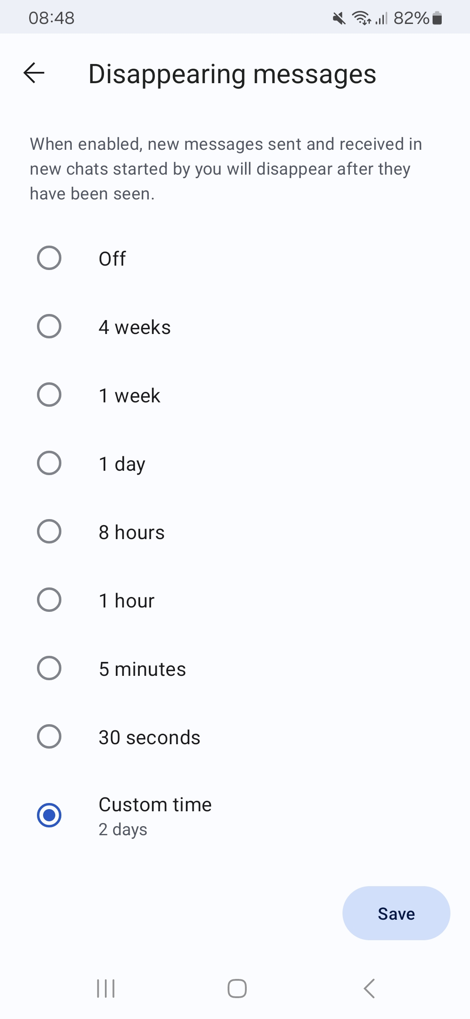

TeamUp App for Room Booking
TeamUp is an app used within RISE for booking, rescheduling and cancelling rooms. It does not replace any aspect of the referral procedure or room cancellation procedure which requires notice for rental tracking. Affiliates can reschedule ongoing appointments within the same week without contacting the centre manager e.g. where there is no change to rental collection.

Step 1
Download the TeamUp app from Google Play to your iPhone or android device. Get started by clicking the link issued to you via text message by the centre manager. On the home screen you have the option to view room availability by day, week, month etc.
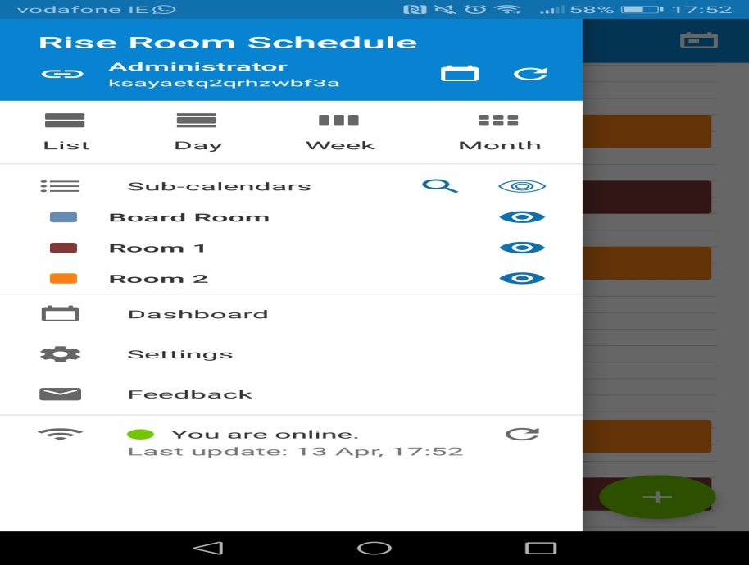

Step 2
When booking a room, select the date and click on the green button with the plus sign (on most devices this will appear bottom right as shown).
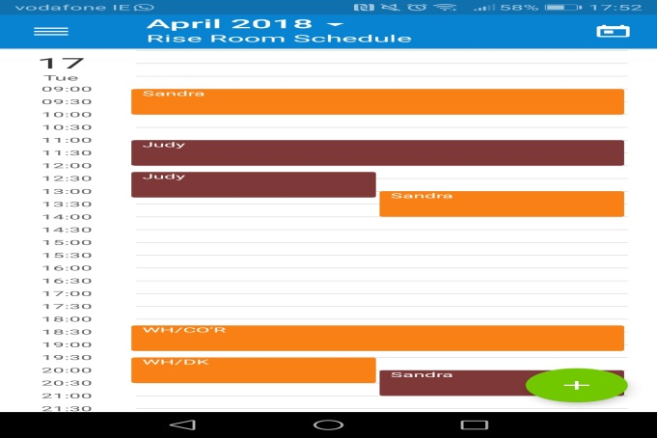

Step 3
Input your name into the title tab. Important: Where you are inputting an MDN, fortnightly or low cost client please include this in brackets beside your name e.g. Wayne (lc) or Wayne (mdn), Wayne (f). Then select the time by clicking on the hour displayed (13:00 below). Once input click on the tick icon denoted below. This is the same to navigate through all steps shown below.
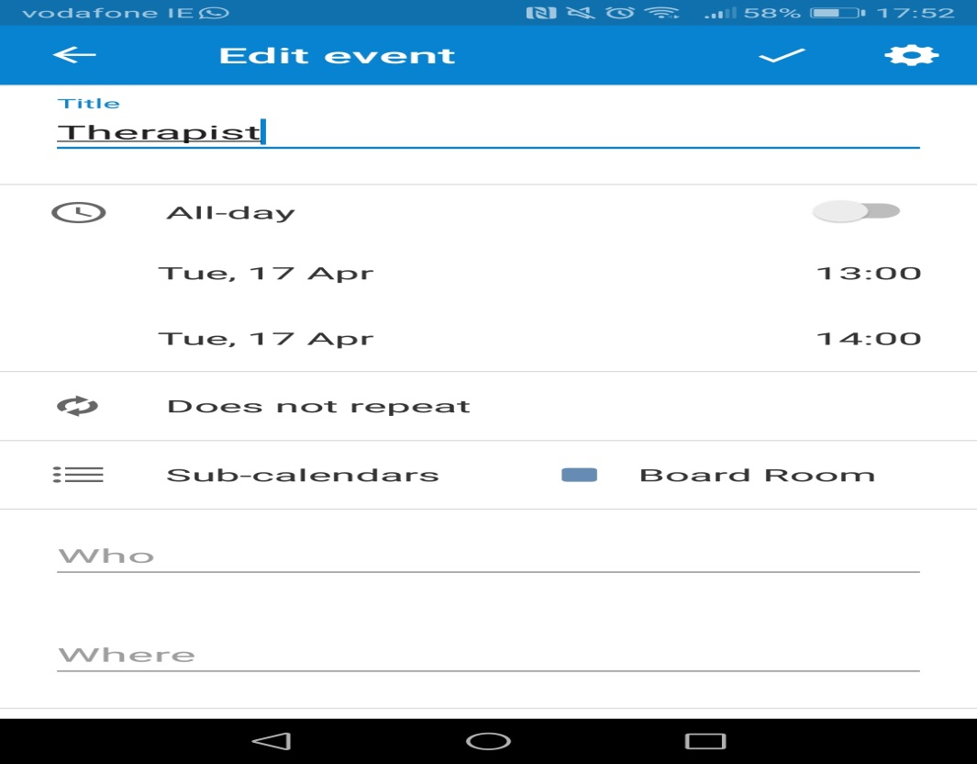

Step 4
Input the time by using the clock or manual entry using the keyboard to the bottom left of Set Time window. Then click on the dropdown labelled ‘Does not repeat’ to move to the next step which is frequency of sessions.
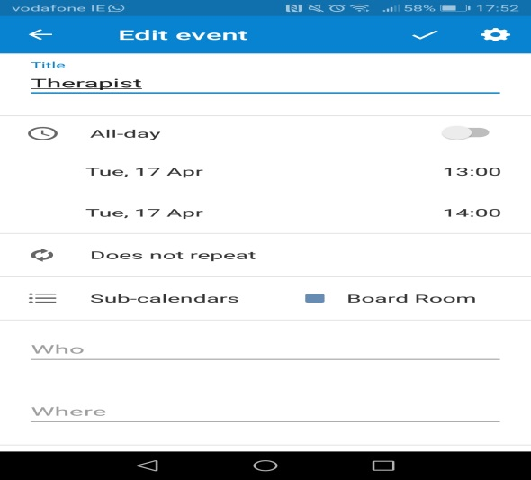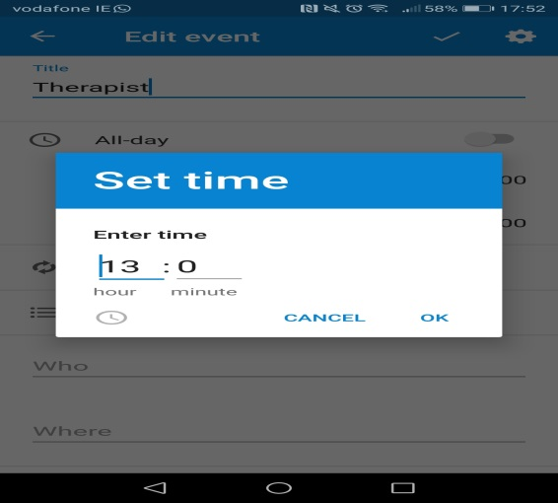

Step 5
Where this is a new weekly client, you do not have to change the ‘Every’ tab as this defaults to 1. In the event you have a fortnightly client you can change it to 2. Fortnightly appointments are discouraged at RISE but we accept sometimes there is no alternative. In the tab ‘Forever’ if you drop down the list you can choose ‘For’ in the event that you are booking the room for a set number of weeks or ‘Until’ if you happen to know a finish date, e.g. if you take an EAP client or contract for a fixed number of sessions.
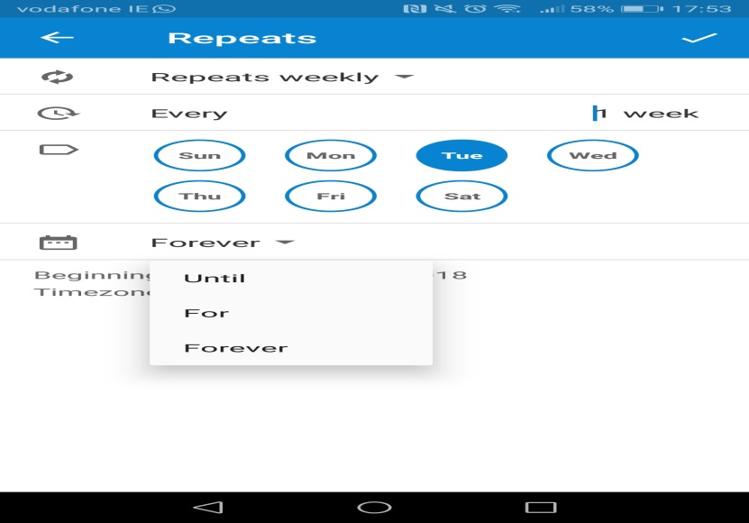

Step 6
The next step, back in the edit event tab is to click on ‘Sub-Calendars’. In the next window select either room 1 or 2 depending on what is available and ensure no other option is ticked before moving on. You can now click on the tick box in the main Edit Event tab to complete booking.
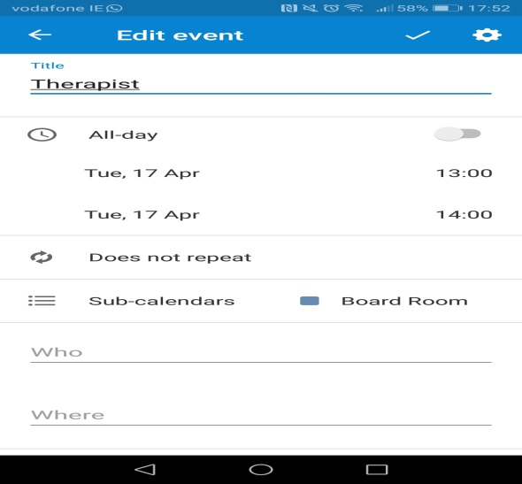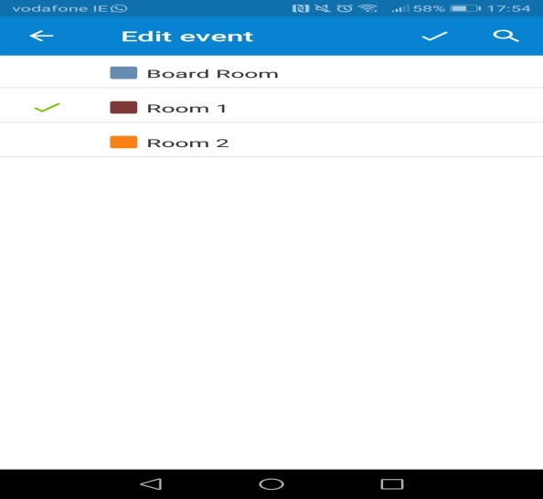

Step 7
Check that your booking is now showing in the calendar. If it is not showing, client on the menu button top right and hit the refresh button shown in the second image below, then check again.
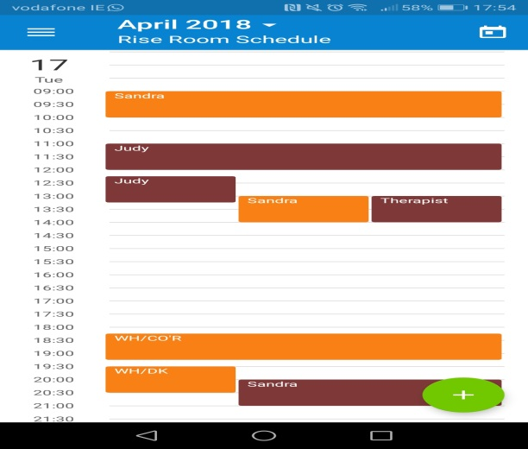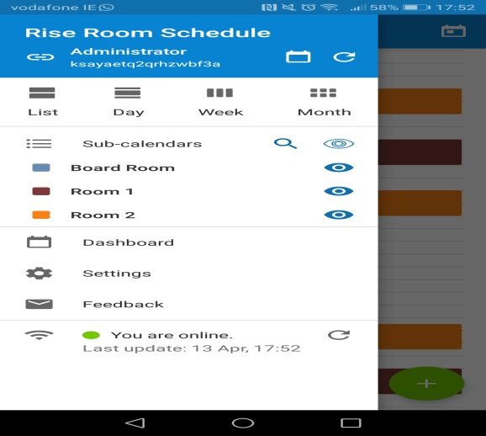

CANCELLING A ROOM
To cancel a room, select the event from the calendar and then click the bin button on the top right, then click delete event. In the next window shown, you have the option of choosing ‘this event only’ or ‘all future events’. NB: DO NOT USE THIS FUNCTION UNLESS A CLIENT IS ENDING IN WHICH CASE ‘THIS EVENT AND ALL FUTURE EVENTS’ IS THE OPTION TO SELECT. TO CANCEL A ROOM ONCE OFF OR FOR A NUMBER OF WEEKS, SELECT THE EVENT FROM THE CALENDAR AND USE THE PENCIL BUTTON TO EDIT THE DETAILS WHICH RETURNS YOU TO STEP 3. BESIDE YOUR NAME INPUT ‘Cancelled until XX/XX/XXXX’ INCLUDING THE DATE THE CLIENT IS RESUMING. IT WILL BE UP TO YOU TO REMEMBER TO AMEND THE EVENT ON THE DATE THE CLIENT HAS RETURNED TO REMOVE THE CANCELLATION NARRATIVE SO PLEASE DIARISE IF NECESSARY. IF LATE CANCEL, PLEASE STATE.
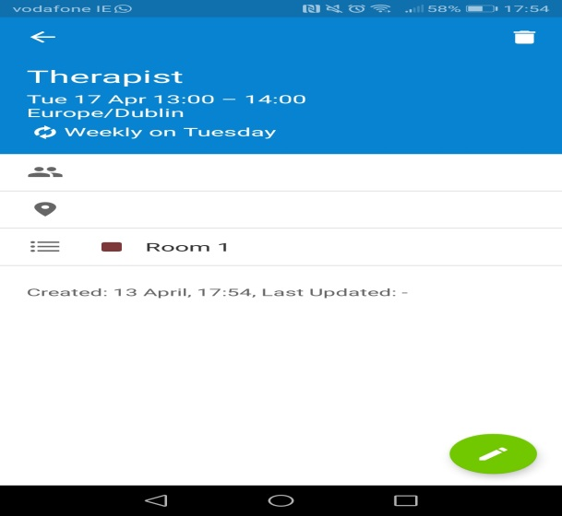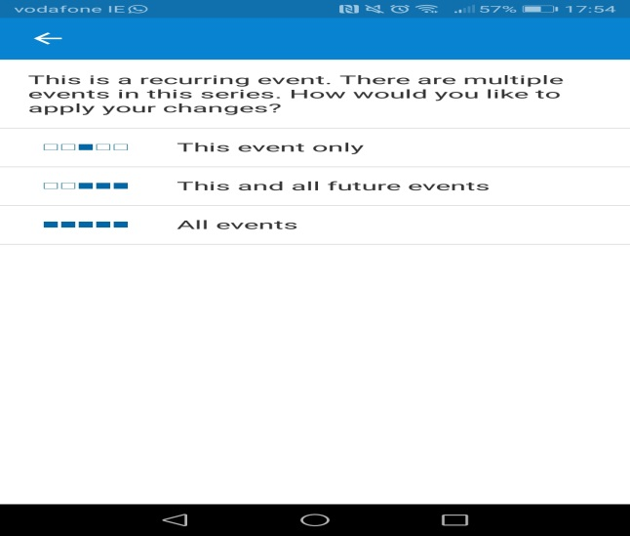
IF YOU ARE REPLACING THE ABSENT CLIENT WITH ANOTHER CLIENT IT IS IMPORTANT TO IMPORTANT TO REMEMBER TO REPEAT THE ABOVE STEP IN THE CLIENT EVENT THAT YOU ARE TEMPORARILY MOVING TO THE NEW TIME. PLEASE CHECK WITH EACH OTHER IF USING A SPACE THAT IS DESIGNATED TO ANOTHER THERAPIST BUT SHOWING AS CANCELLED TO AVOID OVERLAP.

