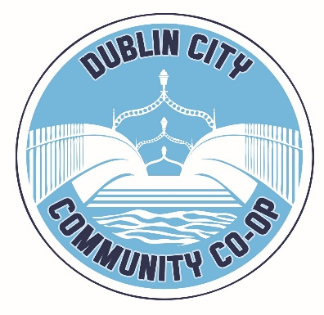
Dublin City Community Cooperative, Register Number 5628 R, Registered Charity Number (RCN) 20107079, Unit 1 Killarney Court, Buckingham Street, Dublin 1

Governance & Compliance Officer

Job Specification

Role of Governance & Compliance Officer
To ensure that Dublin City Community Co-operative (’the Co-op’) continually complies with its external regulatory requirements as well as internal policies and procedures. The Governance & Compliance officer also manages the regulatory risk of the organisation and advises the CEO and board accordingly.
Job Purpose
The Governance & Compliance Officer will support the CEO, the senior management team and the board to ensure ongoing organisation wide compliance with the Charities Regulator Governance Code, relevant governance/compliance legislation and funder requirements (regarding governance matters). The role will also involve supporting programme teams to enable them to achieve compliance and thus deliver a wide range of client-centred services.
Reporting to: The CEO.
Hours: Part-time (21 hours per week)
Contract Term Contract – 12 months (subject to a 3-month probation period
Main Duties & Responsibilities:
• Assist the CEO & the Co-op’s senior management team in the development of policies and procedures to ensure ongoing compliance with the Charities Governance Code, relevant governance legislation and funder governance requirements;
• Monitor, and ensure the implementation of all Co-op policies and procedures to ensure compliance with the Charities Governance Code, and other funder requirements;
• Ensure compliance with funder Contracts and Service Level Agreements;
• Undertake the duties of the Company Data Protection Officer and advise and counsel the CEO on all GDPR related matters;
• Manage the annual Insurance policy renewal process and regularly review adequacy of cover across all programmes. Maintain insurance claim files.
• Maintenance of the company Risk Register (liaising with the CEO, the Finance & Audit subcommittee and the Governance subcommittee);
• Ensure compliance with Health & Safety legislation incl. Co-op safety statement and risk assessments;
• Ensure the Co-op is compliant with Garda Vetting procedures and requirements for all programmes;
• Ensure programme compliance with the Children First Act 2015 in close consultation with the Co-op’s Child Protection Officer;
- Attend board meetings to record the Minutes and ensure all approved Board Minutes have the requisite signatures;

- Support the CEO and Administrative Officer in planning and organising the Co-op’s Annual General Meeting

- In conjunction with the CEO and Board prepare and update the Co-op’s Business Continuity Plans/Contingency Plans/Emergency Response Plans (e.g in case of Data Protection Breeches, IT hacking etc)

Skills, Qualifications & Experience
The ideal candidate should have the following:
- A relevant third level degree;
- A demonstrable expertise in governance and compliance requirements;
- Excellent IT knowledge & skills;
- Experience of internal and project file auditing;
- Experience of developing and implementing policies/procedures across an organisation;
- A demonstrable knowledge of Data Protection/GDPR procedures & best practice;
- Experience of working with public funders
- Excellent interpersonal and teamwork skills

Core Essential Competencies
• Organisational skills
- Ability to work on own initiative
• Attention to detail and an ability to work under pressure and to tight timeframes
• Excellent communications skills; written and verbal
• Analytical skills
• Problem Solving skills in an ever more complex and fast paced environment.
• Decision Making skills
• Project Management experience
• Commitment to high quality standards of work and continuous improvement
- An understanding of and experience in the charity/NGO sector desirable

Interested candidates should submit a cover letter and CV (max 4 pages) to info@dublincitycommunitycoop.ie by close of business 23rd April. Please mark the subject box Compliance & Reporting Officer.
Only short-listed candidates will be contacted.
The Co-op is open to discussing hybrid/remote working arrangements should this suit applicants.

