

**South Munster MABS**

**Recruitment Booklet**

**For the Appointment of Directors**

**Closing Date: 30th April 2024**

Company Registration Number: 621210

Charity Registration Number: 20202874

CHY (Revenue) Number: 22620

**Table of Contents**

|  |  |  |
| --- | --- | --- |
| 1. Background |  | 3 |
| Locations |  | 4 |
| 1. Functions of the MABS Regional Boards |  | 5 |
| 2.1 Board Subcommittees |  | 6 |
| 1. Board Vacancy Details |  | 7 |
| 1. Person Specification |  | 7 |
| 4.1 Core Values |  | 7 |
| 4.2 Skills |  | 8 |
| 4.3 Expertise |  | 8 |
| 4.4 Additional Competencies |  | 9 |
| 4.5 Fiduciary Duties |  | 9 |
| 1. Application Process |  | 9 |
| Closing Date |  | 9 |
| 1. Maintaining Board Confidentiality |  | 10 |
| 1. Confidentiality of Applications |  | 10 |
| 1. Data Protection |  | 11 |
| **Appendix 1:** Grant Receiving Body Statement |  | 12 |
| **Appendix 2:** Role of Charity Directors |  | 13 |
| **Appendix 3:** Data Protection Notice |  | 14 |

1. **Background**

The Money Advice and Budgeting Service (MABS) is a national, free, confidential and non-judgemental service open to all members of the public, providing money advice and budgeting service to people in debt or in danger of getting into debt for more than 25 years. Each MABS company is rooted within the communities they serve and staff work with clients to enable them to cope with immediate debt problems and assist them to develop good money management skills.

MABS Services work with clients who may have difficulties with a wide range of personal debts including personal loans, mortgages, credit card debts, catalogue debts, debts to legal moneylenders and hire purchases. They assist clients by reviewing budgets, negotiate with creditors and look at opportunities to maximise income.

MABS also act as Approved Intermediaries under Personal Insolvency legislation for clients availing of a Debt Relief Notice. MABS has always dealt with mortgage and housing related debt and this is treated as a priority debt in MABS.

MABS acts as the gateway to advice under the Abhaile scheme, which provides vouchers for clients to see Personal Insolvency Practitioners, Legal or Financial Advisers. In addition MABS supports clients at all of the repossession court sittings in the country as Court Mentors.

MABS has a remit in Money Management Education by advising clients in relation to budgeting and debt management. MABS facilitates group talks in schools and the community in relation to money management, good saving and spending habits, sources of credit and the avoidance of over-indebtedness.

MABS runs a Helpline and also operates from over 55 locations across the country, with Money Advisers available by phone, email and live chat. For further information please see: [Home - MABS](https://www.mabs.ie/en/). MABS is funded and supported by a public agency, namely the Citizens Information Board.

**South Munster MABS** (SM MABS) is one of eight regional MABS companies and was established in 2018. The company covers the counties of Cork and Kerry. The company provides its service through a network of six local offices in Tralee, Killarney, Dunmanway, Cork city, Mallow and Charleville. The Regional Company is a registered charity and lead by a Regional Manager reporting to a voluntary board of Directors and funded through a service level agreement with the Citizens Information Board.

The service delivery model changed significantly in 2020 because of COVID-19. MABS as an essential service, adjusted its operations to ensure it remained accessible to its customers. The board of the SM MABS adopted a three-year strategic plan in 2020 and has just commenced year two of the action plan to realise the strategy. Although an adjustment to the annual action plan was required due to COVID-19, the agreed strategic themes were broad enough to support the flexible and responsive approach required to continue operations throughout regularly changing public health restrictions.

**L****ocations**

Each MABS covers a geographical region, facilitating both rural and urban areas delivering services through a network of local MABS offices.

The eight regional MABS companies are as follows: North Dublin, Dublin South, North Connacht & Ulster, North Leinster, North Munster, South Connacht, South Leinster and South Munster, as illustrated in the map below.

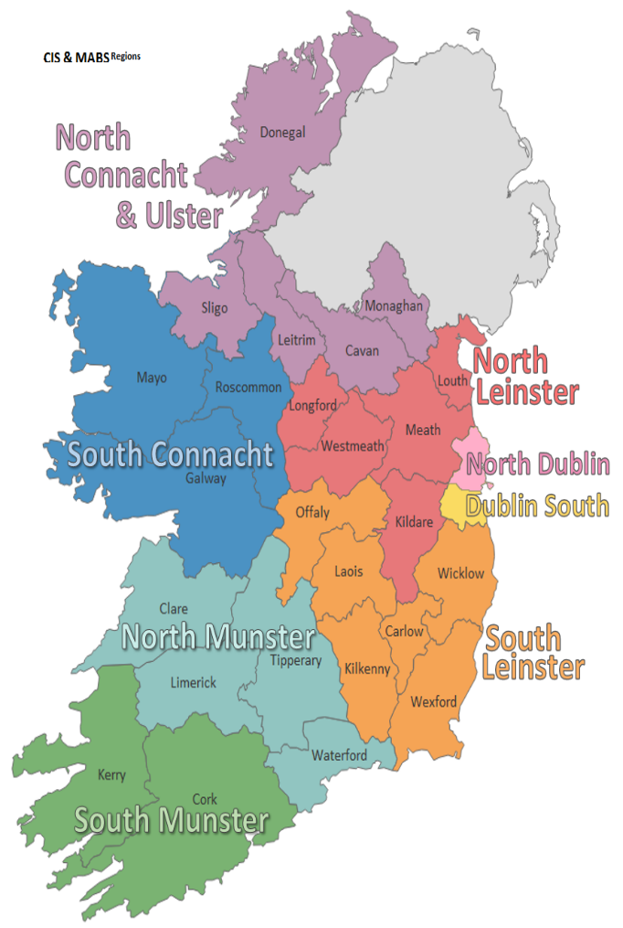

1. **Fun****ctions of the MABS Regional Boards (The Company)**

The overall function of each Board is to deliver Money Advice and Budgeting Services in its region in accordance with a Service Level Agreement with the Citizens Information Board (CIB). High standards of corporate governance in community and voluntary Boards are critical to ensuring a positive contribution to the State’s overall social and economic development.

The main objects of the Companies are:

* to provide an independent, free, confidential and non-judgemental Money Advice and Budgeting Service to individuals and families in the Area to facilitate them to cope with their immediate debt problems and become financially independent in the long term;
* to provide an Approved Intermediary Service under the provisions of the Personal Insolvency Act 2012, as amended;
* to educate and impart skills for money management to low income families, individuals and relevant target groups within the Area through Money Management Education;
* to identify and facilitate access to credit where appropriate and to negotiate with creditors on behalf of clients when necessary, relevant and appropriate;
* to highlight changes in policy and practice which need to be implemented at local and/or national level to combat economic hardship, financial exclusion and over indebtedness;
* to implement any national programmes and initiatives that may be developed from time to time in furtherance of the main object of MABS including targeted programmes for particularly vulnerable clients such as those in Mortgage Arrears;

The members of the Regional Boards are appointed to oversee and support the provision of money advice and budgeting services to the public.

They must serve the interests of service users, the taxpayer, pursue value for money in their endeavors (including managing risk appropriately), and act transparently. [1]In line with the obligations of entities in receipt of public funding Regional Boards must adhere to the principles of:

* Clarity
* Governance
* Value for Money
* Fairness

Regional Board members should act on a fully informed basis, in good faith, with due diligence and care, and in the best interest of the organisation, subject to the objectives of the company.

An important role of the Regional Board members is to maintain the trust of the clients and customers in the independence of the Money Advice and Budgeting Service.

**2.1 The following Board S****ubcommittees have been established in SM MABS**

**The Finance, Audit and Risk (FAR) Committee**

Among the members of FAR committee there is at least one qualified accountant and it includes other members who are experienced in dealing with budgeting and financial systems and reporting on a scale similar to that of the operations of the company. Where possible, the committee should include a member who has experience of managing risk in a non-commercial setting. The FAR committee is responsible for advising the board on matters including budgeting and monitoring of cash-flow, financial reporting requirements, value for money, governance, risk management, procurement, internal control, internal audit, external audit and reviewing its own effectiveness.

**The Services Delivery (SD) Committee**

The SD committee is responsible for advising the board on matters relating to the quality and quantity of service delivery across the region, to identify services which are not meeting agreed standards, to identify the potential and need for different and / or new services and to propose changes which will enhance the nature of services through the initiation of research or of piloting new approaches.

**The Nominations Committee**

The company establishes a Nominations Committee as needed for the purposes of board self-evaluations and the recruitment and nomination of new board members.

**The HR Committee**

The purpose of the HR Committee is to provide support and advice to the regional manager and the board of directors in the management of the human resources, employee and industrial relations (IR) functions within the company.

The board may establish other standing / sub or project committees to assist the board in the effective and efficient performance of its responsibilities. All members will be expected to make themselves available to be a member of a committee. Composition of committees is a matter for the regional board.

1. **Board Vac****ancy Details**

The current Board recruitment process is for **three (3)** individual directors.

The maximum Board membership is 10 Directors, including the Chairperson.

These are voluntary Regional Boards of Management and as a result no fees are paid to Regional Board members. Travel and subsistence expenses will be paid to members where applicable.

There will be approximately 8 meetings per annum, plus attendance at sub-committee meetings, as required. Together with preparatory reading for meetings and follow up activities and information analysis, the total commitment could be up to 10 - 15 hours per month.

Each Director of a Board shall be appointed to serve for a term of up to three years and may only serve for a maximum of two terms either consecutively or cumulatively.

Should more than three (3) candidates be deemed suitable for appointment, the Board may form a panel for any future vacancies (12 months), or a candidate may be offered a position on a board committee.

1. **Person Spe****cification**

Fundamental to the role of being a Board Member of the Money Advice & Budgeting Service is the understanding of the values and importance of serving local communities and having Governance experience and expertise.

Candidates for board membership must demonstrate that they have an understanding of the core values of South Munster MABS; that they possess the essential knowledge, skills and experience of governance required for board membership and that they understand the importance of serving local communities.

**4.1 Core V****alues**

In executing the main object of the company, South Munster MABS are looking for candidates that can demonstrate the following core values:

* **Public Service**: Board members should act solely in terms of the public interest. They should not do so in order to gain financial or other benefits for themselves, their family or their friends
* **Integrity**: Board members should not place themselves under any financial or other obligation to outside individuals or charities that might seek to influence them in the performance of their official duties
* **Objectivity:** In carrying out public business, including making public appointments, awarding contracts, or recommending individuals for rewards and benefits, board members should make choices on merit.
* **Accountabilit**y: Board members are accountable for their decisions and actions to the public and must submit themselves to whatever scrutiny is appropriate to their office.
* **Openness**: Board members should be as open as possible about all the decisions and actions that they take. They should give reasons for their decisions and restrict information only when the wider public interest clearly demands.
* **Honesty**: Board members have a duty to declare any private interests relating to their public duties and to take steps to resolve any conflicts arising in a way that protects the public interest
* **Leadership**: Board members should promote and support these core values by leadership and example.
  1. **Skills Req****uired of Board Members**

The following four criteria are essential to the role of a Board member with SM MABS

* Demonstrated knowledge of the community & voluntary sector and / or publicly funded bodies
* Previous experience as a Board member
* Senior Management / Leadership Experience
* Good knowledge of Corporate Governance
  1. **Exper****tise and experience in the following areas are considered important and highly desirable for the membership of the Board of SM MABS:**
* Financial Management experience, relating to publicly funded bodies
* Legal
* Human Resource Management/Strategy
* Public Relations / Marketing Communications skills
* Policy & Strategy Development (Social Policy)
* Customer Experience Management / Service Delivery Risk & Compliance
* Knowledge or experience of debt management issues
  1. **The following ad****ditional competencies are considered beneficial:**
* Procurement
* Change Management
* Data Protection
* Health & Safety
* Advocacy & Influencing skills
* Information/Digital Technology Project Management Experience
  1. **Fiduci****ary Duties**

A list of the fiduciary duties of an individual company director and charity trustee are listed in Appendix 2

1. **Applica****tion Process**

Having considered the general suitability criteria for membership of the SM MABS board, you should consider carefully how your background and experience fits with the specific appointment criteria set out in the person specification above.

Please give consideration to the possibility of any potential conflict of interest that may arise if appointed to this board.

* **Please email your expression of interest application to:** [**fiona_hendrick@mabs.ie**](mailto:fiona_hendrick@mabs.ie)

Please type ‘South Munster MABS Board of Director Expression of Interest’ in the subject line.

**Clos****ing date / time for receipt of applications is: 30th April 2024**

Ensure your application form clearly specifies how your particular background and experience meets the requirements of the Regional Board position(s) specified in this expression of interest document.

**The assessment will:**

* Review and discuss the expressions of interest received against the specific appointment criteria for the role, as advertised in this Information Booklet;
* Assess potential candidates further once they meet the specified appointment criteria by undertaking any or all of the following steps:
  + Consideration of the written applications; and / or
  + Meeting / conference call; and / or
* Referee checks; and / or any other selection or verification method deemed appropriate.
* Arrive at a shortlist of the most suitably qualified candidates (based on the information provided by the candidate) to be sent forward for consideration by the full board.

In evaluating Expressions of Interest, the appropriate skills match and the needs of the Board at any given time are considered. This may mean, that despite a strong skills match, it may not lead to an automatic recruitment to the Board of SM MABS. Please note that the SM MABS will not be responsible for any expenses incurred by candidates as part of our selection process.

If you have any questions regarding the application process please email:[**fiona_hendrick@mabs.ie**](mailto:fiona_hendrick@mabs.ie)

1. **Maintaining Board Confiden****tiality**

From time to time board members / trustees will be involved in activities either at Board meetings or on behalf of the Board which call for tact, discretion and above all, confidentiality.

Some of the more obvious examples of this include staff and employment issues or commercially sensitive information or comments during honest and open Board discussions. The proceedings of all such meetings are confidential to those taking part.

Successful applicants to this regional board will be provided with induction training as appropriate.

PLEASE NOTE: No person shall be eligible to be a board member if he / she is an employee of a CIB funded service, or is an employee or board member of the CIB.

1. **Confidentiality of Appli****cations**

Subject to the provisions of the Data Protection Act 2018 and GDPR, all applications will be treated in strict confidence. All enquires, applications and all aspects of the proceedings are treated as strictly confidential and are not disclosed to anyone, outside those directly involved in that aspect of the process.

1. **Data Prot****ection**

Please see attached ‘South Munster MABS Data Protection Privacy Notice for Board Applications’. Appendix 3

**App****endix 1**

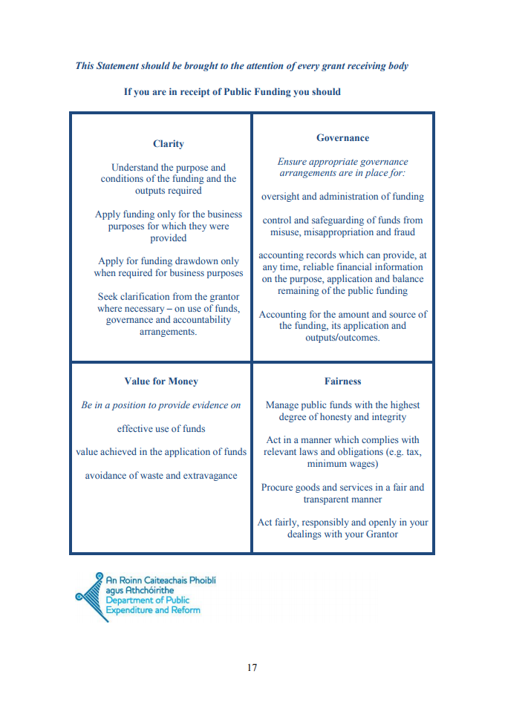

**Appe****ndix 2**

**Role of Individual Charity Directors**

Fiduciary Duties of a Company Director under Companies Act 2014:

* To act in good faith in what the director considers to be the interests of the company;
* To act honestly and responsibly in relation to the conduct of the affairs of the company;
* To act in accordance with the company’s constitution and exercise his or her powers only for the purposes allowed by law;
* Not to use the company’s property, information or opportunities for his or her own benefit, or that of anyone else, unless (a) this is permitted expressly by the company’s constitution or (b) the relevant use has been approved by a resolution of the company in general meeting;
* Not to agree to restrict the director’s power to exercise an independent judgement unless (a) this is expressly permitted by the company’s constitution or (b) the case concerned falls within limited exceptions;
* To avoid any conflict between the director’s duties to the company and the director’s other (including personal) interests, unless the director is released from his or her duty to the company in relation to the matter concerned, whether by the company’s constitution or by a resolution of the members in general meeting;
* To exercise the care, skill and diligence which would be exercised in the same circumstances by a reasonable person having both (a) the knowledge and experience that may reasonably be expected of a person in the same position as the director and (b) the knowledge and experience which the director has; and
* (As mentioned above) to have regard to the interests of the company’s employees in general and its members.

Duty of a Charity Trustee under Charities Act 2009:

* Comply with the [Charity Name] constitution
* Ensure that [Charity Name] is carrying out its charitable purposes for the public benefit
* Act in the best interests of [Charity Name]
* Act with reasonable care and skill
* Manage the assets of [Charity Name]
* Make appropriate investment decisions
* Ensure that [Charity Name] is registered on the Charities Regulator’s Register of Charities
* Ensure that [Charity Name] keeps proper books of account
* Ensure that [Charity Name] prepares and furnishes financial accounts to the Charities Regulator
* Ensure that [Charity Name] prepares and furnishes an annual report to the Charities Regulator
* Ensure the Charities Regulator is informed if you are of the opinion that there are reasonable grounds for believing a theft or fraud has occurred (Disclosure obligation)
* Ensure that you comply with directions issued by the Regulator

**Appe****ndix 3**



**Data Protection Notice for Board Members**

**Who are we?**

We are:

**South Munster Money Advice and Budgeting Service CLG**

Our registered address is: **101 North Main Street, Cork**

We are funded by the Citizens Information Board, a State agency, located at Georges Quay House, 43 Townsend Street, Dublin 2.

We provide services in relation to your debts and financial situation.

This notice sets out the basis on which any personal data we collect from Board Members, or from others, will be processed by us. Please read the following carefully to understand our practices regarding your personal data and how we will treat it.

For the purpose of the Data Protection Acts 1988-2018, (‘’the Acts’’) and the General Data Protection Regulation (‘’GDPR’’) (Regulation (EU) 2016/679) (each as amended, revised, modified or replaced from time to time) the data controller is:

**South Munster MABS Money Advice and Budgeting Service CLG.**

Our data protection contact is the Regional Manager:

**Ms Ursula Collins**

______________________________________________________________________________

**What personal information do we collect from you?**

We may collect a range of personal information from you, including:

* Biographical information
* Contact information
* Information relating to your activities in the organisation

You may give us personal data by:

* Applying for a role or roles in the organisation
* Providing information requested to Human Resources
* Corresponding with us by phone, email or otherwise
* Taking part in training, surveys, performance appraisal processes
* Attending at an office where CCTV (Closed Circuit Television) is in operation

**What information about you do we obtain from others?**

When you apply for a role in the organisation or become a Board Member, we may obtain, with your authorisation, the following categories of personal data from others:

* References from other organisations

**Why do we collect this information?**

We may use this information:

* To coordinate all aspects of your role as a Board Member
* To assist us in processes such as the identification of training needs, performance appraisal processes
* To invite you attend meetings and events
* To keep you up-to-date and informed in relation to the organisation and your role
* To contact nominated individuals in the event of an emergency

The legal bases for the processing of your data are:

* That you have provided consent for the processing
* Processing is necessary for compliance with a legal obligation to which we are subject

From time to time, we may also collect sensitive or ‘special category’ data in the course of your role in the organisation. The legal basis for the processing of your special category data is:

* That you have provided consent for the processing
* Processing is necessary for compliance with a legal obligation to which we are subject

**Who do we share this information with?**

We may share your personal data with the Citizens Information Board and with other organisations.

We attach at Schedule 1 a list of entities and categories of entities with which your personal data may be shared.

In addition, we may disclose your personal information to third parties:

* If there is a risk of serious harm to you or to another person or to property
* If we are under a duty to disclose or share your information in order to comply with any legal obligation
* If we are required to give evidence in court
* To get legal advice or to defend a legal right
* In the event of a disclosure relating to child abuse

**How long do we keep hold of your information?**

The time periods for which we retain your information depends on the type of information and the purposes for which we use it. We will keep your information for no longer than is required or permitted.

**Do we transfer your information outside the European Union or European Economic Area?**

No.

**What are your rights with respect to your personal data?**

You have the following rights:

* The right to access the personal data we hold about you.
* The right to require us to rectify any inaccurate personal data about you without undue delay.
* The right to have us erase any personal data we hold about you in circumstances such as where it is no longer necessary for us to hold the personal data or, in some circumstances, if you have withdrawn your consent to the processing.
* The right to object to us processing personal data about you such as processing for profiling or direct marketing.
* The right to ask us to provide your personal data to you in a portable format or, where technically feasible, for us to port that personal data to another provider provided it does not result in a disclosure of personal data relating to other people.
* The right to request a restriction of the processing of your personal data.

Where our processing of your personal data is based on your consent to that processing, you have the right to withdraw that consent at any time but any processing that we have carried out before you withdrew your consent remains lawful.

You may exercise any of the above rights by contacting the Money Advice Coordinator or Regional Manager at any of the contact points listed above.

You may lodge a complaint with your supervisory authority with respect to our processing of your personal data. The supervisory authority in Ireland is the Data Protection Commission. The website is www.dataprotection.ie.

**What will happen if we change our Data Protection Notice?**

This notice may change from time to time, and any changes will be notified to you and will be effective when notified.

This notice was last updated on **14th April 2022.**

**How can you contact us?**

Our data protection contact can be contacted at any of the contact points listed above.

**Sched****ule 1**

We have set out below a list of third parties with whom we may share your data.

|  |  |
| --- | --- |
| **Third party** | **Description** |
| Any legal successors to the Money Advice and Budgeting Service company | Where the MABS company transfers its business to another company or merges with another company. |
| Citizens Information Board | * In the provision of ICT hardware and software, networks and network storage, case management systems, email, telephony and helpdesk services * In order to maintain business contact details * In order to monitor compliance with funding agreements, service level agreements and other agreements * In order to provide advice in relation to practices and procedures generally * In the provision of training courses including eLearning |
| Companies Registration Office and Charities Regulator | Where we provide company reports and accounts and to meet the company’s legal obligations under the Companies Act, 2014. |
| ICT companies | Where ICT services such as network facilities, hardware, software, email, network storage, HR management systems or similar are provided by or maintained by a third party. |
| Recruitment companies | Where we use a third party to assist in recruitment competitions. |
| External organisations nominated by you | Where you request us to engage with external organisations in relation to your activities in the organisation. |
| Training providers | Where you take part in training as part of your activities in the organisation. |
| Insurance companies | Where we engage with an insurance company in relation to an aspect of your activities in the organisation. |
| HR support companies or other advisers | Where we require advice or support in relation to an aspect of your activities in the organisation. |
| Archiving companies | Where we archive our files in facilities provided by a third party. |
| Shredding companies | Where our files are securely destroyed by a third party. |

1. Extract from Circular 13/2014 page 17 see appendix 1