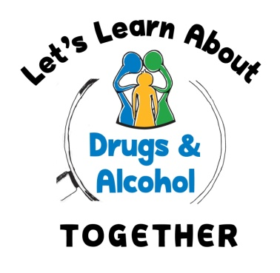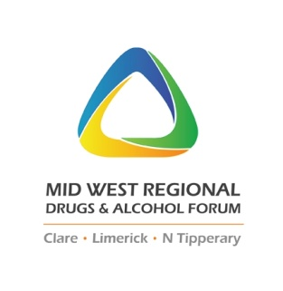

The “Let’s Learn about Drugs and Alcohol Together” Programme

Post Primary Substance Use Education Project – Support Worker

**SPECIFIC PURPOSE CONTRACT POST AY2023/2024**

**Project Summary:**

The Let’s Learn about Drugs and Alcohol Together (LLADAT) Programme is a partnership between the HSE Mid-West Drug and Alcohol service and the Mid-West Regional Drugs and Alcohol Forum (MWRDAF). Developed in September 2012 the programme went into a select few post-primary schools on a pilot basis in January 2013. Following on from a successful pilot a regional pilot took place in the academic year 2013/14, and has continued across the region since. The aim of the programme is to engage parents and 2nd year post primary students in a shared learning experience around the topic of substance use. The aim of the programme is to build parental confidence and knowledge around substances appropriate for the age group and to encourage parental dialogue with young people about the challenges of growing up in today’s world in relation to substance misuse. The programme was stood down in March 2020 due to the COVID 19 pandemic. January 2023 will be a restart to programme delivery for schools across the mid-west.

**Job Description:** Education Support Worker – sessional hours

***Reporting to:*** *MWRDAF Co-Ordinator*

**Location of Post:** Main Office: Corporate House, Mungret St. Limerick City

**Organisational Area:** Regional Basis (Clare, Limerick City & Co and North Tipperary)

**Purpose of Post:** work in partnership with the LLADAT Project Co-ordinator to aid in the delivery of the LLADAT programme across the Mid-West region

**Contract:**  20 hrs per week (plus travel subsistence and expenses)

***Note:***20 hours incorporates time for travel, flexible working hours, primarily evenings

4th September 2023 to 26th April 2024 – exclusive of school holidays, *Post Primary School holidays-listed in appendix*

**Salary:** LCETB Tutor Rate 2

**Principal Duties and Responsibilities:**

|  |
| --- |
| * Deliver the Let’s Learn About Drugs & Alcohol Together afterschool sessions * Support the day to day and planning administration duties of the LLADAT programme * Deliver the resource from an evidence base * Actively engage in the evaluation of the LLADAT programme * Draft written reports and presentations related to evaluation findings. * Liaise with the LLADAT Project Co-ordinator in planning academic delivery * To agree targets for the LLADAT academic delivery across the region |

*Eligibility Criteria Qualifications and/ or Experience*

|  |  |
| --- | --- |
| **Health** | A candidate for and any person holding the office must be fully competent and capable of undertaking the duties attached to the office and be in a state of health such as would indicate a reasonable prospect of ability to render regular and efficient service. |
| **Character** | Each candidate for and any person holding the office must be of good character |
| **Age** | Age restrictions shall only apply to a candidate where he/sheis not classified as a new entrant (within the meaning of the Public Service Superannuation Act 2004). A candidate who is not classified as a new entrant must be under 65 years of age. |

Post Specific Requirements: *additional qualifications and/or experience*

* Completion of a **recognised 3rd level qualifications** (minimum NQF Level 7) in relation to
  + Education, or
  + Substance Use, or
  + Health Promotion or equivalent
* Recognised qualification of **Group** **Facilitation Skills** and/or evidence of related experience
* **Minimum** **two years’ experience** (see below for more information)
  + **Experience working in**:
    - Formal or informal education setting with post-primary children ***or***
    - Experience working in drug education and prevention setting ***or***  equivalent
* **Professional competence and understanding** in relation to post-primary school setting, substance use education and prevention, youth work and child development.
* Knowledge of **Social, Personal and Health Education** (SPHE) and the **NDS Reducing Harm, Supporting Recover 2017-2025**
* **Flexibility in work practices**, commitment to evening work, access to transport as the post will involve travel and flexible working, i.e. unsociable hours. Predominantly after 5.30 p.m., may include some daytime work where necessary.

*Skills competencies and / or knowledge*

|  |  |
| --- | --- |
| **Interpersonal Skills** | * Communication Skills * Facilitative Skills * Ability to influence and persuade * Capacity to build relationships * Competency to work with parents **and** with youths * Ability to work with others as part of a team * Capability to deal with complaints and situations * Customer orientated |
| **Organisational Skills** | * Motivated and energetic * Committed * Adaptable, Flexible * Organised |
| **Competencies** | * Presentation Skills * Willingness to learn * ICT Literate * Methodical / Conscientious |

**The “Lets Learn about Drugs and Alcohol Together” Programme**

The ‘Let’s Learn about Drugs & Alcohol Together’ (LLADAT) post-primary programme began in September 2012 aided by funding made available by the Health Services Executive (HSE) for the development and pilot of “an evidence-based, sustainable workshop for teachers, parents and their children that would allow them to have a shared experience of drugs education”. For the Mid-West Regional Drugs & Alcohol Forum, the initiative provides a further layer of support for schools as a key partner in the prevention pillar of the National Drugs Strategy.

In designing the project proposal, the objectives were to respond in a consistent planned way, in keeping with best practice in this area (of substance use education in schools). Key family risk and protective factors have been repeatedly identified by research. As a key objective in terms of outcomes, LLADAT endeavours to nurture protective factors relating to parent-child relationship and discussion of clear messages surrounding substance use. This meant that the concept of shared learning experiences became central and was a new approach because traditionally, parents and adolescents were addressed as separate groups. For the programme to run in any school the following criteria must be met:

* + Alcohol, Cannabis and Solvents topics covered prior with the pupils in SPHE class.
  + While workshop 1 is always delivered, workshop two delivery is subject to attendance of 6 or more parents at workshop one.

The programme, which is structured as two individual workshops, is aimed at second year pupils in post-primary education and is grounded in the National Council for Curriculum and Assessment (NCCA) guidelines relating to substance use education in SPHE. The first workshop invites parents/guardians only to explore substance information; age-related development; parental influence; prevention messages; how to talk in the home; national and local services. The second workshop invites parents/guardians and their child to explore pertinent information regarding substance abuse, its effects and dangers in an activity based interactive workshop where pupils working with their own parents (or another family member) and others’ develop their own responses and conclusion to activities.

The programme was stood down in March 2020 due to the COVID 19 pandemic after a very successful year. September 2023 will mark as a restart to programme delivery to schools across the mid-west, while also marking our 10 years in operation.

**Appendix 1 – Post Primary School Holidays**

*\*\* These dates are not included in the specific purpose contract \*\**

October 2023 (mid-term)

* Monday 30th October to Friday 3rd November (inclusive)

Christmas and New Year 2023

* Monday 13th February to Friday 17th February (inclusive)

February 2024 (mid-term)

* Monday 25th December to Friday 5th January 2024 (inclusive)

Easter 2024

* Monday 25th March to Friday 5th April 2024 (inclusive)