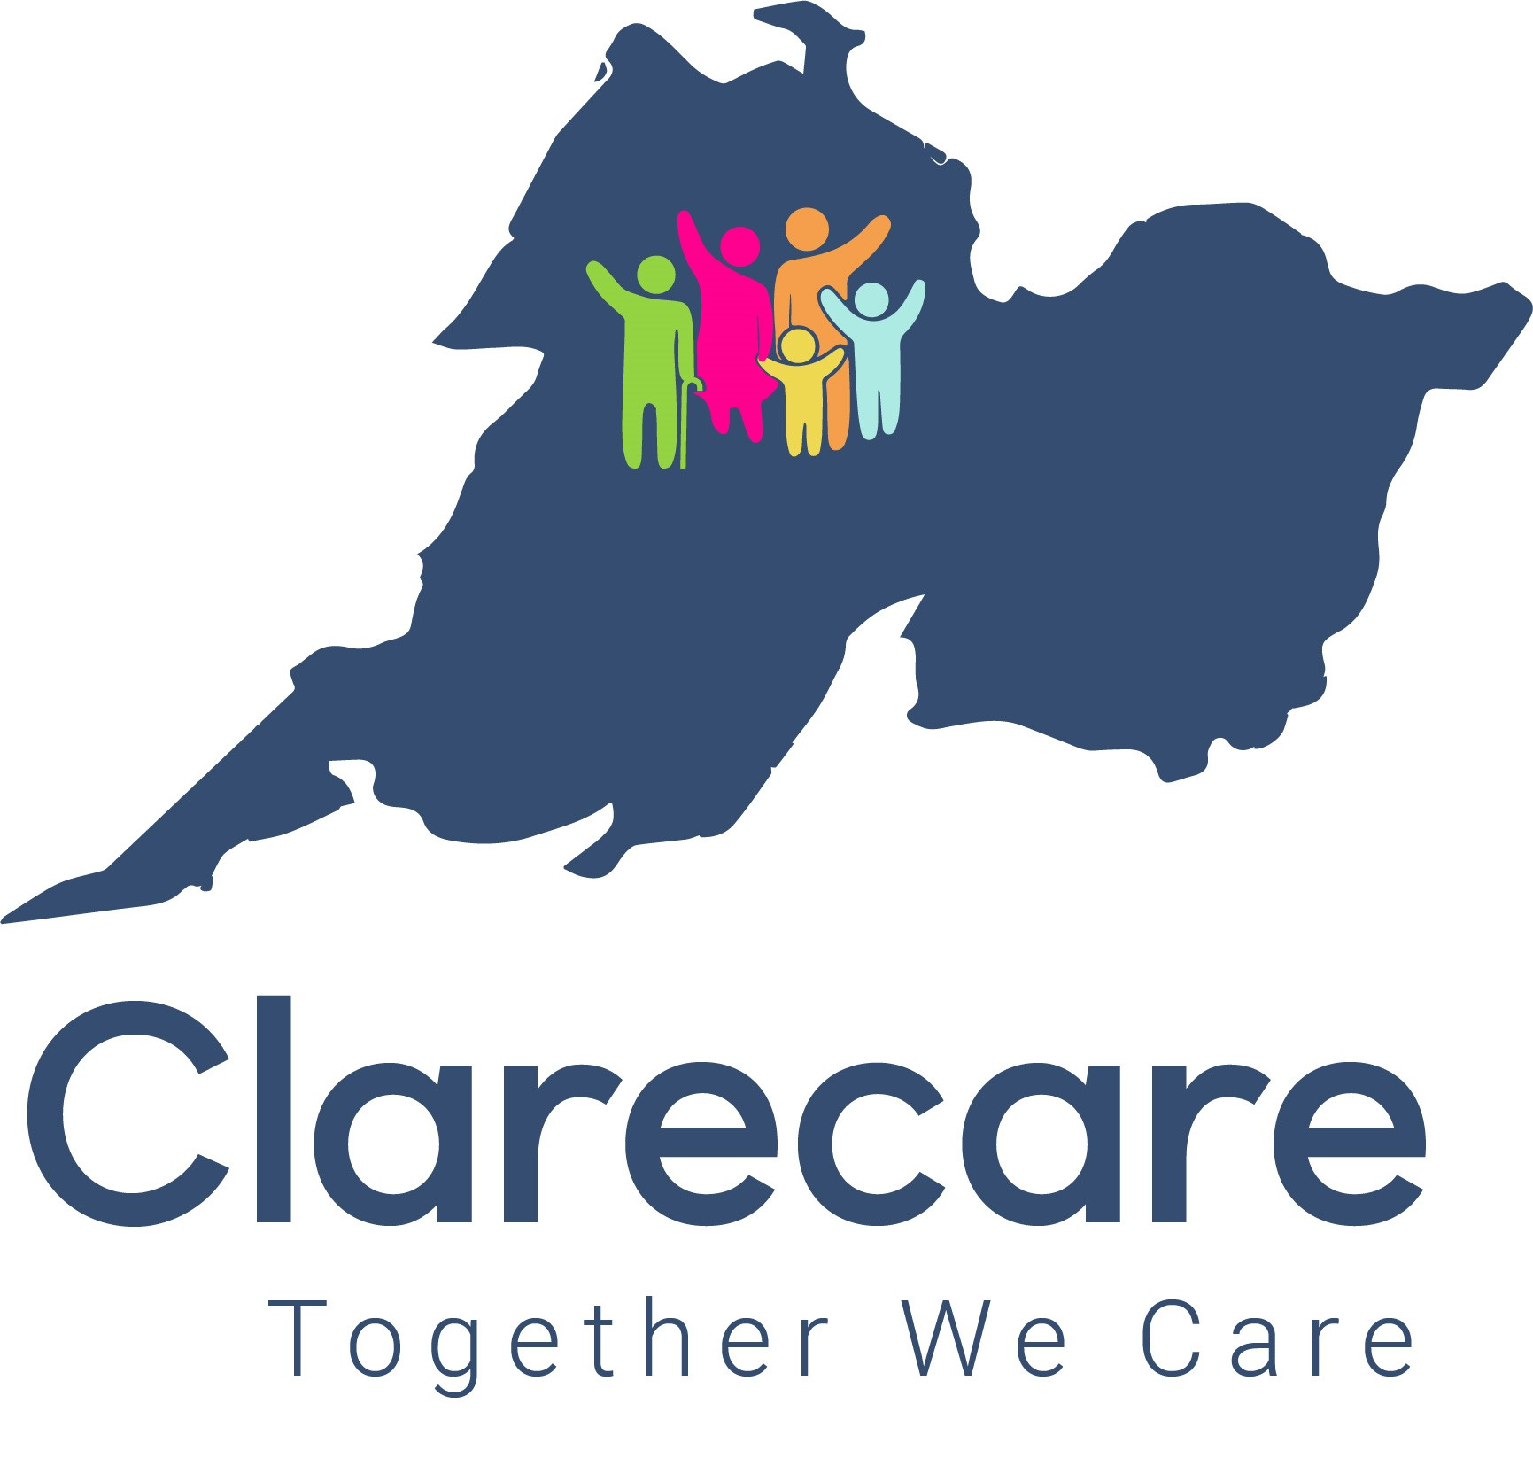
Clarecare’s vision is to be the trusted quality care provider within our communities by supporting individuals and families to reach their full potential.

Clarecare is a professional accredited social enterprise with charitable status, providing a range of people centred social services to individuals and families in County Clare for over 50 years. Current services provided include Family Support, Older Person Services and Bushypark Residential Addiction Treatment Centre, etc. Clarecare’s headquarters are based in Ennis with local offices in Bushypark, Shannon, Kilrush, Killaloe and Ennistymon. Further information is available on www.clarecare.ie www.bushypark.ie

Clarecare is supported by a partnership with TUSLA, Health Service Executive, other Government Departments, by charitable funding and by the Diocese of Killaloe.
Clarecare’s Family Support Service, funded by TUSLA, offers a range of interventions to vulnerable children, including children subject to Safety Plans and/or open case to TUSLA, Child & Family Agency. We work in partnership with service users and professional colleagues in the provision of individual and group-based supports.

JOB DESCRIPTION

SOCIAL WORKER: CHILDREN AND PARENTS
IMMEDIATE VACANCY: 3 DAYS PER WEEK PART-TIME PERMANENT CONTRACT

The Social Worker within Family Support Services aims to work with parents to improve their parenting capacity to ensure better outcomes for children.

DESCRIPTION OF ROLE
- Working from the Clarecare CLG Family Support Service practice model (based on the Tusla National Practice Model – Meitheal), the role of the Social Worker is to deliver quality and innovative interventions and tailored home visiting programmes for families focusing on the child/parent relationship to improve their relationship, communication and family functioning.
- To facilitate evidence informed group-based parenting programmes supporting parents to improve parenting confidence, manage children’s behaviour and build positive and secure parent-child relationships.
- To undertake parenting assessments which inform the supports required to improve parent’s capacity to meet their children’s needs.

CLARECARE’S FAMILY SUPPORT SERVICE OBJECTIVES:
- To deliver quality services to children and parents in their local community.
- To improve outcomes for children through the delivery of interventions underpinned by the National Policy Framework for Children and Young People and Clarecare’s specific overarching goals that all children are (1) safe and protected from harm and are (2) achieving their full potential in learning and development.
- To work in partnership with children and parents to identify their strengths and needs within their home and community environment and to work together to enhance resilience.
- To provide a safe and supportive space, which will give children and parents the opportunity to express and explore issues and concerns, which they may be experiencing.
- To encourage parents to build on their parenting skills and enhance relationships and communication with their children.
- To link and co-operate with other disciplines and agencies in order to promote a cohesive service for children.
JOB RELATIONS: The Family Support Social Worker reports to a designated Team Leader and works as part of a wider Family Support Team which is managed by the Family Support Service Manager.

JOB LOCATION: Covering South and East Clare, the office base for this position is initially in Ennis, Co.. You may, if required, be assigned by the Chief Executive Officer/Family Support Service Manager; to the organisation’s other places of business/centre locations. You will be given as much notice of any such change of place of work as is reasonably practicable. The successful candidate will be covering cases across South & East Clare and surrounding areas based on the needs of the service, therefore, flexibility and willingness to travel is required. You will be required to use your private car to travel for work purposes and must indemnity Clarecare on your private motor insurance policy in respect of same.

TRAVEL FOR WORK: You may, if required, be assigned by the Family Support Service Manager/CEO or designate; to the Services other places of business/centre locations. The Family Support Service delivers supports across Co. Clare, therefore, flexibility and willingness to travel is required. You will be required to use your private car to travel for work purposes in the course of your employment. As part of your role duties/responsibilities, you will be required to carry clients in your own private vehicle and to indemnify Clarecare for same, under your private motor insurance policy.

DAYS/HOURS OF WORK: 3 days work per week – preferably Tuesday to Thursday inclusive (but flexible based on availability of successful candidate) from 9.30 a.m. - 5pm daily, inclusive of 30 mins paid break per day. This position may involve evening or weekend work (as required) and flexibility is required regarding your work days/hours which are subject to change.

ANNUAL LEAVE: The pro-rated annual leave allocation for this position is 15.5 days per annum per full leave year (Jan-Dec incl.).

GENERAL RESPONSIBILITIES
- To adhere to Clarecare’s policies, procedures, protocols in relation to all work within Clarecare.
- To fulfil obligations under Children First Act 2015 and all responsibilities under Children First National Guidance for the Protection and Welfare of Children (2017).
- To store and maintain accurate, confidential records in accordance with the Family Support Service practice protocols and to comply with responsibilities under the Data Protection Acts 1988, 2003 & 2018 (GDPR).
- To complete and submit statistical information and reports in a timely manner as required.
- To work as part of the wider Clarecare structure and carry out duties as required.
- To support the work of staff, volunteers, students and others involved in Clarecare.
- To participate in team meetings and attend meetings as deemed necessary.
- To attend and participate in case management meetings with Family Support Service Manager or designate and relevant team members.
- To engage in continuing professional development opportunities.
- To maintain professional boundaries in all work with clients.
- To perform such other duties appropriate to the position as may be assigned to you

SPECIFIC RESPONSIBILITIES
- To report to the designated Line management structure.
- To work as part of the Clarecare Family Support Team in the development and delivery of services for children and families.
- To adhere to the Clarecare Family Support Service practice framework (based on Tusla Meitheal Family Support Model) and other agreed models used to assess and identify the strengths and difficulties for families referred to the service and to develop targeted and informed support plans.
- To undertake parenting assessments which inform the supports required to improve parent’s capacity to meet their children’s needs, parent-child relationships, communication and family functioning and to complete assessment reports to a high standard.
- To develop and deliver tailored home visiting programmes for families in their local community. This will include one to one work with children and parents and family group interventions.
- To attend and participate in mandatory training and any other training/development as identified by your Line Manager/Service.
- To deliver evidence informed group-based parenting programmes. These include: Incredible Years, Parents Plus and Circle of Security.
- To undertake the responsibilities of a Lead Practitioner in cases involved in the Tusla Meitheal process.
- To actively participate in Tusla Child Protection and Welfare Conferences. This involves in-depth information gathering and report writing.
- To facilitate and attend network meetings/planning meetings as required to co-ordinate support plans for the family.
- To develop and implement innovative and creative ways, appropriate interventions and programmes, to maximise families’ engagement with the supports available to them.
- To operate the Family Support Service Parent Support Line on a rotational basis
- To participate in the planning and delivery of seasonal activities with children and families.
- To manage a case load where there may be a high level of need and complexity.
- Follow policies and procedures in relation to safeguarding, health & safety, etc and all other relevant Clarecare policies & procedures.
- To work as part of a multi-disciplinary team to maximise and enhance outcomes for children. This will include regular monitoring and reviewing one’s own work and engaging in formal supervision and continuous professional development.
- To encourage parental participation and child and youth participation in the design, delivery and quality of services.
- To encourage and support parents to attend relevant services which may enhance their parenting capacity
- To advocate on behalf of parents with the relevant statutory and voluntary services where appropriate.
- To liaise with staff in Clarecare, TUSLA and any other relevant Agencies regarding the family support plan for the family.
- To develop and maintain collaborative working relationships externally with TUSLA and other relevant community, voluntary and statutory groups
- To maintain up to date file records of work undertaken with the child and family and to complete reports outlining work completed.
- To attend relevant staff meetings
- To participate in local, inter agency meeting fora in relation to the development of supports and services for children in the area.
- To be flexible, innovative and adaptable in one’s approach to work with service users. The work with families may include irregular hours
- To attend court as required.
- To deputise for the Team Leader when required.
- To assist in the gathering of statistics and research as required.
- To engage in continuous professional development and training and participate in the social work staff group.
REQUIREMENTS/QUALIFICATIONS FOR THE POSITION

Essential Requirements - Qualifications
- A Social Work Qualification (CQSW, MSW, or NSWQB approved course) and a current certificate of registration with CORU. You will be required to provide ongoing evidence of current registration with CORU.
AND
- At least two years continuous employment as a Social Worker working with children and families.
AND
Essential Requirements - Experience:
Candidates are required to demonstrate their experience and ability in respect of the following:
- Undertaking assessments using an assessment framework /model.
- Working with families with an ability to engage adults and children in assessment and support interventions
- Engaging and working with vulnerable families in their own home.
- Liaising with services on behalf of service users.
- Empathetic understanding of the issues that vulnerable children and families may encounter and also a wide knowledge base including child protection and welfare law, policies and procedures and of recognition of all forms of abuse and reporting requirements under the Children’s First Act (2015) and all responsibilities under Children First National Guidance for the Protection and Welfare of Children (2017).
- Using creative approaches to working with families.
- Excellent verbal and written communication skills with service users, team members and other statutory and voluntary agencies.
- Well-developed computer skills, including use of Microsoft Office, MS Outlook (emails), Spreadsheets and Databases.
- Excellent organisational skills as the role requires the capacity to work in a demanding post; managing time, commitments and priorities effectively
- Ability to communicate appropriately with service users, staff and other statutory and voluntary agencies.
- Ability to maintain professional boundaries with all clients and agencies.
- Ability to work as part of a team and to use one’s own initiative when required.
- Ability to maintain the principles of confidentiality in all areas of work.
- Maintain and submit annual membership of the relevant accredited body as per Clarecare policies and procedures
- A positive ‘fit to work’ pre-employment medical.
- A positive Garda vetting through Clarecare.
- Two positive employment references from your current and most recent employers.
- Full driving licence. You will be required to use your private car to travel for work purposes in the course of your employment and will be required to indemnity Clarecare in respect of same. As part of your role duties/responsibilities, you will be required to carry clients in your own private vehicle and to indemnify Clarecare for same, under your private motor insurance policy.

Desirable:
- Experience of working in the area of Family support and knowledge of Meitheal framework.
- Experience of working in the area of child protection.
- Experience of facilitating group-based programmes with vulnerable parents and children.
- Experience of trauma informed and relationship-based practice.
- Good knowledge of the legislative and policy context governing statutory and voluntary service delivery.
- A knowledge of the ethos of Clarecare and the not for profit social enterprise sector.

Salary & Benefits:
The gross salary for this 3 days per week permanent role is available from HR on 086 – 4161520.
NOTE: The foregoing contains an outline of the main duties and cannot be complete. You will be required to respond flexibly when ad hoc tasks arise which are not specifically covered in this job description. This includes additional duties which may arise from future legislation affecting the Charities sector.

